**Annotated Flow Scheme for Analysis: Experiment 10 – Chemical Microscopy**

**Step 1: Initial (Presumptive) Testing- Inorganic versus Organic**

Place a medium sized drop of **distilled water** on a clean slide

and add a few crystals of your unknown

[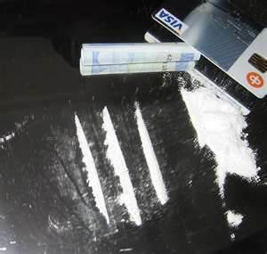](http://www.google.com/url?sa=i&rct=j&q=&esrc=s&frm=1&source=images&cd=&cad=rja&uact=8&docid=YKWv06b0HGd05M&tbnid=FRrkAbjlFBJc7M:&ved=0CAUQjRw&url=http://totalpict.com/cocaine%20crystals&ei=q7mxU-GdIIKBqgatsYL4BA&bvm=bv.69837884,d.b2k&psig=AFQjCNHNTbW6Y54yHkgFFpFSZKVRAPTP4g&ust=1404242722316515)

[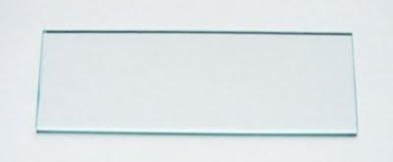](http://www.google.com/url?sa=i&source=images&cd=&cad=rja&uact=8&docid=Ceb1wJ2jQ58jGM&tbnid=gRffnh3oLhBscM:&ved=0CAgQjRw4Ig&url=http://www.studyblue.com/notes/note/n/lab-midterm/deck/5778993&ei=nKqxU--6FoyPqAb4rIHwDg&psig=AFQjCNE0V5CZE2hHJdK6oOIWxAMv4Hp11A&ust=1404238876466713)

**Sample doesn’t**

**dissolve**

Place fresh unknown on slide and add a medium sized drop of **6M HCl**

**Sample dissolves**

[](http://www.google.com/url?sa=i&source=images&cd=&cad=rja&uact=8&docid=Ceb1wJ2jQ58jGM&tbnid=gRffnh3oLhBscM:&ved=0CAgQjRw4Ig&url=http://www.studyblue.com/notes/note/n/lab-midterm/deck/5778993&ei=nKqxU--6FoyPqAb4rIHwDg&psig=AFQjCNE0V5CZE2hHJdK6oOIWxAMv4Hp11A&ust=1404238876466713)

**Sample doesn’t fizz=> organic**

**(aspirin or caffeine)**

**Inorganic (NaCl )**

**Sample fizzed**

**when dissolving1**

**Sample doesn’t fizz**

**when dissolving**

**Step 2: presumptive test for aspirin**

**Repeat the sequence of tests you experienced for the unknown with a bona fide sample of what you tentatively have concluded is the identity of your unknown.**

**It is, of course, of paramount importance that digital documentation and subsequent hard and annotated copies of your microcrystalline observations are recorded for both known and unknown and that a careful comparison of each paired set of known and unknown results is made.**

**Run both caffeine microcrystalline tests**

**(Tests G and H: see attached)**

**Step 3: confirmatory tests for caffeine**

**Step 3: confirmatory test for aspirin**

**Run the aspirin microcrystalline test**

**(Test F: see attachment)**

**1the `fizzing’ and dissolution is confirmation of carbonate (CO32-):**

**2H+  + CaCO3(s) 🡪 Ca2+ + H2O +CO2(g)**

**Aspirin (?)**

**Caffeine (?)**

**Red color doesn’t form**

**Red color forms**

**Run the colorimetric “Marquis” test**

**(Test E: see attachment)**

**Re-crystallize a dilute sample**

**(Test C: see attachment)**

**Step 2c: confirmatory test for NaCl(s)**

**NaCl (?)**

**Run the Cl- microcrystalline test**

**(Test B: see attachment)**

**Step 2b: confirmatory test for Cl-**

**Run the Ca2+ microcrystalline test**

**(Test D: see attachment)**

**Run the Na+ microcrystalline test**

**(Test A: see attachment**)

**Step 2: confirmatory test for Ca2**+

**Step 2a: confirmatory test for Na**+

**CaCO3**

**TEST A**

**MICROCRYSTALLINE TEST FOR Na+**

Place a medium-sized drop of concentrated H2SO4 on a slide and then add to it a drop of distilled water. Carefully add Bi2(SO4)3 solid with stirring and gentle warming until the solution appears ~saturated, as evidenced by faint cloudiness. Add just enough 1M HNO3 to cause the cloudiness to disappear.

Place 5-6 crystals of the suspected NaCl on a second slide and add just enough concentrated H2SO4 so that a thin, damp paste is created after gently warming the sample. (This step converts chloride to sulfate). Add a drop of the Bi2(SO4)3 solution initially prepared to the paste. Warm gently at 50~60o on a hotplate.

***Na+ is indicated if slender, narrow hexagonal rods or short prisms with angular ends appear singly or in star-shaped clumps.***

***student result 50X reference 1, p. 53, fig. 34***

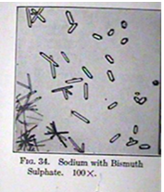

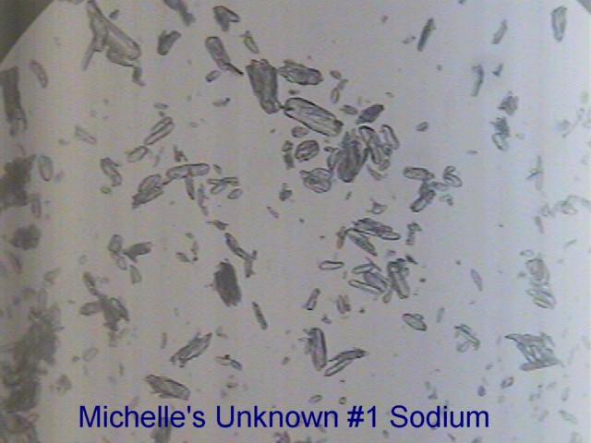

**TEST B**

**MICROCRYSTALLINE TEST FOR Cl-**

Place a medium-sized drop of distilled water on a clean slide and carefully add 3-5 small crystals of your suspected NaCl using a flat toothpick as a spatula and allow the crystals to dissolve. Place a small to medium drop of 0.5 w/v% (~0.03 M) AgNO3 solution. Use the sharp end of the toothpick to draw a thin line of the AgNO3 solution into the dissolved NaCl. ***Cl- is indicated if a white, cloudy precipitate forms, composed of thick amorphous clumps of microcrystals scattered among small diffuse, small, poorly shaped microcrystals.***

***Instructor result at 100X (bright field)***

**0.5% AgNO3 with NaCl(aq) Fong 7/2/14 100X**

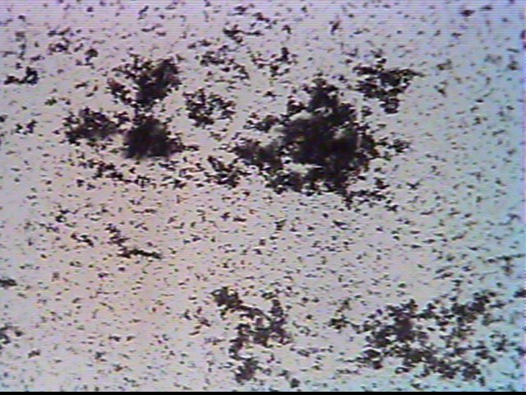

**TEST C**

**MICROCRYSTALLINE TEST FOR NaCl(s)**

Put a medium-sized drop of weak (0.05 M) acetic acid on a glass slide and dissolve into it 3-5 small crystals of suspected NaCl using a flat toothpick to deliver and stir the crystals until they dissolve. Solution should be weak to avoid mass crystallization.

Gently dry the solution on a hot plate set to ~ 65-70 oC until a fine white `rind’ of micro-crystals appear at the outer edge of the drop. ***NaCl crystals should appear as strongly birefringent, cubical or rectangular-shaped crystals under dark field phase illumination.***

***instructor result at 100X (dark field)***

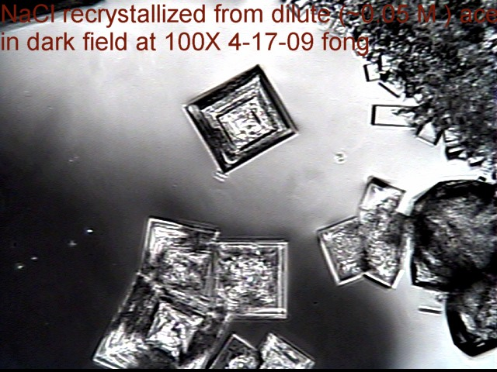

**TEST D**

**MICROCRYSTALLINE TEST FOR Ca2+**

Place a drop of 6M HCL on a clean slide and add a small crystal of the suspect CaCO3(s). Place a drop of 6M H2SO4  next to the first drop and draw together with a tooth pick.  ***Ca2+ is indicated if fine micro- dendritic needles form within a few minutes at drop boundaries and in the isthmus between drops. The microcrystalline habits are discernible at 50- 100X.***

***instructor result at 50X reference 1, p. 105, fig. 70***

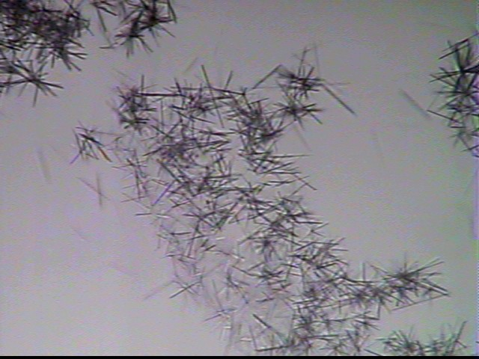

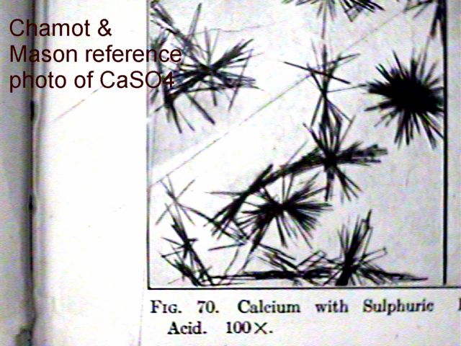

**TEST E**

**COLORIMETRIC (PRESUMPTIVE) MARQUIS TEST FOR ASPIRIN**

Place a few drops of freshly prepared Marquis reagent ( ~ 1mL of 37 % HCHO diluted to 10 mL with concentrated H2SO4) in two wells of a ceramic spot plate.

Place a healthy dose (10-15 crystals) of your unknown into one of the two solutions and wait 1 minute. ***Aspirin (o-acetylsalicylic acid) is indicated if a deep rose color develops, particularly around the boundaries of un-dissolved crystals as compared to the blank Marquis reagent in the other well. Other colors occur with different materials, notably alkaloids, as shown on the right, below.***

***Blank and Marquis Test Result***

***with Aspirin Obtained In-House***

***Examples of Marquis Test with Other Materials***

[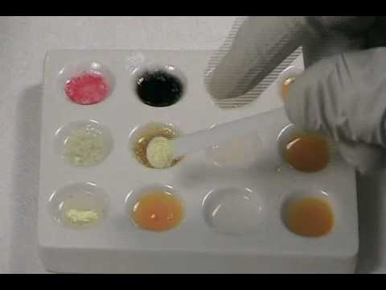](http://www.google.com/url?sa=i&rct=j&q=marquis+reagent&source=images&cd=&cad=rja&uact=8&docid=jLTj6Vw4FYcn4M&tbnid=mr7RxXxIAt807M:&ved=0CAUQjRw&url=http://www.youtube.com/all_comments?v=1DU3R8kkBI8&ei=TFO0U7CUBpCSqgb-14G4Cg&bvm=bv.70138588,d.cWc&psig=AFQjCNHB4onwNksjQbinCl9OUO_qLiA81g&ust=1404413099867897)

http://t1.gstatic.com/images?q=tbn:ANd9GcT8i2AvZ9XT20F8Gn6oARFQ8IXFZEEaJr-NWExhVI7YiMRy0QdT

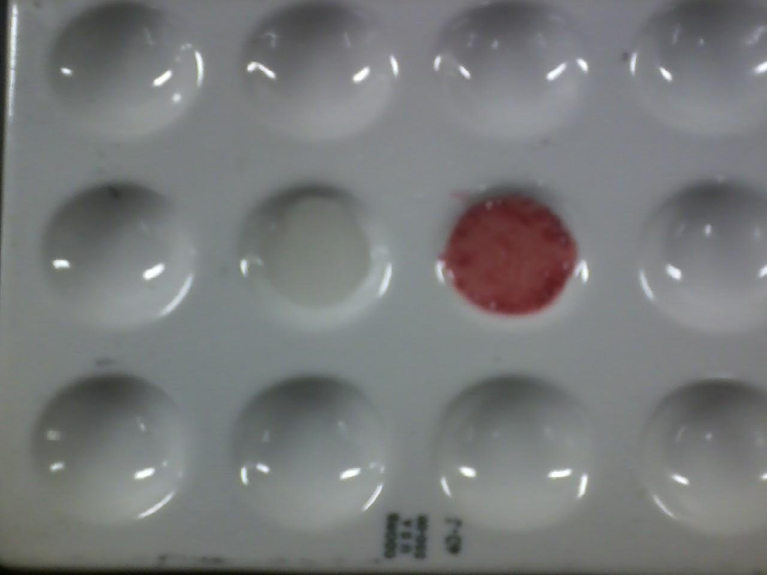

**TEST F**

**MICROCRYSTALLINE TEST FOR ASPIRIN**

Place a medium sized drop of a 1:5 mixture of concentrated (85%) phosphoric acid and glacial acetic acid on a glass slide. Deposit a small crystal of the suspected aspirin in the drop and carefully stir and pulverize the crystal with a toothpick or small spatula until the crystal dissolves. Gently warm the solution on a hot plate set at 70-75 oC. Aspirin is indicated if ***long, narrow filaments and curls of recrystallized o-acetyl salicylic acid (aspirin) form in a thick mat at the drop boundaries after several minutes at 50-100X. (see also: reference 2, pg. 263(7).)***

***Instructor results***

***dark field 100X bright field 100X***

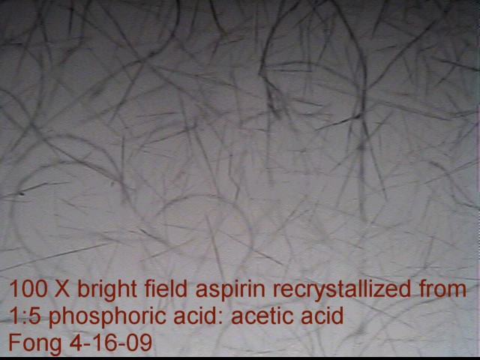

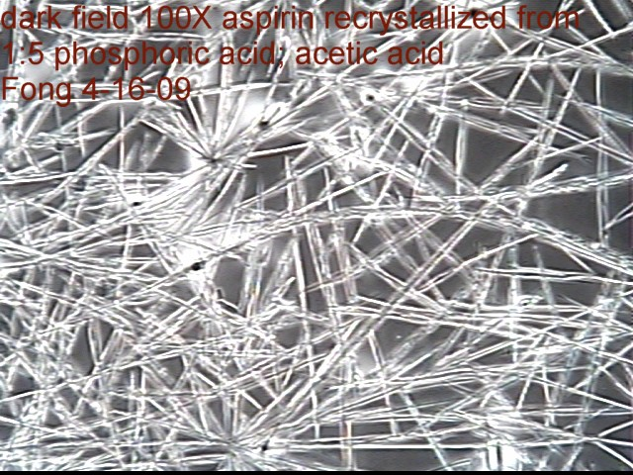

**TEST G**

**MICROCRYSTALLINE TEST FOR CAFFEINE**

Place a medium sized drop of 5% HNO3 on a slide and completely dissolve a few crystals of suspected caffeine in the drop. Place a drop of 0.1M AgNO3 next to the sample drop and draw the two drops together with a toothpick. ***Caffeine is indicated if, after a few minutes dense, black fuzzy balls appear at the boundaries of the drops and in the isthmus with habits discernible at 50-100X. (See also, reference 2, p. 288 (3))***

***Early state Late stage Bright field, 100X Bright field, 100X***

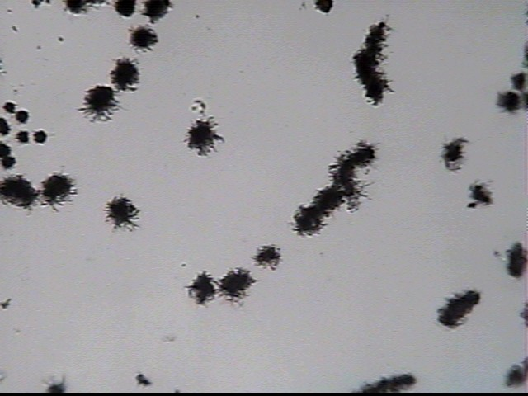

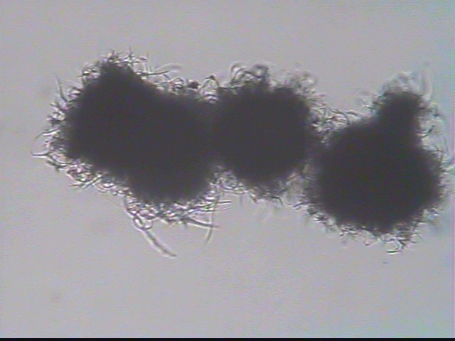

**TEST H**

**MICROCRYSTALLINE TEST FOR CAFFEINE**

Place a medium sized drop of 1% NaOH on a slide and completely dissolve a few crystals of suspected caffeine in the drop. Add powdered NaHCO3 until it no longer dissolves. Place a drop of the KI/I2 solution ((14 g KI & 4.8 g I2/100 mL water) next to the sample drop and draw the two drops together with a toothpick, then place a small crystal of KCl in the mixture. ***Caffeine is indicated if, after a minute or so:***

***Greenish or dark red solution forms, and small, red***

***colored cubes appear at 100X.(See also, reference 2, p. 97(2).)***

***early stages late stage***

***100 X, bright field 100 X, bright field***

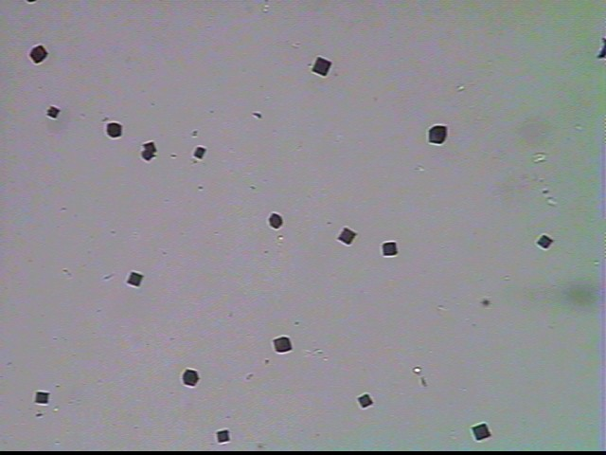

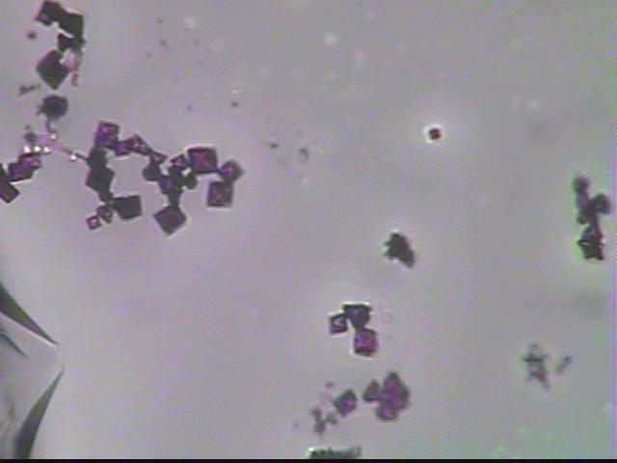

1. **References**
2. E. Chamot and C. W. Mason, **Handbook of Chemical Microscopy, volume II** , John Wiley

& Sons NY, 2nd edition (1931)

1. C. C. Fulton, **Modern Microcrystalline Tests for Drugs**, Wiley-Interscience, NY (1969)
2. M. P. Elie and L. E. Elie, **Microcrystalline Tests for Forensic Drug Analysis**, from **Encyclopedia of Analytical Chemistry, R. A. Meyers, ed., Wiley & Sons, NY 2011**

4) J. Bronowski, **The Ascent of Man,** Little and Brown Inc., New York, NY, 1976