**Laboratory #8**

**Chem 6614 Instrumental Methods of Chemistry**

**SUNY Alfred State College**

**Gas Chromatography/Mass Spectroscopy: Part 2**

**Drug Bust Scenario**

**Due Thursday 10 April**

**8.1. Background**

Several different, suspicious powders found in unmarked plastic bags have been seized by US Border Protection officers during a search of Harry Hippie’s 1964 Volkswagen bus. Harry, who was attempting to cross back into the United States from Ciudad Juarez is a 59 year old male of indeterminate Caucasian ancestry whose passport shows an unusually large number of US-Mexico border crossings and who was-at the time of his detention- in possession of four rolls of twenty dollar bills totaling $4600. His appearance is dominated by an uncombed mane of graying shoulder-length hair and a psychedelic orange `Power to the People ’ tee shirt purchased at Jimmy Hendrix’s1970 Isle of Wight concert. Harry is currently a `guest’ in the DEA’s detention center near Allenby, Texas until the nature of the powders can be ascertained. Harry, unsurprisingly, swears that the powders are legit and that he is a victim of the Amerikan police state. As a side note, none of this would have happened had Harry simply refrained from calling the Border Protection Officer who requested his passport a `f…ing, fat, facist pig.’ Making `oink’ noises when asked to step out of his vehicle didn’t help either.

**8.2. Purpose**

You are each drug analysts at the DEA who have been assigned a bag from Harry’s stash. You are tasked with doing the following

1. Prepare an initial elution of the sample powder in the bag.
2. Carry out an initial GC-MS examination on the initial elution.
3. If necessary, alter either the elution conditions or the GC-MS run conditions to obtain reasonable (SSS) peaks.
4. Provide an identification of the likely `drug’ (or drugs) -if any- in the elution using the MS Chem Station’s NIST search library.
5. Determine if Harry is in possession of a controlled substance, or whether he’s just a closet hypochondriac. You may need to use the Internet to check for common names of the compounds you identify in order to do this.

**8.3. Procedure**

**8.3.1. Initial elution**

Gently crush some of the powdered sample in a clean mortar and pestle and deliver a small spatula tip’s worth of the pulverized result to ~2 mL of dry methanol held in a small test tube.

Make sure to observe the approximate size of your spatula dose since you may have to re-make the elution again at higher or lower concentrations. Use a vortex mixer to `shake’ the sample and aid its dissolution. Allow the elution to stand and settle for a few minutes until the upper layer is clear. Extract the upper clear layer and store it in a clean, capped and labeled vial.

8.3.2 Initial GC-MS run

The Agilent instrument will be pumped down and ready the day of the lab. Because you are dealing with true unknowns a wide temperature range should be ramped over. To start it is suggested that an initial temperature of ~ 75 C and an upper temperature of 300 C be applied. The oven rate is your choice, but faster is better to start. Also, the parent masses of drugs can be quite high so the initial m/e window should be in the 40-400 amu range. The solvent delay may need to be adjusted (methanol boils at 65 C but it still can be resident after several minutes at 75) An initial starting solvent delay of 2 minutes is reasonable. To start, wet needle inject and a split ratio of 100:1 should be used. These can be adjusted if signal sizes are either too big or too small.

You must follow your sample run with a blank run (pure methanol) to purge the column of any residual using the same schedule as you applied to the sample.

8.3.3. Further GC-MS runs

While it is possible that the above conditions suffice to produce reasonable peak separations, you may need to adjust conditions. Since only one GC-MS instrument is currently available, you will need to allow other analysts to carry out their own initial runs before trying an amended run. For this reason, the 5890N Agilent GC-MS will be left on all week. You will need to schedule times with the instructor during the week to come in and use the instrument. Make sure to run a blank between sample runs or the column will become cluttered with residual peaks from previous runs.

You will also need to come in to use the Chem Station Data MS analysis software to search and identify your peaks likely chemical composition.

**8.4. Data and Observations**

As in experiment 7 the following instrument conditions for your unknown analysis should be recorded In **Data & Observations** :

**Table 1:**

**Method Parameters Used to Analyze Unknown # _____ on Alfred State Agilent 5975C GC/MS**

0) unknown # (in title)

1) secondary He tank pressure (in psi)

2) He flow rate

3) split ratio

4) auxiliary heater (transfer line) temperature

5) thermal ramp schedule

start T, hold time, ramp rate, end T, hold time, post-run time, equilibration time)

6) solvent delay time

7) injected sample volume

8) ambient, pre-injection manifold pressure in torr

9) quadrupole temperature

10) EI (source) temperature

11) mass range scanned (low to high)

12) file location for your Method

13) file location for your collected Data

You should also collect and place in **Data & Observations** a hard copy of the total ion chromatogram as well as summary mass spectral peak reports for ion peaks observed in the former.

Finally, make sure to describe how you prepared the sample you used in the first place.

**8.4.2 GC ion chromatogram**

The resulting chromatographic data should be re-tabulated as shown below.

**Table 2: Retention times, ion count and any comments vs component for unknown # ____ 1**

|  |  |  |  |
| --- | --- | --- | --- |
| **Component #** | **~ ion count** | **tr(minutes)2** | **Comments** |
| **1** | **23,000** | **1.9** | **Barely ahead of MeOH carrier** |
| **2** | **Etc** | **Etc** | **etc** |
| **3** | **Etc** | **Etc** | **etc** |

1include filename and address for total ion scan 2 peak retention time

**8.4.3 Component Mass Spectrum**

**Tables 3, 4,…:**

Tabulate as shown below, the 8-10 peaks with the largest % intensities for each significant component detected by GC.

**Table 3: major mass fragments observed for Component #1 (an example)**

(see file.. include file name(s) and address for data and any analysis you do)

)

|  |  |  |
| --- | --- | --- |
| m/e | Raw Peak height (or rel % = P/Pmax) | Comments |
| 42 | 28000 (28) |  |
| 77 | 40000 (40) |  |
| 82 | 100000 (100) | Pmax |
| 96 | 35000 (35) |  |
| 105 | 30000 (30) |  |
| 182 | 70000 (70) |  |
| 198 | 10000 (10) |  |
| 272 | 10000 (10) |  |
| 303 | 15000 (15) |  |

**8.5 Calculations and Analysis**

You will rely primarily on the suggested possible identities of the mass spectral peaks deduced by the NIST library assignment. Some common sense needs to be applied based on the case. Once you decide on the unknown’s component identities, you need to follow the format for assignment below . There will be no need to attempt fragment assignment since drug structure is too complex to allow unequivocal identification of the m/e peaks.

Components Assigned to Unknown # __2___ Based on GC/MS Analysis

|  |  |  |  |  |
| --- | --- | --- | --- | --- |
| **Component #** | **tr(min)** | **Ion count** | **Chemical identity**  **(structural formula and name)** | **Notes** |
| **1** | **4.3** | 129000 | cocaine | Major component…this is pure dope ! |
| 2 | 5.1 | 13,000 | benzocaine | impurity |
| 3 | Etc | Etc | **Etc** |  |
|  |  |  |  |  |

Suggested Unknown Component 1 vs NIST1 reference peaks for Cocaine

Unknown m/e rel intensity % NIST m/e for cocaine rel intensity %

42 28 42 30

77 40 77 38

82 100 82 100

96 35 96 41

105 30 105 25

182 70 182 74

198 10 198 9

272 10 272 11

303 15 303(parent) 10

1 reference source

Suggested Unknown Component 2 vs NIST2 reference peaks for benzocaine

Unknown m/e rel intensity % NIST m/e for benzocaine rel intensity %

Etc etc etc etc

2reference source

**Conclusions:**

Based on gc-ms analysis Unknown 2 contains DL cocaine (major) and benzocaine (minor).

(If other gc peaks were observed but weak, you should say something like:

“GC peaks at 2.5, 3.6 and 8 minutes were observed but at ion counts ~ 1% of those seen for the two components assigned above.”

[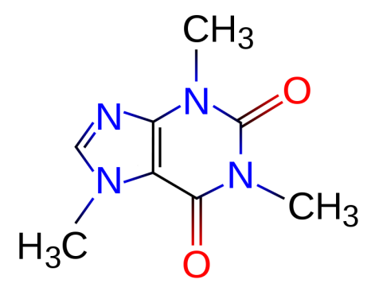](http://upload.wikimedia.org/wikipedia/commons/d/d8/Caffeine.svg)

samples

1. Caffeine

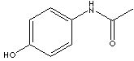

1. Tylenol acetaminophen

[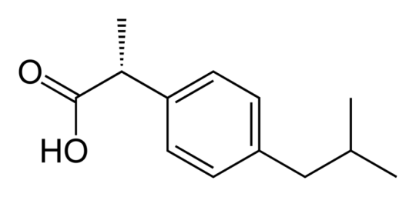](http://upload.wikimedia.org/wikipedia/commons/f/f8/R-ibuprofen-B-2D-skeletal.png)

1. Advil, Motrin ibuprofen

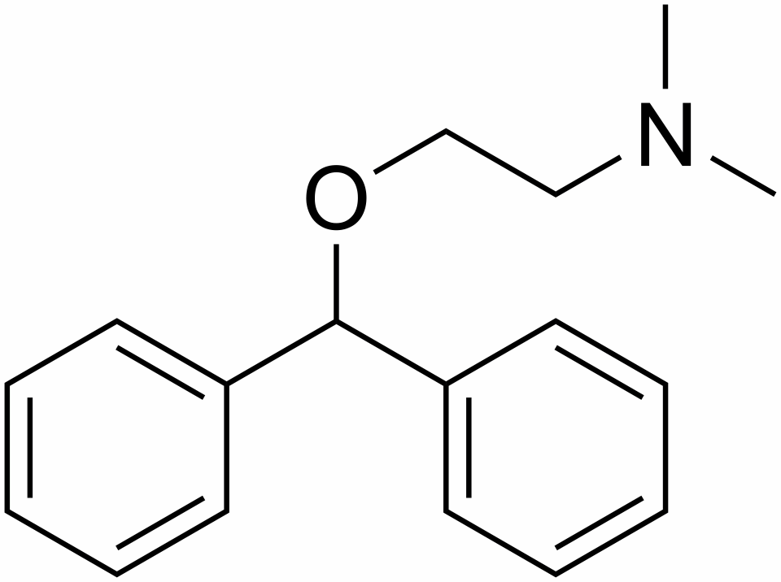

1. Benadryl **Diphenylhydramine hydrochloride**

[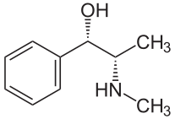](http://upload.wikimedia.org/wikipedia/commons/e/e5/(+)-Pseudoephedrin.svg)

1. **Sudafed pseudoepinephrin**

[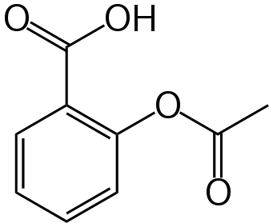](http://upload.wikimedia.org/wikipedia/commons/6/67/Aspirin-skeletal.svg)

6) **Aspirin acetylsalicylic acid**

[](http://upload.wikimedia.org/wikipedia/commons/d/d8/Caffeine.svg)

**Unknowns**

**1)No Doz caffeine**

1,3,7-trimethyl- 1*H*-purine- 2,6(3*H*,7*H*)-dione

* **Acute** caffeine poisoning gives early symptoms of anorexia, tremor, and restlessness. Followed by nausea, vomiting, tachycardia, and confusion. Serious intoxication may cause delirium, seizures, supraventricular and ventricular tachyarrhythmias, hypokalemia, and hyperglycemia.
* **Chronic** high-dose caffeine intake can lead to nervousness, irritability, anxiety, tremulousness, muscle twitching, insomnia, palpitations and hyperreflexia. For blood testing, cross-reaction with theophylline assays will detect toxic amounts. (Method IA) Blood concentration of 1-10 mg/L is normal in coffee drinkers, while 80 mg/L has been associated with death.

### Symptoms

* Abdominal pain
* Appetite loss
* [Coma](http://health.nytimes.com/health/guides/symptoms/consciousness-decreased/overview.html)
* [Convulsions](http://health.nytimes.com/health/guides/symptoms/seizures/overview.html)
* [Diarrhea](http://health.nytimes.com/health/guides/symptoms/diarrhea/overview.html)
* Irritability
* [Jaundice](http://health.nytimes.com/health/guides/symptoms/jaundice-yellow-skin/overview.html)
* [Nausea](http://health.nytimes.com/health/guides/symptoms/nausea-and-vomiting/overview.html)
* [Sweating](http://health.nytimes.com/health/guides/symptoms/sweating/overview.html)
* [Upset stomach](http://health.nytimes.com/health/guides/symptoms/nausea-and-vomiting/overview.html)

Vomiting

**2)Tylenol acetaminophen**



4_-Hydroxyacetanilide

Note: Symptoms may not occur until 12 or more hours after the acetaminophen was swallowed

**3)Advil ibbuprofen**

[](http://upload.wikimedia.org/wikipedia/commons/f/f8/R-ibuprofen-B-2D-skeletal.png)

**4)Motrin**

[**2-[4-(2-methylpropyl)phenyl]propanoic acid**](http://www.chemindustry.com/chemicals/099764.html)

unsteadiness, blurred vision, ringing in the ears, gastrointestinal, nausea plus vomiting, diarrhea, stomach pain, probable loss of blood in intestinal areas or stomach or both, headache, agitation, drowsiness, incoherence and confusion

**5)Benadryl Diphenylhydramine hydrochloride**



2-(diphenylmethoxy)-*N,N*-dimethylethanamine

**(allergies, antihistamine)**

This leads to profound drowsiness as a very common side-effect. Diphenhydramine has also been used as an [anxiolytic](http://en.wikipedia.org/wiki/Anxiolytic) because of these sedating side effects. However, other side effects include possibilities of motor impairment ([ataxia](http://en.wikipedia.org/wiki/Ataxia)), dry mouth and throat, flushed skin, rapid or irregular heartbeat ([tachycardia](http://en.wikipedia.org/wiki/Tachycardia)), blurred vision at nearpoint owing to lack of accommodation ([cycloplegia](http://en.wikipedia.org/wiki/Cycloplegia)), abnormal sensitivity to bright light ([photophobia](http://en.wikipedia.org/wiki/Photophobia)), pupil dilation ([mydriasis](http://en.wikipedia.org/wiki/Mydriasis)), [urinary retention](http://en.wikipedia.org/wiki/Urinary_retention), constipation, difficulty concentrating, short-term memory loss, visual disturbances, hallucinations, irregular breathing, dizziness, irritability, itchy skin, confusion, decreased body temperature (generally in the hands and/or feet), [erectile dysfunction](http://en.wikipedia.org/wiki/Erectile_dysfunction)

**6)Aspirin acetylsalicylic acid**

[](http://upload.wikimedia.org/wikipedia/commons/6/67/Aspirin-skeletal.svg)

hives, swelling, and headache…stomach ulcers and

internal bleeding

**7) Sudafed pseudoepinephrin**

(R*,R*)-2-methylamino-1-phenylpropan-1-ol

[](http://upload.wikimedia.org/wikipedia/commons/e/e5/(+)-Pseudoephedrin.svg)

sleeplessness, nervousness, excitability, dizziness and anxiety. Infrequent ADRs include: [tachycardia](http://en.wikipedia.org/wiki/Tachycardia) and/or [palpitations](http://en.wikipedia.org/wiki/Palpitation). Rarely, pseudoephedrine therapy may be associated with [hallucinations](http://en.wikipedia.org/wiki/Hallucination), [arrhythmias](http://en.wikipedia.org/wiki/Arrhythmia), [hypertension](http://en.wikipedia.org/wiki/Hypertension), seizures and [ischemic colitis](http://en.wikipedia.org/wiki/Ischemic_colitis);[[10]](http://en.wikipedia.org/wiki/Pseudoephedrine#cite_note-Rossi-9) as well as severe skin reactions known as recurrent pseudo-scarlatina, systemic contact dermatitis

**Unknowns**

1. Ibuprofen (advil) S form is active…major component of advil

[**2-[4-(2-methylpropyl)phenyl]propanoic acid**](http://www.chemindustry.com/chemicals/099764.html)**,** [](http://upload.wikimedia.org/wikipedia/commons/f/f8/R-ibuprofen-B-2D-skeletal.png)

|  |  |  |
| --- | --- | --- |
| **IBUPROFEN** | | |
| PRODUCT IDENTIFICATION | | |
| CAS NO. | 15687-27-1 | IBUPROFEN |
| EINECS NO. | 239-784-6 |
| FORMULA | (CH3)2CHCH2C6H4CH(CH3)COOH |
| MOL WT. | 206.29 |
| H.S. CODE | 2916.39 |
| TOXICITY | ORL-RAT LD50:636 MG/KG |
| SYNONYMS | 2-(4-isobutylphenyl)propionic Acid; Apsifen; Apsifen-F; | |
| Alpha-Methyl-4-(2-methylpropyl)benzeneacetic acid; Acide (Isobutyl-4 Phenyl)-2 Propionique (French); Ibuprocin; para-Isobutylhydratropic acid; (+/-)-2-(p-Isobutyl phenyl)propionic acid; (+)-2-(4-Isobutyl phenyl)propionic acid; 4-Isobutyl- alpha-methylphenylacetic acid; Ibufen; Ibuprin; Alpha-methyl-4-(2-Methylpropyl)- Benzeneacetic Acid; | | |
| DERIVATION |  | |
| CLASSIFICATION |  | |
| PHYSICAL AND CHEMICAL PROPERTIES | | |
| PHYSICAL STATE | white crystalline powder | |
| MELTING POINT | 75 - 78 | |
| BOILING POINT |  | |
| SPECIFIC GRAVITY |  | |
| SOLUBILITY IN WATER | Practically insoluble | |
| pH |  | |
| VAPOR DENSITY |  | |
| AUTOIGNITION |  | |
| NFPA RATINGS |  | |
| REFRACTIVE INDEX |  | |
| FLASH POINT |  | |
| STABILITY | Stable under ordinary conditions | |
| APPLICATIONS | | |
| Ibuprofen is a drug belong to a class of NSAID (nonsteroidal anti-inflammatory drug acts by inhibiting isoforms of cyclo-oxygenase 1 and 2. It has an activity to treat inflammatory  rheumatoid diseases and relieve acute pain. It is effective against period pains, pain after surgery, and fever. | | |

**Thermodynamic evaluation of ibuprofen solubility in aqueous and non-aqueous cosolvent systems**

by *Khalifeh, Ismail Mahmoud*, Ph.D., **Purdue University**, 2000, 234 pages; AAT 3033111

**Abstract (Summary)**

The purpose of this research was to investigate the mechanism of solubilization of a model drug, ibuprofen, in cosolvent-water mixtures by applying enthalpy-entropy compensation analysis. The solubility of ibuprofen in pure solvents decreased in the following order: DMSO > methanol > ethanol > isopropanol > n-propanol > PEG-200 > PG > water. The addition of ibuprofen to n-propanol-water mixtures, isopropanol-water mixtures and DMSO-water mixtures resulted in phase-separation. The increase in ibuprofen solubility in the binary cosolvent-water mixtures decreased in the following order: isopropanol-water mixtures > n-propanol-water mixtures > ethanol-water mixtures > methanol-water mixtures > PEG-water mixtures > PG-water mixtures. The solubility of ibuprofen in PG-ethanol mixtures decreased linearly as the amount of PG in the solvent mixture increased. The enthalpy of solution of ibuprofen in the solvent mixtures varied nonlinearly with solvent composition. In aqueous systems, the enthalpy of solution increased to a maximum and then decreased as the cosolvent mole fraction increased. The entropy of solution of ibuprofen showed similar trend as that of heat of solution. The maximum in enthalpy and entropy of solution appeared at the same cosolvent mole fraction. The free energy evaluated at the harmonic mean of experimental temperature decreased as the cosolvent mole fraction increased. At low cosolvent mole fraction, up to the maximum in enthalpy and entropy versus composition curves, the solubility of ibuprofen was entropy driven while beyond the peaks, the solubility of ibuprofen was enthalpy driven. For PG-ethanol system, a linear increase in both enthalpy and entropy of solution as a function of PG mole fraction was found. The mechanism of decrease in ibuprofen solubility was due to unfavorable increase in enthalpy of solution. Enthalpy-entropy compensation analysis, showed that a nonlinear compensation existed between enthalpy and entropy due to variation in solvent composition and not to propagation of experimental errors. The change in the slope of ΔH versus ΔG hm curves for aqueous systems indicated that two different mechanisms contribute to the solubility of ibuprofen depending on the nature of the solvent system. However, for PG-ethanol mixtures, no peak was observed in the ΔH versus ΔG hm plot suggesting that one mechanism is responsible for the decrease in ibuprofen solubility as the amount of PG was increased.



**Indexing (document details)**

|  |  |
| --- | --- |
| **Advisor:** | Kildsig, Dane O. |
| **School:** | Purdue University |
| **School Location:** | United States -- Indiana |
| **Keyword(s):** | Ibuprofen, Solubility, Cosolvent |
| **Source:** | DAI-B 62/11, p. 5057, May 2002 |
| **Source type:** | Dissertation |
| **Subjects:** | Pharmaceuticals |
| **Publication Number:** | AAT 3033111 |
| **ISBN:** | 0493460659 |
| **Document URL:** | http://proquest.umi.com/pqdlink?did=726066411&Fmt=7&clientId =79356&RQT=309&VName=PQD |

1. Caffeine (No Doz)

[](http://upload.wikimedia.org/wikipedia/commons/d/d8/Caffeine.svg)

1,3,7-trimethyl- 1*H*-purine- 2,6(3*H*,7*H*)-dione

2.17 g/100 mL water at 25 C

#### **Soluble** in water (1 in 68), boiling water (1 in 1), alcohol (1 in 40), chloroform (1 in 7), ether (1 in 400), or benzene; its solubility in water is much increased by the addition of sodium benzoate or salicylate

[http://bits.wikimedia.org/skins-1.5/common/images/magnify-clip.png](http://en.wikipedia.org/wiki/File:Main_symptoms_of_Caffeine_overdose.png) Caffeine intoxication

Main symptoms of caffeine intoxication.[[68]](http://en.wikipedia.org/wiki/Caffeine#cite_note-Medline-67)

An acute overdose of caffeine, usually in excess of about 300 milligrams, dependent on body weight and level of caffeine tolerance, can result in a state of central nervous system over-stimulation called *caffeine intoxication* ([DSM-IV](http://en.wikipedia.org/wiki/DSM-IV) 305.90),[[91]](http://en.wikipedia.org/wiki/Caffeine#cite_note-DSM-IV-90) or colloquially the "caffeine jitters". The symptoms of caffeine intoxication are not unlike overdoses of other [stimulants](http://en.wikipedia.org/wiki/Stimulants). It may include restlessness, [nervousness](http://en.wikipedia.org/wiki/Nervousness), excitement, insomnia, flushing of the face, [increased urination](http://en.wikipedia.org/wiki/Diuresis), [gastrointestinal](http://en.wikipedia.org/wiki/Gastrointestinal_tract) disturbance, [muscle twitching](http://en.wikipedia.org/wiki/Fasciculation), a rambling flow of thought and speech, irritability, [irregular](http://en.wikipedia.org/wiki/Cardiac_arrhythmia) or [rapid heart beat](http://en.wikipedia.org/wiki/Tachycardia), and [psychomotor agitation](http://en.wikipedia.org/wiki/Psychomotor_agitation).[[89]](http://en.wikipedia.org/wiki/Caffeine#cite_note-EofMD-88) In cases of much larger overdoses, [mania](http://en.wikipedia.org/wiki/Mania), [depression](http://en.wikipedia.org/wiki/Depression_(mood)), lapses in judgment, [disorientation](http://en.wikipedia.org/wiki/Disorientation), [disinhibition](http://en.wikipedia.org/wiki/Disinhibition), [delusions](http://en.wikipedia.org/wiki/Delusions), [hallucinations](http://en.wikipedia.org/wiki/Hallucinations), and [psychosis](http://en.wikipedia.org/wiki/Psychosis) may occur, and [rhabdomyolysis](http://en.wikipedia.org/wiki/Rhabdomyolysis) (breakdown of skeletal muscle tissue) can be provoked.[[92]](http://en.wikipedia.org/wiki/Caffeine#cite_note-91)[[93]](http://en.wikipedia.org/wiki/Caffeine#cite_note-92)

1. Acetaminophen (Tylenol)

**Chemical Names**

*N*-(4-Hydroxyphenyl)acetamide

4_-Hydroxyacetanilide

**Other Names**

Paracetamol, Tempra, Tylenol

**Form Molecular Formula MW CAS**

Acetaminophen C8H9NO2 151.2 103-90-2

**Appearance**

Acetaminophen occurs as a white crystalline powder with a slightly bitter taste.

**Solubility**

Acetaminophen is soluble in boiling water and freely soluble in alcohol.

|  |  |  |
| --- | --- | --- |
| **ACETAMINOPHEN** | | |
| PRODUCT IDENTIFICATION | | |
| CAS NO. | 103-90-2 | ACETAMINOPHEN |
| EINECS NO. | 203-157-5 |
| FORMULA | CH3CONHC6H4OH |
| MOL WT. | 151.17 |
| H.S. CODE | 2924.29 |
| TOXICITY | Oral rat 2404 mg/kg |
| SYNONYMS | 4'-hydroxyacetanilide; Tylenol; Paracetamol; Paracetamolo; | |
| Paracetamole; P-acetamido-Phenol; 4'-hydroxyacetanilide; n-(p- Hydroxyphenyl)-Acetamide; N-(4-hydroxyphenyl)-Acetamide; P-acetamidophenol; 4-Acetamidophenol; Acetaminofen; Acetaminophen; P- Acetaminophenol; N-acetyl-p-aminophenol; P-Acetylamino Phenol; P-hydroxyacetanilide; Paracetamol; 4-hydroxy Acetanilide; 4-hydroxyanilid Kyseliny Octove; N-(4-hydroxyphenyl) Acetamide; | | |
| DERIVATION | p-aminophenol, acetic anhydride | |
| CLASSIFICATION |  | |
| PHYSICAL AND CHEMICAL PROPERTIES | | |
| PHYSICAL STATE | white crystalline powder | |
| MELTING POINT | 169 - 172 C | |
| BOILING POINT |  | |
| SPECIFIC GRAVITY | 1.293 | |
| SOLUBILITY IN WATER | miscible | |
| pH | 5.5 - 6.5 | |
| VAPOR DENSITY |  | |
| AUTOIGNITION |  | |
| NFPA RATINGS | Health: 0 Flammability: 1 Reactivity: 0 | |
| REFRACTIVE INDEX |  | |
| FLASH POINT |  | |
| STABILITY | Stable under ordinary conditions | |

1. Allergy tablets (antihistamine) diphenylhydramine

2-(diphenylmethoxy)-*N,N*-dimethylethanamine



|  |  |
| --- | --- |
| [CAS number](http://en.wikipedia.org/wiki/CAS_registry_number) | [58-73-1](http://www.nlm.nih.gov/cgi/mesh/2009/MB_cgi?term=58-73-1&rn=1) |

Water solubility 3.06 mg/mL water at 37 oC (Beilstein)

Description **Diphenhydramine** **Hydrochloride** occurs as

white crystals or crystalline powder. It is odorless, and has a

bitter taste, followed by a sensation of numbness on the ton-

gue.

It is very soluble in methanol and in acetic acid (100), free-

ly soluble in water and in ethanol (95), sparingly soluble in

acetic anhydride, and practically insoluble in diethyl ether.

It is gradually affected by light.