**Homework #9: Electronics menagerie 45 points**

*Chem 6614 Chemical Instrumentation Due Monday 5 May*

1. Which passive component(s) below do not produce a phase shift between alternating voltage and its alternating current ? ________________

Capacitor inductor resistor rheostat

1. **Match symbols and units**
2. Henries b) mho c)μA d) mW

e) uF f)J/coulomb g)MΩ h) coulombs

C______________

Q_____________

I ______________

V ______________

R ______________ **A B C D**

L _______________





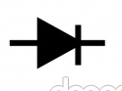

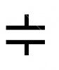

P_______________

1. **Match components to symbols**

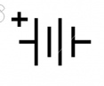

Resistor ____

Capacitor ____ **E F**

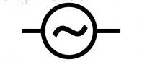

Voltage monitor____

Inductor ____

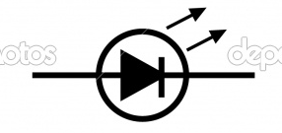

Op amp ____ **G H I**

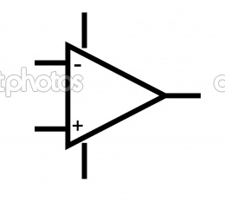

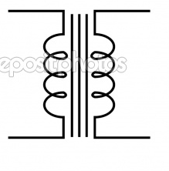

Diode ____

Transformer ____

Transistor ____

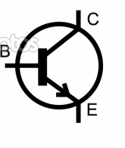

AC source ____ **K** **L**

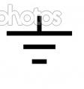

DC source ____

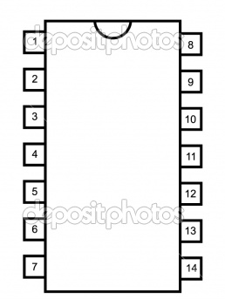

Current monitor____

control chip ____

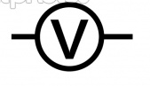

ground ____ **M N O**

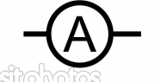

LED ____

1. **Wheatstone Bridge Detection**

[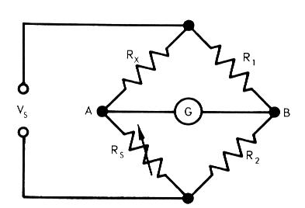](http://www.google.com/url?sa=i&rct=j&q=wheatstone+bridge&source=images&cd=&cad=rja&docid=dQ0ny4Gw0YED9M&tbnid=dMbapMwpxZ2m1M:&ved=0CAUQjRw&url=http://www.matni.com/Arabic/Elec-Info/Basic%20Electronics/Basic%20E3.htm&ei=DW2AUfLFOKqK0QGb1YCIBA&bvm=bv.45645796,d.dmQ&psig=AFQjCNFwEzsndakQ3l8sIpECNd-cawJ6eQ&ust=1367457279359039)

R1 =100 ohms, R2 =300 ohms. If the galvanometer

(G) shows zero current (null) when Rs = R4 = 1500 ohms, what

Is the value of Rx = R3 ? Rx= ___________ohms

1. **Component Uses**
2. Divides V and I; passive _____
3. Voltage lags current; blocks DC _____
4. Current lags voltage; blocks AC _____
5. Transistor
6. Inductor
7. Capacitor
8. Resistor
9. Diode
10. One-way electronic valve _____
11. Solid state switch _____

___/29

**6. Sketchy Stuff (7 pts)**

For each component shown, sketch the expected time variation of the voltage or current

across the indicated component

**VA = applied voltage describe time effect**

**On I or V in words below:**

0 τ

[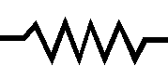](http://www.google.com/url?sa=i&rct=j&q=&esrc=s&source=images&cd=&cad=rja&uact=8&docid=G7lO7MINB5qRwM&tbnid=_aNpgI800L_KqM:&ved=&url=http://lateblt.tripod.com/electron.htm&ei=QidYU-fXF6GCyQGH04DgCg&bvm=bv.65397613,d.aWc&psig=AFQjCNFcrtxhCTyElnSNT5mDBx2Zq6UUfw&ust=1398372546794843)

VR

(2 pts)

I

V(R)C

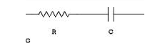

(3 pts)

I



VR(C)



V(R)L

(2 pts)

I( R) L

**7. Computer Speak (10012 points= 910 pts)**

1. What is meant by the term: “A 3 GHz machine” ?
2. What is meant by 4 Gb RAM ?
3. How is cache different than hard drive memory?
4. What is a `BUS’ ?

Match us:

1) (older style) 9 pin Serial port mostly for printers

2) modern serial connectors

3) Hard connection to Ethernet

4) MAC connector

5)(newer style) parallel port to peripherals

DB-25 _____

USB _____

RJ-45 _____

RS-232 _____

DIN-8 ____