Homework #6: MS Basics 24 pts total
Chem 6614 Chemical Instrumentation Friday 7 April

Your name: ____________________________________________ N

6.1. Theory ( 7 pts/1 pt each)
+
1) Draw way will the (+) charge move as it passes through the magnetic field shown to the right (note: the rh rule was for – charges)

S
2) Which is not true about a magnetic sector MS ?
a) as mass increases, radius of deflection increases
b) as magnetic field increases, close lying masses can be better separated
c) the speed of the charged species increases with increasing filament current
d) the higher the accelerator voltage, the higher the mass separated at fixed magnetic field
and curvature

3) Fill in the table below
Variable changed | Effect on r, the curvature of the ion through magnet: up or down
Decrease of B
Increase of accelerating V
Increase of charge on mass
Decrease of mass at fixed charge

4) What resolution , R, is ~ needed at 28 amu to distinguish N₂ (mass =28.0061 amu) from CO (mass=27.9949 amu) .Show work below:

6.2. Part-pourri (8 pts/1 pt each)

a) Pump type also referred to as a roughing pump: _____________________
b) Kind of vacuum gauge that is least expensive and used to monitor rough vacuum______
c) Traditional detector in magnetic sector MS___________________________
d) Name of traditional ion source for most MS: _______________________
e) high vacuum pumps found in Alfred’s MS.__________________________
f) Most common, magnetically based MS design________________________
g) `Commercial flange’ design commonly found in MS plumbing: ______________________
h) Part that focuses the mass fragments into the magnet_____________________________

6.3. Assignment Puzzles

a) The following masses are observed after a mixture of two gases are analyzed in a MS:
44 32 28 16 15 14 13 12 1 amu

What are the likely identities of the two gases ? ____________ & _________________
( 2 pts)

b) The MS spectrum of a pure, unknown organic compound is shown below.
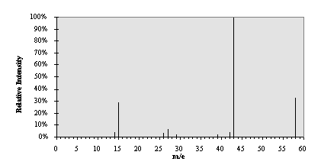

1)Determine the ID of the compound: (2 pts)

2)assign the compound’s likely fragment identities at: (5 pts)

Amu Fragment ID

58 ______________________

43 ______________________

42 ______________________

28_______________________

15_______________________

