Exercise #4: GC/HPLC Practical Separations
Chem 6614 Chemical Instrumentation

4.1. General strategies
1) Pick a column (see attached table), oven temperature schedule and GC detector that would be best to separate and analyze the % composition of mixture of alcohols with boiling points ranging from 120-180 ºC so that the entire chromatogram takes no longer than 10 minutes to record.

2)The pyrenes (fused aromatic rings bp 300-500 C) collected from an arson site are eluted into ethanol. Suggest a method (GC or HPLC) to isolate and identify the various pyrene components. Suggest not only the technique but also a detector, column , flow rate and mobile phase composition.

3)The exhaust gas from a diesel generator needs to be analyzed for CO, CO₂, unburnt hydrocarbons, and SO₂. Suggest a GC method including a detector.

4.2. GC Nerd Factoids
4) What advantages do capillary columns have over packed columns ?

5) Name the various GC detectors that are:
- destructive of the sample:

- reliant on changes in conductivity

- universally applicable to all organics, insensitive but cheap

- universally applicable to all organics and ID’s compound but expensive

6) List 3 ways to sharpen a GC peak

i)

ii)

iii)

7.) What does MAOT stand for ?______________________________________

A B C
7) List 3 ways to separate overlapping GC peaks

i)
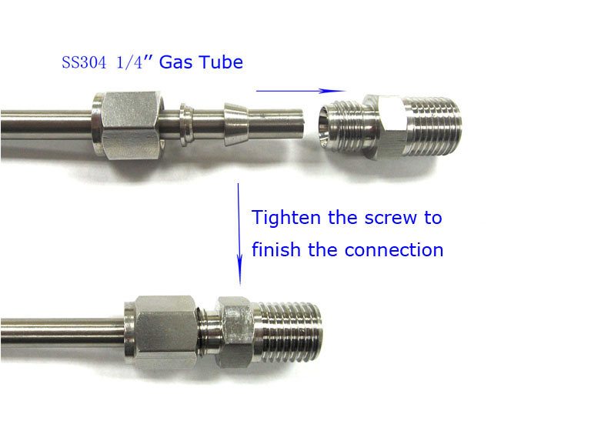
ii)

iii)

8) What is the name of the common plumbing attachment
method shown to the right ?

A=___________________ B=_______________
What kind of fitting are we ?_________
C=__________________

3.3) HPLC Nerd Factoids
9) What does HPLC stand for ?______________________
10) What essentially takes the place of the thermal ramp in HPLC ?______________________
11) What is the specific name of the pump design in HPLC ?______________________
12) What levels out the pressure variation in the HPLC from the above pump ? _____________
13) If you use a polar carrier solvent, then you are operating in reverse phase or normal phase ?
14) What is a typical column length for HPLC ?
15) The following is written on an HPLC column’s metal `dog tag’: What does each term refer to ?

SOME COMMON STATIONARY (ACTIVE) GC PHASES (MAOT < 350 C)

stationary phase commercial name uses

Polymethyl silicone OV-1, SE-30 general purpose
(methyl silicone) (ROH, alkanes, alkenes, PCB,
Aromatics, drugs, steroids)

Poly(phenymethyl) siloxane OV-17 aromatics, glycols, steroids
(50:50 methyl: phenyl)

Polyethylene glycol carbowax 20M acids, ethers, natural oils (fats)

Polyethylene glycol-
Terephthalic acid OV-351 alcohols, fatty acids

Molecular sieve Mol Sieve 5A,13X permanent gases
(finely divided aluminosilicates, carbon Poropak (must be in packed column)
Similar cellular inorganics)

COLUMN TYPES = capillary, open (>10’) packed, closed (< 10’)
DETECTORS=TCD, PID, FID, ECD ,MS

