**Exercise #8 : DSC Mixture Interpretations**

*Chem 6614 Chemical Instrumentation*

For the DSC-ograms shown below, pick the most likely matieral or combination of materials

present that could have created them:

**1) pure, stable CaCl2 *2H2O crystal**

**2) pure silica glass**

**3) pure cristobalite quartz (silica crystal) {may undergo c-c change to tridymite at high**

**temp)**

**4) pure PVC amorphous plastic**

**5) pure PVC crystalline plastic**

**6) Pyrex**

**7) NaCl (stable, pure cubic crystal, mp ~ 820)**

**8) KCl (stable, pure, cubic crystal, mp ~ 740)**

**9) soda-lime glass**

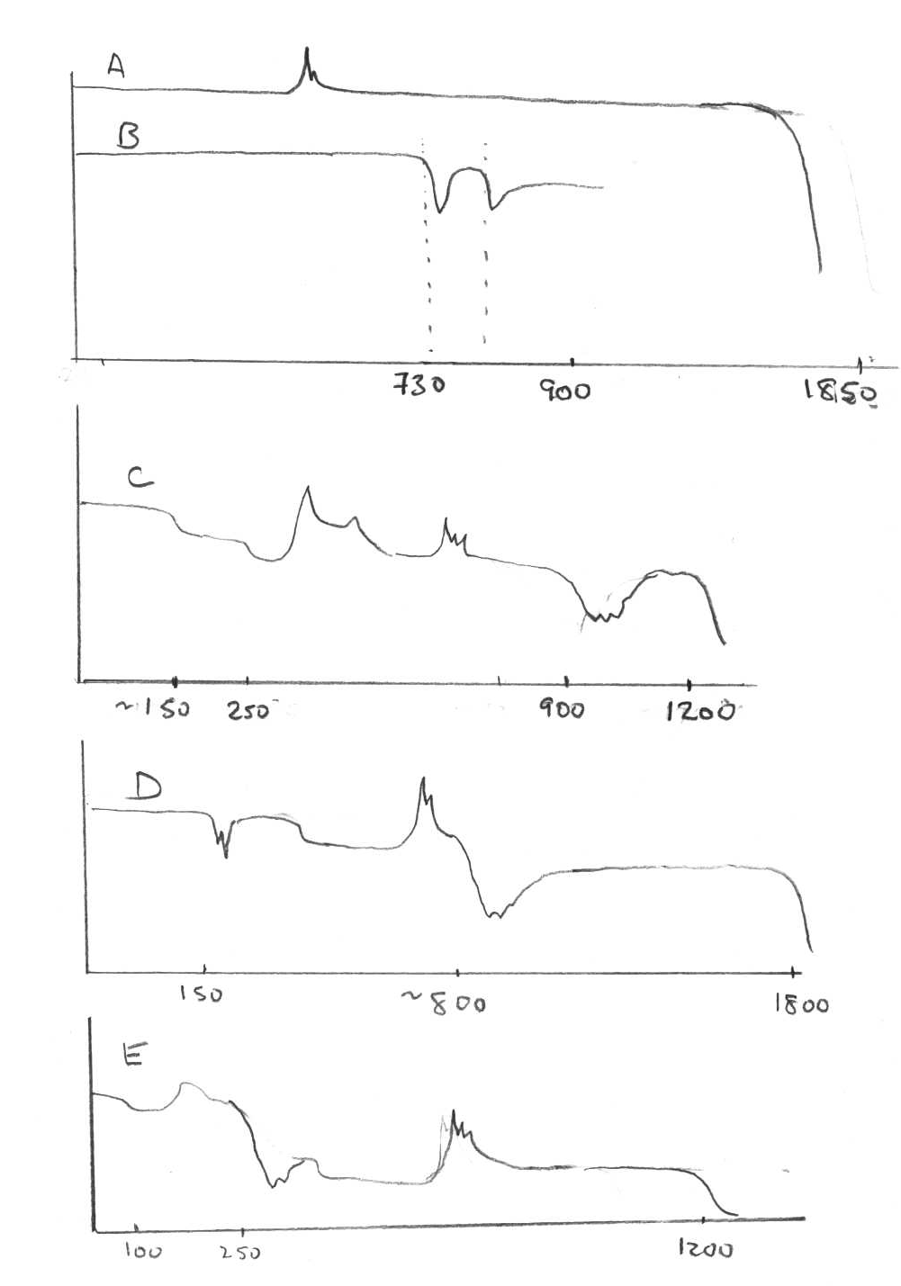

**endo**

**exo**