**Exercise #7 : Crash Course in** **SEM basics**

*Chem 6614 Chemical Instrumentation*

**Basic Theory**

7.0 Why does λ = h/mv guarantee that an SEM is better than an optical microscope ?

Mass m of electron in denominator produces a very low λ. Ex. If v= 2*108 m/s, m=9.1*10‑31 kg, h=6.63*10-34 J s=> λ(m)= 6.63*10-34 J*s/(9.1*10-31 *2*108)=3.6*10-12 m 0.0036 nm

**Basic Resolution and Magnification**

7.1 What is the ~minimum theoretical resolution of an SEM in nm? ____~0.002 nm________

7.2 What is the practical resolution of an SEM in nm ? ___0.1-1 nm_________

7.3. What is the ~ practical magnification range typical of an SEM ? __40,000-100,000X__________

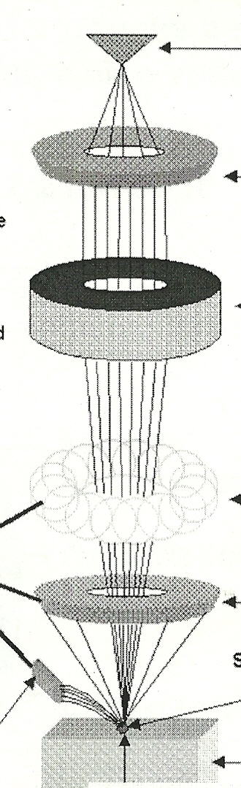b

**Basic SEM Design f**

7.4 Place the terms below (using letters) with their position on the diagram of

An SEM to the right:

1. Scanning coils b) stage + specimen c) Magnetic lens d) Anode d

e) back scattered/SE electron detector f) electron gun

**Beam Spot geography c**

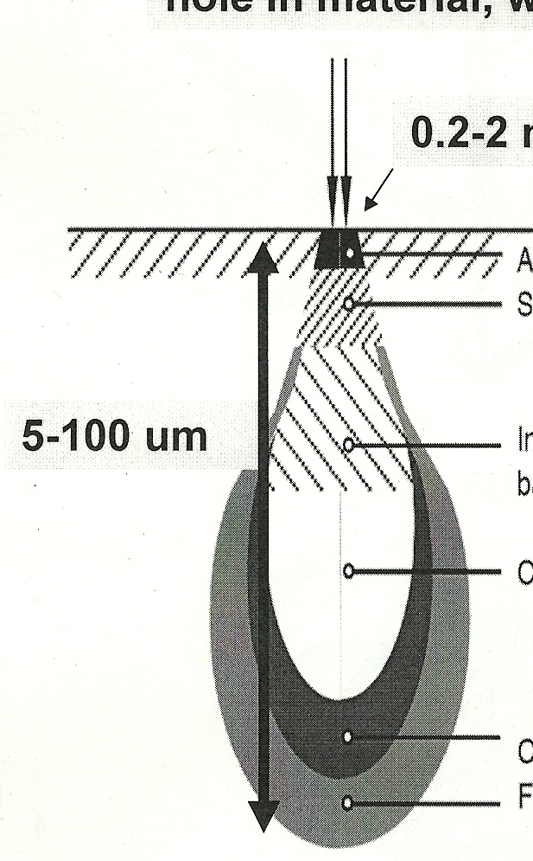

e- beam

1

7.5 Indicate from what level (1 or 2)

nm

the following electrons emit:

2

1. (inelastically) back scattered electrons 2
2. Secondary emitted electrons 1 c

**SEM Images and add-ons**

**e**

7.6 What two major imaging sources are used in an SEM ?

a) ________SE (secondary electron emission)_____

b) _______BSE inelastic backscattered emission)____________________

7.7a Of the two images collected, which is the main source of the 3D topographical pictures like those taken of a spider mite and the surface of cheese ? SE

7.7b Of the two images collected, which provides compositional maps of the surface, but has poor depth of field ? BSE

7.8 What `add-on’ supplies semi-quantitative data about the elemental composition of the observed SEM spot ? (acronym and full name) XRED (X-ray Energy Dispersion)

7.9. What is a `scan’ of a sample across the surface called in SEM-speak ? _______raster___________

**SEM sample details**

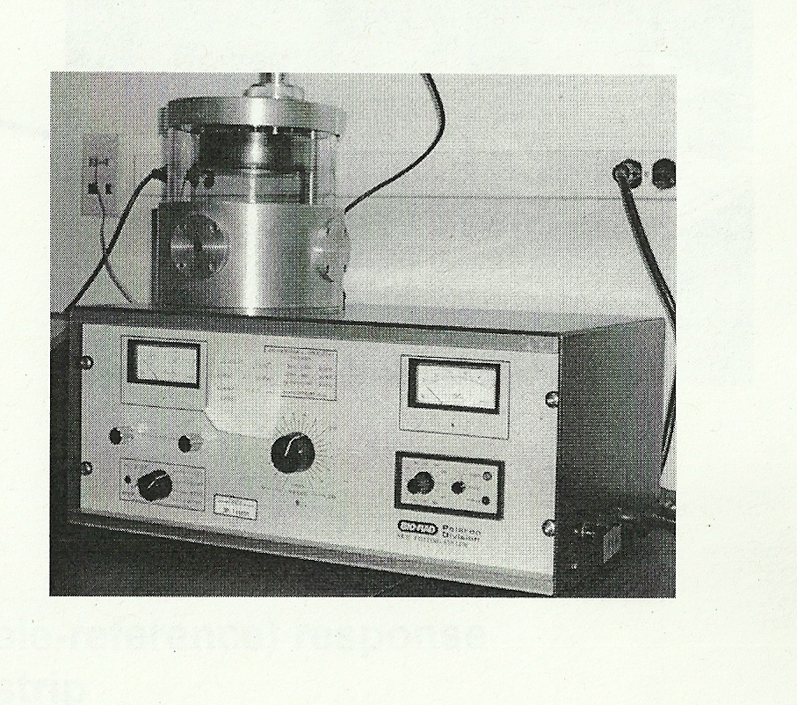

The item to the right is a common sight in an SEM lab. What does do and why ?

SEM (vacuum) coater- to lay down conductive surface on non-conducting samples

(else sample is burned to a crisp)

[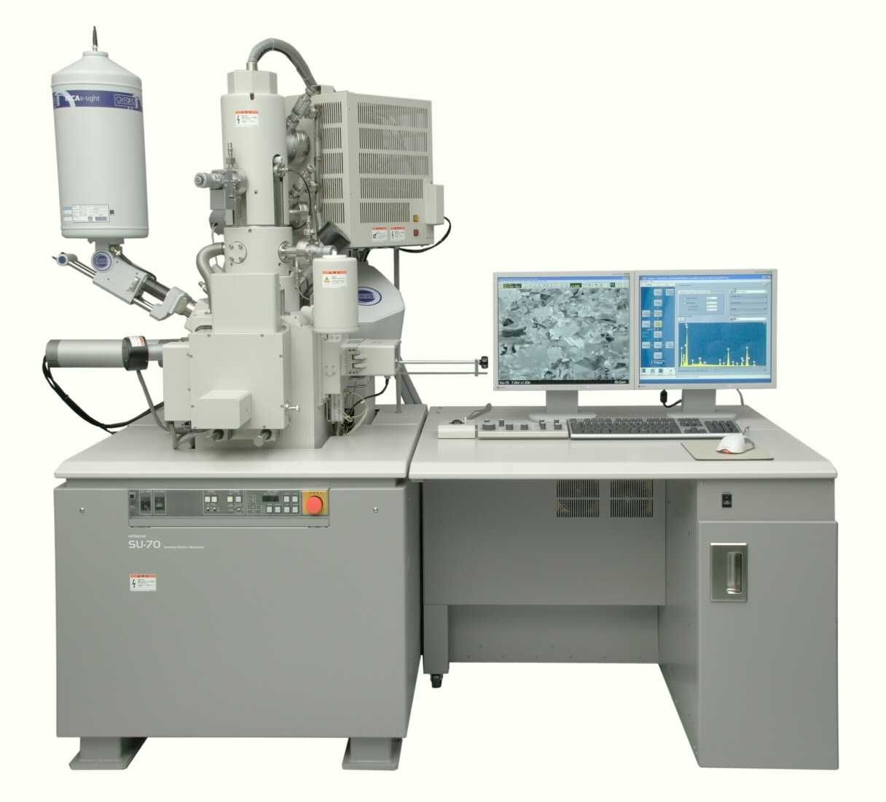](http://www.google.com/url?sa=i&rct=j&q=&esrc=s&source=images&cd=&cad=rja&uact=8&ved=0ahUKEwiR4rf0ofbLAhVhuoMKHWjYA2MQjRwIBw&url=http://binoculas.net/sem-scanning-electron-microscope/&psig=AFQjCNEk2iSTENTOb-xCqrnrnIgxzlek7g&ust=1459903334726507)

A

B

C

Screen 1

Screen 2

7.10) Match us with the pieces in the picture



XRED detector ___C__

Secondary electron detector ___B__

main electron focusing optics ___A___

7.11a) Which monitor is likely to show the SEM image ?

1 or 2

7.11b) Which monitor is likely connected to elemental 7.11c What do I do ?

analysis ?

1 or 2

7.12) Why must biological and non-conductive samples be `coated’ with films of gold or carbon for SEM imaging ?

SEM (vacuum) coater- to lay down conductive surface on non-conducting samples

(else sample is burned to a crisp)