**Exercise #4 :**  **SEM basics**

*Chem 6614 Chemical Instrumentation*

**Basic Theory**

4.0 Why does λ = h/mv guarantee that an SEM is better than an optical microscope ?

**Basic Resolution and Magnification**

4.1 What is the ~minimum theoretical resolution of an SEM in nm? ____________

4.2 What is the practical resolution of an SEM in nm ? ____________

4.3. What is the ~ practical magnification range typical of an SEM ? ____________

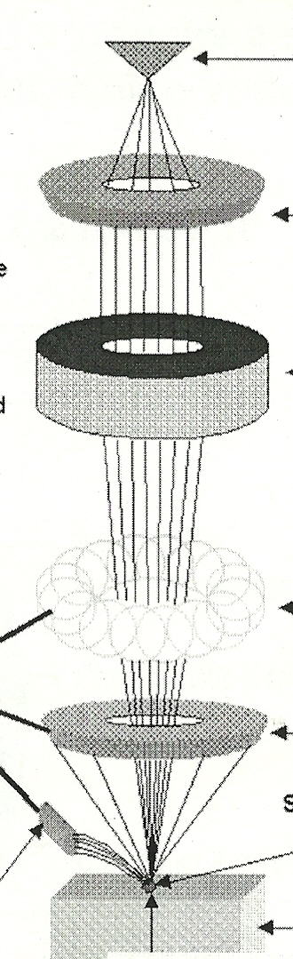

**Basic SEM Design**

4.4 Match the terms below with their position on the diagram of

An SEM to the right:

1. Scanning coils b) stage + specimen c) Magnetic lens d) Anode

e) back scattered electron detector f) electron gun

**Beam Spot geography**

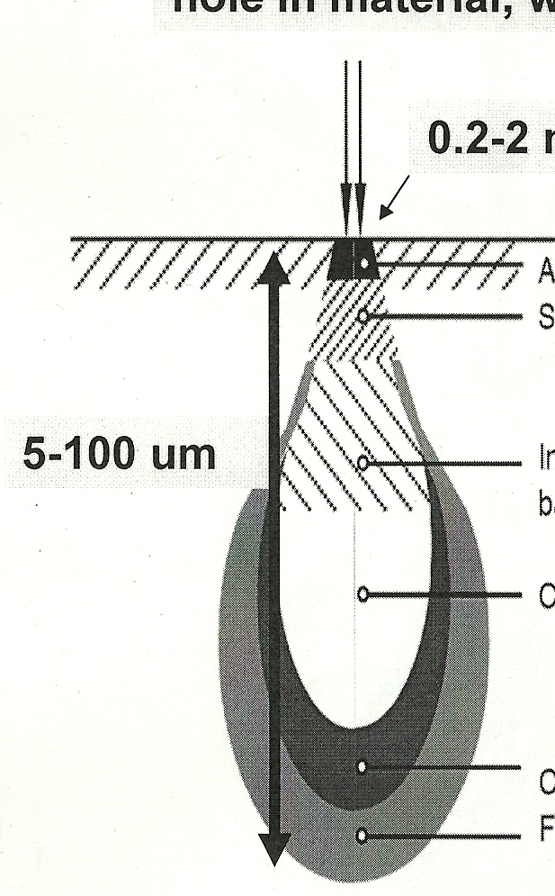

e- beam

4.5 Indicate from what level (1 or 2)

nm

the following electrons emit:

1

1. (inelastically) back scattered electrons
2. Secondary emitted electrons

2

**SEM Images and add-ons**

4.6 What two major imaging sources are used in an SEM ?

a) ___________________________

b) ___________________________

4.7a Of the two images collected, which is the main source of the 3D topographical pictures like those taken of a spider mite and the surface of cheese ?

4.7b Of the two images collected, which provides compositional maps of the surface, but has poor depth of field ?

4.8 What `add-on’ supplies semi-quantitative data about the elemental composition of the observed SEM spot ? (acronym and full name)

4.9. What is a `scan’ of a sample across the surface called in SEM-speak ? __________________

**SEM sample details**

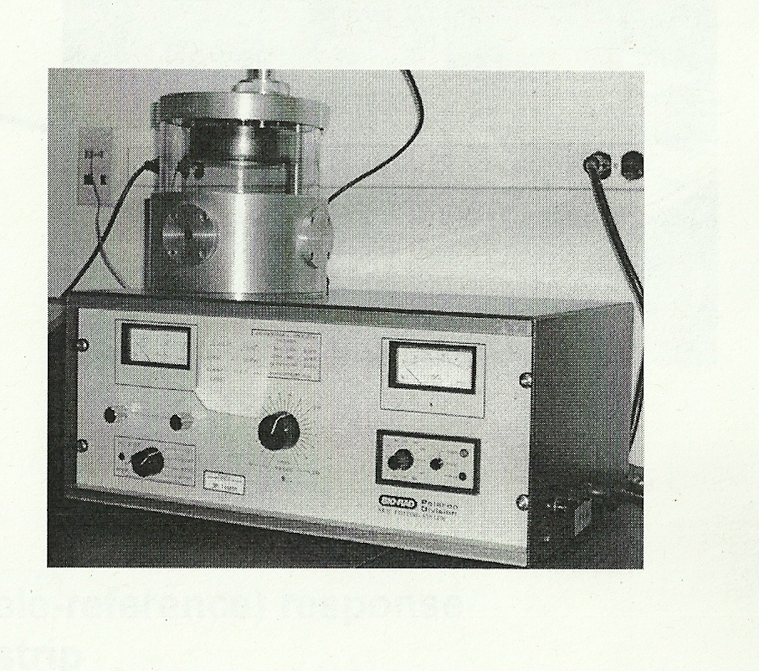

The item to the right is a common sight in an SEM lab. What does do and why ?

4.10) Match us with the pieces in the picture

**C**



XRED detector _____

Monitor 1

Sample port to vacuum ____

Secondary electron detector _____

Monitor 2

**D**

main electron focusing optics ______

**B**

4.11a) Which monitor is likely to show the SEM image ?

1 or 2

4.11b) Which monitor is likely connected to elemental

analysis ?

1 or 2

4.12) Why must biological and non-conductive samples be `coated’ with films of gold or carbon for SEM imaging ?