**Physical Chemistry Lab 10: Quantum Calculations with Spartan QChem Program**

**WORKSHEET**

Your name: ______________answers__________________________________________

**10.3**  **Guided Practice Session 1: H2+ Using the Spartan 08 Essentials Program**

**Prelab Questions**

1. What integral is responsible for stable bonding? **Exchange integral**
2. What function forms the basis for approximating atomic orbitals in atoms? (Full name, not the abbreviation) **Slater orbitals**
3. What does STO 3G mean ? **The slater orbital is approximated by the sum of 3 Gaussians**
4. What is meant by an atomic orbital being approximated by a double zeta representation?

Each basis element is estimated by a the sum of two STO

1. What is meant by a `split basis’ set ?

The core electron orbits are estimated with a single STO, while the valence are represented by a double zeta representation

1. What does STO 6-32G* mean?

Core electrons are all single STO estimated by a sum of 6 Gaussians (GF)

Valence electrons are in double zeta format with the first of the two STO estimated by 3 GF, and the second of the two STO estimated by 2 GF. The `star’ means that 6 additional `d’ orbitals are added in to adjust the non-H atoms s and p orbits for polarization

**Spartan QChem Predictions for H2+**

(1 a.u. =27.211 eV, (1 a.u. =27.211 eV, 1 nm = 10 $\dot{A }$)

Use `Equilibrium Geometry’ and ‘Hartree-Fock’ setting and list answers to 4 places

|  |  |  |  |  |
| --- | --- | --- | --- | --- |
| Basis set | r(nm) | % error vs exp.  to 0.1 place | ΔE+(eV) = 13.6-E(HF) | % error vs exp.  (to 0.1 place) |
| **1s (see 10.2)** | ***0.1322*** | ***24.7*** | ***-1.760*** | ***+36.7*** |
| STO-3G | ***0.1061*** | ***0.9*** | ***-2.266*** | ***+18.5*** |
| 3-21G | ***0.1055*** | ***-0.5*** | ***-2.278*** | ***+18.1*** |
| 6-31G* | ***0.1041*** | ***-1.8*** | ***-2.303*** | ***+17.2*** |
| 6-31G** | ***0.1031*** | ***-2.7*** | ***-2.587*** | ***+ 6.9*** |

**Experiment 0.106 -2.78**

What principle ensures that the predicted ΔE+(eV) never falls below the experimental value ?

**Variational principle**

What trend in the error % for ΔE+(eV) do you see ? Briefly explain why the trend exists.

% error decreases as more basis elements included again because of variational principle

**10.5 Guided Practice Session 2: H2 Using the Spartan 08 Essentials Program**

**Prelab questions**

1. It is essentially impossible to solve the Schr $\ddot{o}$ dinger equation directly for H2. Why ?

1/r12 term makes integrations practically impossible

1. In your own words state what basic assumption underlies the Hartree-Fock approximation

A constant, average field is felt by each electron which is static and unchanged.

1. What `trick’ (with the help of a computer) is used to produce a final `answer’ in either the Hartree-Fock or Roothans-HALLHalHHHall method ?

Recycling of computation to produce new estimates of wave functions and energies and V until succeeding computations all converge.

**Equuilibrium geometry calculations**

|  |  |  |  |  |
| --- | --- | --- | --- | --- |
| Basis set | r(nm)  (3 places) | % error vs exp.  to 0.1 place | EHF (a.u.)  (4 sig figs) | % error vs exp.  (to 0.1 place) |
| 1sa + 1sb* | 0.850 | +14.6 | -1.099 | -6.4 |
| STO-3G | ***0.712*** | ***-4.0*** | ***-1.117*** | ***-4.9*** |
| 3-21G | ***0.735*** | ***-0.9*** | ***-1.123*** | ***-4.3*** |
| 6-31G* | ***0.730*** | ***-1.6*** | ***-1.127*** | ***-4.0*** |
| 6-31G** | ***0.732*** | ***-1.3*** | ***-1.131*** | ***-3.7*** |

**Experiment 0.742 -1.174**

*MO analysis assuming simple non-STO 1s orbitals of H atom. (See p. 336 of McQuarrie)

**Energy Minimization calculations**

|  |  |  |  |  |
| --- | --- | --- | --- | --- |
| Basis set | r(nm)  (3 places) | % error vs exp.  to 0.1 place | EHF (a.u.)  (4 sig figs) | % error vs exp.  (to 0.1 place) |
| 1sa + 1sb* | 0.850 | +14.6 | -1.099 | -6.4 |
| STO-3G | ***0.738*** | ***-0.5*** | ***-1.117*** | ***-4.9*** |
| 3-21G | ***0.738*** | ***-0.5*** | ***-1.113*** | ***-5.2*** |
| 6-31G* | ***0.738*** | ***-0.5*** | ***-1.127*** | ***-4.0*** |
| 6-31G** | ***0.738*** | ***-0.5*** | ***-1.131*** | ***-3.7*** |

**Experiment 0.742 -1.174**

**After carrying out an `Energy’ minimization rather than a `Equilibrium Geometry’ calculation:**

What doesn’t seemed to have changed when you select `Energy’ minimization that changes when you do an `Equilibrium Geometry’ minimization ?

Geometry fixed as initially determined by in energy minimization.

Which is less good at finding the H2 energy total, E(HF): `Energy’ or ‘Equilibrium Geometry' minimization ?

`Energy’…by a little bit. The 3-21G error is better for the geometry case

Why do you think your answer above is so?

No variation in structure is carried out to search the energy minimum space

Does your understanding of the difference in the two minimization methods explain why `Equilibrium Geometry’ calculations always take longer than `Energy’ Minimization calculations ?

Yes. The program must be trying many calculations to minimize energy as it varies structure in

Equilibrium Geometry’ calculations

. What do you conclude selecting `Energy’ and not `Equilibrium Geometry’ means? Why is the energy minimum for one less negative than the other ?

Equilibrium Geometry’ calculations systematically vary the structure of the molecule and searches for the best energy minimum for each one, then compares all the varied structures for the lowest energy to report.

**10.7 Guided Practice Session 3: H2O Using the Spartan 08 Essentials Program**

**Prelab questions**

1. How many MO would you expect if we analyzed NH3 using STO-3G?

**8**

1. Of these MO, how many would be filled at ground state?

**5 (N electron count = 7, 3 H electrons = 3 => 10 electrons paired into 5 MO)**

1. Four of NH3’s MO contain strong admixtures of 2sN and 2pNx, 2pNy, 2pNz wherein 25% of each MO is comprised of `2s’ like character and 75% of the MO appears `2p’ like. What simpler valence bond orbital system do these 4 MO mimic ? (Hint: think Pauling**) sp3**

**Spartan QChem Predictions for H2O**

**Electronic energies (report to 3 sig figs)**

|  |  |  |  |
| --- | --- | --- | --- |
| MO # | E(ev) calculated | E(obs) | % error =100*(calc-obs)/obs (2 sig fig) |
| 1 | ***-559*** | -540a | ***-3.5%*** |
| 2 | ***-36.6*** | -32.5b | ***13*** |
| 3 | ***-19.4*** | -19.8b,c | ***-2.0*** |
| 4 | ***-15.5*** | -15.9b,c | ***-2.5*** |
| 5 | ***-13.6*** | -13.9b,c | ***-2.21*** |

aK. Nishizawa , N. Kurahashi , K. Sekiguchi , T. Mizuno , Y. Ogi , T. Horio , M. Oura , N. Kosugi and T. Suzuki ***Phys. Chem. Chem. Phys.***, **13**, 413-417 (2011) b <http://www.dcf.ds.mpg.de/index.php?id=13> cFigure 10.14, p 387, McQuarrie

**Physical parameters**

|  |  |  |  |
| --- | --- | --- | --- |
| parameter | calculated | Observeda | % error =100*(calc-obs)/obs (2 sig fig) |
| r(O-H), nm | ***0.0947*** | 0.0947 nm | **0.00** |
| θ(H-O-H)o | ***105.5*** | 104.5o | **0.96** |
| Dipole moment, debyes | ***2.20*** | 1.85 debyes | **19** |

ap. 430, Table 11. 8 McQuarrie

**Infrared Frequencies (report to nearest cm-1)**

|  |  |  |  |
| --- | --- | --- | --- |
| Motion | calculated | Observeda | % error =100*(calc-obs)/obs |
| Asymmetric OH stretch | ***4189*** | 3756 cm-1 | ***12*** |
| Symmetric OH stretch | ***4072*** | 3657 | ***11*** |
| H-O-bend | ***1827*** | 1595 | ***15*** |

aP. F. Bernath, Phys. Chem. Chem. Phys. **4** 1501-1509 (2002)

**Thermodynamic state functions(for gas state)**

|  |  |  |  |
| --- | --- | --- | --- |
| State function (298 K , 1 atm) | calculated | Observed | % error =100*(calc-obs)/obs |
| Qp =ΔH (kJ/mol)a | 70 | 66.9b | ***4.6*** |
| So (J/mol K ) | *188* | 189c | ***-0.53*** |
| Cv(J/mol K) | *25.0* | 25.1d | ***0.40*** |

a ΔHcalc ~ ΔEcalc = ZP + Evib(ideal) + Etrans + Erot. The ZP = zero point energy = ½ Σhfi , Evib (ideal) = Σ hfi/(ehfi/kT-1) . See also: T. Engel and P. Reid, **Physical Chemistry** Prentice Hall, New York, NY 2nd edition pp 629-630 (2010). This is the energy to heat water from 0 K🡪 steam at 373 K (**not** ΔHf) at 1 atm

bQp ~ cp(ice/g)*273*18 + ΔH(ls🡪L)+ cp(liq/g)*100*18 + 40,700 J (liq🡪 gas) at 100oC + PΔV = 2.11*273*18 + 6.0*103+ 4.18*18*100 +40,700 J + 1 atm*22.4 L*102 J/atm L= 66.9 kJ/mol

cA S. S. Zumdahl and S. A. Zumdahl, **Chemistry:** **An Atoms First Approach**, Brooks/Cole, New York, NY, Appendix 4, pg A-20 (2012)

dI.M. Klotz, **Chemical Thermodynamics: Basic Theory and Methods** W.A. Benjamin Inc. New York, NY p. 57 , with K=Cp/Cv =1.32, ( 1964)

**10.8 Guided Practice Session 4: Benzene Using the Spartan 08 Essentials Program**

**Prelab questions**

1. Compute the total number of valence and core electrons in benzene (C6H6). How many filled MO do we expect for benzene ? ____21______ 6C = 6*6= 36 e-

6 H=6*1 = 6 e-

=42 e- => 42/2 =21MO

1. Go to your Organic Chemistry textbook and look up what it says the `MO’ levels of benzene look like for the 6 delocalized π electrons of the ring. Sketch the filled and unfilled levels and label them as you find them in your textbook here.

____ π6 *

π4 * ____ _____π5*

Un mixed 2p AO energy

π2 ____ _____ π3

___ π1 see Carey p. 454

See McMurry Fig. 15.5 pg 435

1. Based on the experimental UV-VIS spectrum of benzene (in hexane solvent) below, do the levels proposed by your Organic text book for the π electrons make sense? Why or why not?

No. Only 4 possible transitions are predicted by the above: π1🡪 [π4* or π5*] and π6* and

[π2 or π3] to [π4* or π5*] and π6*. At least eight (8) apparent close lying transitions are observed.

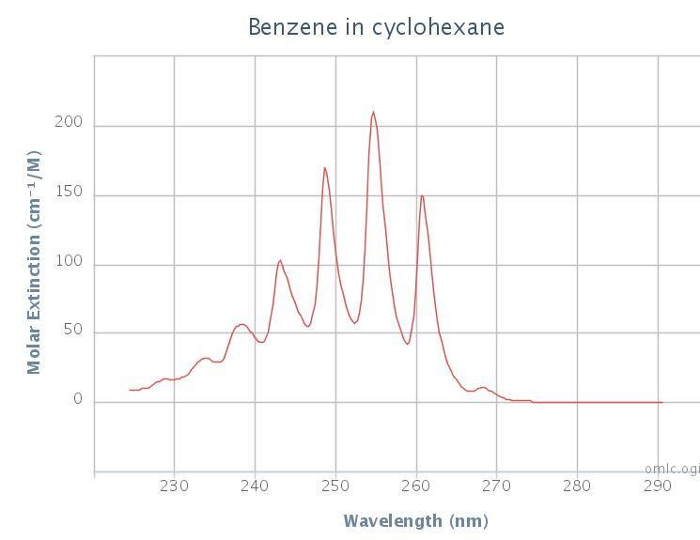

Peak λmax(nm)

a 268.5

b 261.0

c 254.8

d 248.8

e 243.0

f 238.3

g 234.0

h 228.8

g

h

f

e

d

c

b

a

http://omlc.ogi.edu/spectra/PhotochemCAD/html/042.html

**10.8 Guided Practice Session 4: Benzene Using the Spartan 08 Essentials Program (continued)**

1. Sketch the relative positions of the MO predicted by the Spartan program for the three highest energy, occupied MO and the three lowest, unoccupied MO and write their energies (in a.u. units) by their positions in the box below. (Some may be `degenerate levels’=> two MO have the same energies. Show them both.) Make sure to fill the lower levels with two electrons each using Label the lower filled levels with letters or numbers like A,B,C or 1,2,3 and the upper, unfilled levels with letters like A*,B*, C* or 1*,2*3*

**Spartan 08 predictions of Benzene MO Predicted and Observed Electronic Bands for Benzene**

**For Five Longest Wavelength Absorptions in UV**

Transition (e.g. A🡪X) Δa.u. λpred(nm) λobs(nm)

**___A🡪A*____ _0.4858_ _93.96_** 268.5

**___A🡪B*____ _0.5901_ _77.35_** 261.0

**__ B🡪A*____ _0.6370_ _71.66_** 254.8

**___C🡪A*____ _0.6528_ _69.93_** 248.8

**___A🡪C*____ _0.6578_ __69.39_** 238.3

Note: $\frac{45.65}{a.u.}=$ λ(nm) where:

Δa.u. = [a.u.(upper unoccupied MO )-a.u.(lower occupied MO)]

**____ 0.32025 a.u. C\***

**____ 0.25250 B\***

**____ ____ 0.14819 A\***

**--------------- 0**

**_ _ -0.33760 A**

** _ -0.48951 B**

**___ -0.50466 C**

1. Assign and compute the five longest wavelength (lowest transition energy) UV band positions (λmax in nm) predicted by the Spartan program and fill in the table above.
2. Plot λpred vs λobs from the above with λpred as the `y’ axis value and attach it to this worksheet. Does the plot suggest that the Spartan calculation at least correlates linearly with observation or does it appear the correlation energy problem has reared its’ ugly head .

not linear…correlation problems

1. Fill in the table entries below.

**Predicted vs Observed Physical Parameters for Benzene**

|  |  |  |
| --- | --- | --- |
| Parameter | Spartan Prediction | Observed |
| r(C-C), nm | ***0.1395*** | 0.1397 a |
| r(C-H), nm | ***0.1087*** | 0.1076a |
| θ(C-C-C)o | ***120*** | 120a |
| C-H in plane stretch modes (cm-1) | ***3232*** | 3091,3072b |
| C-H in-plane ring breathing modes (cm-1) | ***1655*** | 1520,1479b |
| In-plane rocking mode (cm-1) | ***1126*** | 1030b |
| Out-of-plane bend mode (cm-1) | ***859*** | 674b |

a**V. Schomaker, L. Pauling J. Am. Chem. Soc***.*,  ***1*** (7), pp 1769–1780 (1939) bNIST Webdata

1. **Which is the most accurate statement based on your experience with the Spartan Program**
2. It’s generally accurate at predicting electronic states but less good at estimating physical parameters
3. It’s accurate for both electronic and physical parameters
4. It’s sometimes relevant for predicting electronic states and good at estimating physical parameters.
5. It’s poor at predicting anything for medium sized molecules like benzene but good for small molecules like H2O and H2.

**10.9 Final Practice Session 5: Predicting the Geometry and Dipole Moment of Vinyl Difluorophosphine**

1. Sketch the final structure you determined for PF2CH=CH2 below. Include values for r(C-H), r(P-C), r(P-F) and indicate values for all relevant angles.

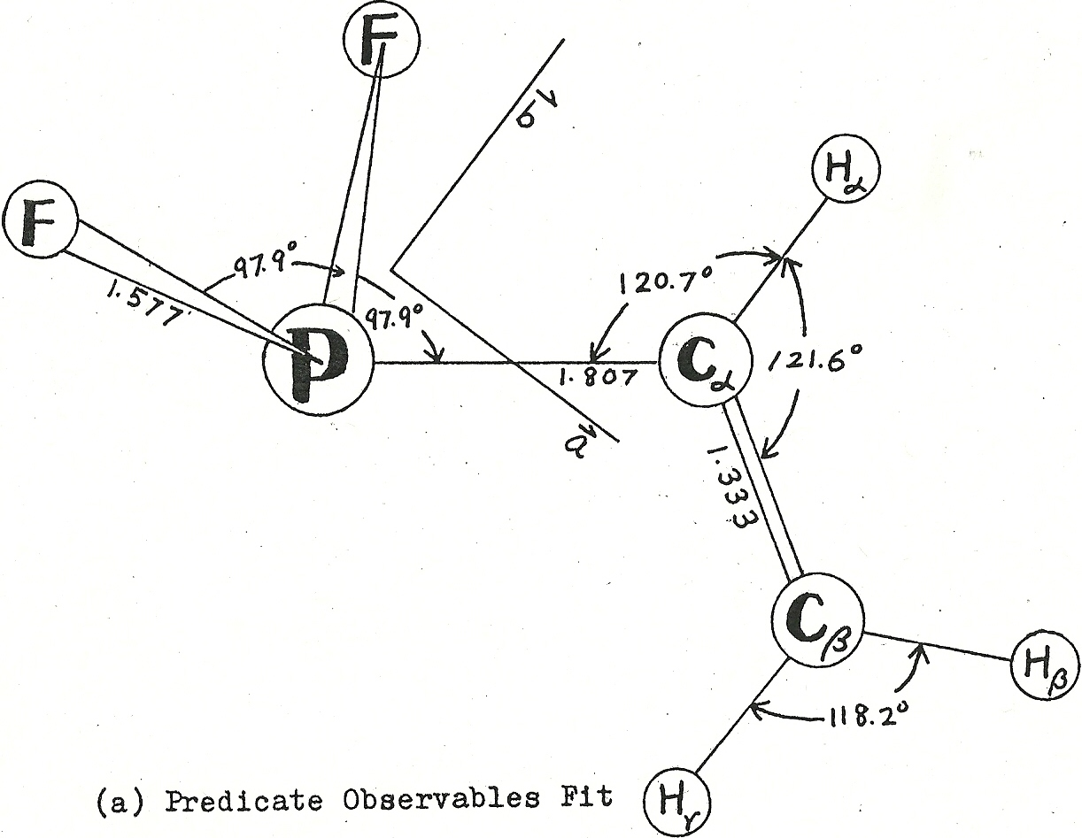Fong Thesis 1978

**Configuration is:**  Compact Extended Asymmetric

(circle one)

Predicted dipole moment = _____2.3_______________ debyes

1. Look up and report the accepted bond lengths of P-C , P=C, C-C and C=C Where does your determined bond lengths for P-C and C=C fall for PF2CH=CH2 ?

Accepted values

r(P-C) = ____0.182__________ nm r(C-C) = _____0.154_____________ nm

r(P=C) = ____0.168__________ nm r(C=C)= _____0.134_____________ nm

**Table 2: Spartan Essentials Predictions for PF2CH=CH2**

r(P-C) in PF2CH=CH2 = ___(0.181 )____ nm r(C=C) in PF2CH=CH2= __1.333_______ nm

1. Argue, based on your findings above, whether you can conclude that resonance shifting occurs in PF2-CH=CH2. No evidence of resonance shifting. The P-C bond is single bond and the C=C bond is not lengthened.