**Chem 6854: Physical Chemistry**

**Homework Assignment #6**

Show work/include Maple outputs

Due Wednesday 3 April

**35 pts total (1 point for your name)**

The properties of the H atom solution should be explored to verify the basic properties asserted for them, e.g. normalization and orthogonality. The latter property insures that once centrosymmetry of the potential is lifted as we add electrons, that individual

N,L, m states will be unique in energy. This is where the seeds of the Periodic Table lie within Schrodinger’s H atom solution.

**6.1. Problem 6.16 of text, page 221**. Use Maple and Table 6.5 page 208 to verify that:

1. <1s|2s>=0 **2 pts**
2. <2s|2p>=0 for 2p with L=1, m=0 **2 pts**

You are advised to write out the relevant integrals for the above long hand here before using Maple to check their values. In case it pops up, remember that limr🡪∞ for e-kr🡪 0.

Notes: σ in the table is r/ao, the convenient variable for electronic distance from the nucleus. Also Z=1, and ao= constant. Remember that the integration must be taken over the differential volume: r2 sinθ dr dθdφ.

1. Since neither 1s or 2s contain terms in θ or φ, the check for orthonormality devolves to evaluating the integral

2π π ∞

∫ dφ ∫ sin θ dθ∫ (2-r/a)* e-r/2a e-r/a (r)2 dr where C contains terms in ao, π and Z.

0 0 0

Where k = 1/a.

**> **



∴As r🡪 ∝, e-3r/2 🡪 0

1. The relevant integral is:

2π π ∞

∫ dφ ∫ cosθ sinθ d θ∫(2-kr)* e-kr/2 (kre-kr/2)(r)2 kdr

0 0 0

Where k = Z/ao. Note that Maple computes the central term:

**> **



**6.2. Using Maple or the table of integrals on the back flap and Table 6.5 page 208, verify that :**

a)<3s|3s> =1 **3 pts**

b)<2p|2p> =1 for 2p with L=1,m=+1 **3 pts**

You are advised to write out the relevant integrals for the above long hand here before using Maple to check their values. (See example 6.9 page 209-210). FYI- Maple supplies an unnecessarily complex answer to many integrals of the class used here, so the McQuarrie equations on the back flap are actually easier to deal with.

If you insist on using Maple, remember that limr🡪∞ e-kr🡪 0.

<3s|3s>=

Maple output:

**> **



All the exponents as r🡪∝ 🡪 0 leaving:

4/19683 *(-3/4)*a-6 *(-6561*a6) =1

<2p|2p>

Maple output

**> **



**> **

All the exponents as r🡪∝ 🡪 0 leaving:

-1/24a4 * -24a4 = 1

6.3 Problem 6.17 of text. (Hint: This is best done by hand rather than via Maple so that you can `experience’ using the H atom spherical coordinate quantum Hamiltonian in the basic eigenvalue problem form used to solve for the wave functions originally). To simplify the clerical task, note that the leading constant term for ψ100 =(π-1/2* (1/ao)3/2 cancels out on both sides of the equation so that the reduced wave function becomes just: e-r/ao, where ao is the Bohr radius. Also, note that in order for the solution to work, a solution for ao falls out as a side benefit.

The basic task is to substitute ψ100 into the eigen value equation 6.4 page 192, which is the quantum eigen value problem **H** ψ = Eψ for the H atom.

Since ψ100 = where σ = (1/a)r and a= Bohr radius, the absence of φ and θ terms in ψ100 means equation 6.4 reduces to derivatives involving just r.

Since both sides of this equation have a leading constant= $\frac{1}{\sqrt{π}}*{\left(\frac{1}{a}\right)}^{3/2}$ we can cancel it out on both sides of equation 6.4 to leave the basic eigenvalue form below, as discussed above. Thus, the differential equation reduces to that below, which is worked out as indicated to find E.

Equation 6.4, page 192 for the case of ψ100 ~ e-r/a

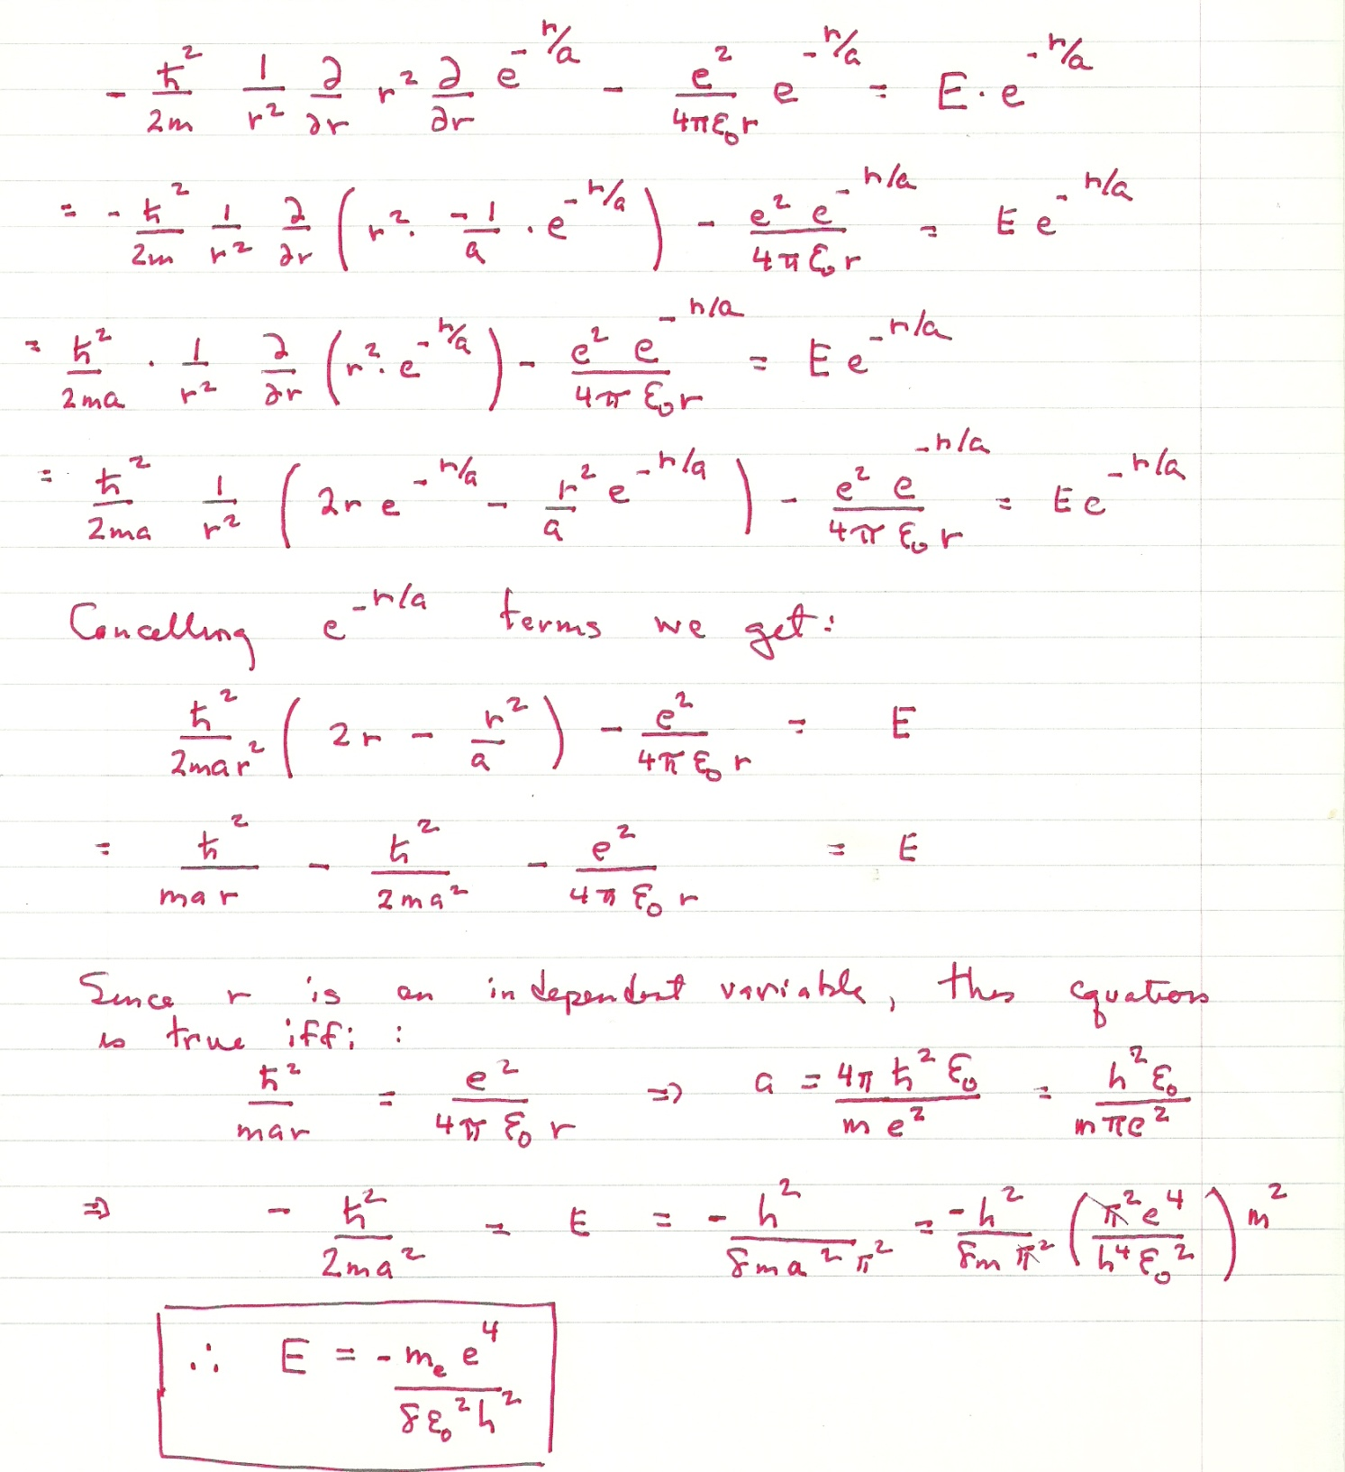

Note:

You could also do this problem by computing: < $\frac{1}{\sqrt{π}}*{\left(\frac{1}{a}\right)}^{\frac{3}{2}}e^{-\frac{r}{a}}\left|\frac{ħ^{2}}{2mr^{2}}\frac{∂r^{2} }{∂r}\frac{∂}{∂r}\right|\frac{1}{\sqrt{π}}*{\left(\frac{1}{a}\right)}^{\frac{3}{2}}e^{-\frac{r}{a}}>$ =E without resorting to the use of the `trick’ of setting $\frac{ħ^{2}}{2mar}=\frac{e^{2}}{4r}$ but it’s more work.

6.4 Problem 6.20 of text page 221 .Can be done via Maple where the `approximate’ function allows computation of the numeric answer. Note that if you do the integral correctly with unspecified ao , the Bohr radius, ao ,disappears from the final answer.

Integral to evaluate: $\frac{4}{a^{3}}*\frac{1}{π}* r^{2}*e^{-2ar}dr$ from 0🡪2a where the 4π represents the θ and φ components of the space integral in spherical coordinates.

The general result is 4*( ¼ a3 -13a3/4 *e-4)/a3 = 1-13*e-4 =0.76189 ~ 0.762 √

6.5 Problem 6.28 of text page 222. Either McQuarrie’s expressions or Maple can be used here. If the latter is used, remember that limit x🡪∞ for any function P(r) e-ar🡪 0 if P(r) is a polynomial in r.

If we work the integrals out by hand: (a=ao)

For the 2s orbital, n=2,l=0

**<2s|r|2s> = $\frac{1}{32π} *4π*{\left(\frac{1}{a}\right)}^{3}\int_{0}^{∞}{{\left(2-\frac{r}{a}\right)}^{2}*r*e^{-r/a}*r^{2}dr}$**

= $\frac{1}{8a^{3}}\int_{0}^{∞}{\left(4-\frac{4r}{a}+\frac{r^{2}}{a^{2}}\right)e^{-\frac{r}{a}}}r^{3}dr$

= $\frac{4}{8a^{3}}\int_{0}^{∞}{r^{3}*e^{-r/a}dr-\frac{4}{8a^{4}}\int_{0}^{∞}{e^{-r/a}r^{4}dr +1/8a^{5}\int_{0}^{∞}{e^{-r/a}r^{5}dr}}}$

I II III

Using McQuarrie’s recipe: $\int_{0}^{∞}{r^{n}e^{-ar}dr=\frac{n!}{a^{n+1}}}$

I= $\frac{1}{2a^{3}}*\frac{3!}{{\left(\frac{1}{a}\right)}^{4}}$ = 3a

II= $\frac{-1}{2a^{4}}*\frac{4!}{{\left(\frac{1}{a}\right)}^{5}}$ =-12a

III= $\frac{1}{8a^{5}}*\frac{5!}{{\left(\frac{1}{a}\right)}^{6}}$ =15a

**I+II+III= 6a=<2s|r|2s>**

Alternatively, using Maple if we set all the e-r/a terms in Maple’s solution of the original integral🡪0

Only 1/8a3 * 48a4 = 6a are left √

For the 2p orbit n=2,l=1 (m=0)

<2p|r|2p> = $\frac{1}{32π}*{\left(\frac{1}{a}\right)}^{3}*{\int_{0}^{2π}{e^{-iϑ}*e^{iϑ}dϑ*\int_{0}^{π}{(cos{θ)}}}}^{2 }\sin{θ}dθ\int_{0}^{∞}{r*e^{-\frac{r}{a}}}{\left(\frac{r}{a}\right)}^{2}r^{2}dr$

I II III

I= 2π

II=2/3 (according to Maple)

III= = = 120a4

<2p|r|2p> =

**=5 a = <2p|r|2p>**

That the 2p is on average slightly closer to the nucleus than 2s reflects the angular restriction imposed by the L=1 condition, which means the same total electron count (unity) occupies a smaller net volume. (Note that the angular contribution is 4π for 2s, and only 4/3 π for 2p

6.10 Problems E-1 🡪 E-5 pp 238-239 of text.

E-1: old school expansion 2(3*1-2*0) – 1*(-1*1-2*2) + 1*(-1*0-2*3) = 2(3) -1*(-5) +1(-6) = 6+5-6=5

Note that the addition of columns (according to rule 6 page 235) leaves the determinant unchanged as we demonstrate be computing:

3 1 1

Det 2 3 2 = 3*(3*1-2*0) -1*(2*1-2*2) + 1*(2*1-2*3) = 3*(3) -1*(2-6) +1*(-6) = 9+4 -6 =5

2 0 1

Rule 6 also says adding two rows results in the same determinant as we demonstrated by computing:

1 4 3

Det -1 3 2 = 1*(3*1-0*2) -4*(-1*1-2*2) + 3*(-1*0-2*3) = 1*(3) -4*(-5) +3(-6) = 3+20-18= 5

2 0 1

E-2 according to rule 3, exchanging columns or rows reverses the determinant sign

Det 1 1 2 =1*(3*2-0*-1) - 1*(2*2)+1*1) + 2*(2*0-1*3) = 1*(6) -5 -6 = -5

2 3 -1

1 0 2

Det -1 3 2 =-1*(1*1-0*1) – 3*(2*1-1*2) + 2*(2*0-1*2) = -1-3*0 -4 = -5

2 1 1

2 0 1

E-3 By inspection, the first determinant columns 1 and 3 are the same so according to rule2, the determinant = 0

Likewise, the second determinant’s column 1 is merely the addition of the first determinants column 1 with column 3

And according to rule 6 this leaves the determinant value unchanged, e.g. 0

E-4

**> **













E5











Both the above show only a finite solution with x=0 for det A =0