**Chem 6854: Physical Chemistry**

**Homework Assignment #5**

Show all work !

Due ~~Wednesday 13 March~~  25 March post-break

38 points total

Chapter 5 serves two purposes. First, it presents the quantum solutions to the harmonic oscillator and rigid rotor. Second, it gets us prepared for some of the mathematics to come that is used to describe the quantum solution to the H atom.

The spherical coordinate system is often used to treat spherically symmetric systems like the H atom, whose quantum eigenvalue problem is taken up in chapter 6. Getting you comfortable with this coordinate system in digestible bits and pieces underlies the problems below.

5.1 In your own words briefly explain why spherical coordinates seems a better way to describe an electron orbiting

the H nucleus than the traditional (x,y,z) Cartesian system. 3 pts

*Essentially, we need a system that focuses on the fact that the potential term is of the form V(r) =1/r.*

*In Cartesian coordinates, r=(x2 +y2+z2)1/2 which is unwieldy to compute with since it has the pesky presence of the square root function which is not linear and generally difficult to simplify. Moreover, with x,y,z coordinates, separability of wave functrions is disallowed.*

5.2a In spherical coordinates the differential volume element has the dimensions dV=(r sin θ dφ)*(rdθ)*(dr)

Using your knowledge of geometry and trigonometric relationships, re-explain how these terms come about. (See Figure D.2 page 148 to help think through the geometry.) 3 pts

*The volume element has a thickness of dr as shown in the reproduction of Figure D.2 of your text. The area of the grayed section, dA = dw*dL. The total volume element dV is thus:*

*dV=dA*dr= dw*dL*dr*

*As seen in Figure D.2, dL=rdθ, the arc traced out by dθ at distance r. Thus:*

*dV = dw*(rdθ dr)*

*The hardest part of the volume element to understand is the portion traced out by dφ, the width d****w.*** *The length of the arm swept along this final side is formed by the side opposite θ in figure D.2, and is the projection of r onto the x-y plane at height z. This arm is then moved in the plane dφ, tracing out the arc length indicated by d****w*** *. It is this arm length that is swept by dφ along the volume element so has a length d****w****= r sin θ dφ. The entire volume is then:*

***dw***

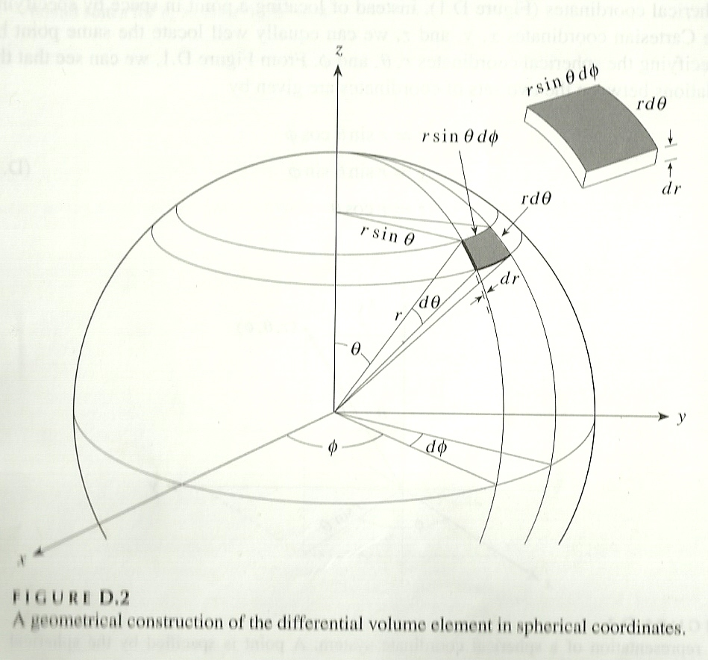

***dL***

***∴dV = dw*(r dθ dr) =*** *r sin θ dφ \*****(r dθ dr) =r2sinθ dθ dφ dr***

5.2b The spherical coordinate system’s volume element dV =(r sin θ dφ)*(rdθ)*(dr) is often written as dA*dr,

where dA is the area of the outer skin of the volume element. Use this to show how A of a sphere =

4πr2. 2 pts

*If we integrate dA at fixed r, over θ=0🡪π and φ= 0🡪2π, we must compute the double integral:*

π 2π π 2π

*A= ∫dA = ∫ ∫ (r2 sin θ dφ)*(rdθ) = r2 ∫ sin θ dθ∫dφ*

*0 0 0 0*

*π*

*A= r2 (-cos θ)| * 2π = 2πr2(-[-1-1])=* ***4πr2******√***

*0*

5.2c When integrating to find the volume of a sphere,V, on page 149, dφ is integrated from 0🡪2π,

but sin θdθ is only integrated from 0🡪π. Provide a brief, qualitative answer for why. 3 pts

The main idea is to sweep out the entire area of the sphere. We can think of doing this by imagining the area as being formed by a series of ever decreasing concentric circles that start at maximum area on the x-y plane. Half of the sphere imagined so is sketched below. The other half (not shown) is below the x-y plane.

To sweep each circle out, you need to cycle φ completely around the circle, e.g it must sweep out 2π

To include all the concentric circle plates in the sphere we must only cycle from 0🡪 π In order to cover both the upper and lower half of the sphere plates, as shown

In the figure to the right.

X

φ

Y

θ

5.3. Using Maple and the formulas at the back flap of McQuarrie, evaluate ∫ e-r r3 dr ∫sin3θ dθ ∫cos2 φdφ

For the limits r= 0🡪∞, θ=0🡪π, φ=0🡪2π. *Note that rearranged, the integration has the form:*

*∫f(r,θ,φ) dV where dV =r2sin θ dφ dθ dr and f(r,θ,φ) = re-r sin2 θ cos2 φ . 2 pts*

*It is probably best to do the integrations separately and then multiply the results together to avoid simple clerical errors in inputting variables and functions into the more complicated multiple integral. (At least, that’s what I did…)*

*2π π ∞*

*∫cos2 φdφ ∫sin3θ dθ ∫ e-r r3 dr*

*0 0 0*

*=π =4/3 =6*

*φ piece θ piece r piece*

*Multiplying all the terms together we get: π*4/3 * 6 =* ***8π***

We will be using the results of the quantum harmonic oscillator solution without attempting to directly solve the problem, since the resulting differential equation no longer contains constant coefficients. The problems below let you gain some experience manipulating the results to obtain physically significant quantities.

5.4a. The `O-H’ stretch in the infrared region occurs near 3500 cm-1.  Assuming this is the result of a Δn =1

transition for the diatomic molecule O-H, determine the force constant, k, for the diatomic O-H.

(see example 5.3 p. 168) 3 pts

*Using the recipe on page 169, equation 5.34, we rearrange it to solve for k*

*υ = (1/2πc) (k/μ)1/2*

*2πcυ = (k/μ)1/2*

*[2πcυ]2μ = k*

*…where all the units above are assumed to be in MKS*

*To stay within MKS units, we now convert the observed υobs(cm-1 ) to m-1*

*(3500/cm )*100 cm/m = 350,000 m-1*

*μ = 15.997 amu *1.01 amu* =0.950 amu = 0.950 amu * 1.661*10-27 kg/amu=1.578*10-27 kg

*(15.997 amu+ 1.01 amu)*

*c= 3*108 m/s*

*Plugging in we get:*

*[2πcυ]2μ = k*

*k=[2π*3*108*350,000]2*1.578*10-27 kg=686.8 (kg/ s-2) =* ***686.8 N/m***

*Compared to the H-Cl force constant of 478 N m-1 (page 168) the bond strength of O-H is about 686.8/478 =1.44 X stronger*

*consistent with chemical experience. (It’s easier to rupture an HCl bond than an H-O bond in water,)*

5.4.b If we replace H with D in the above, and assume k is unchanged, at what frequency in cm-1 will O-D

show a Δn=1 absorption 3 pts

*This problem only requires recalculating μ, and then substitution of it and the just-calculated k into the original equation fot υ to find υ(O-D).*

*μ= 16 amu * 2.02 amu = 1.793 amu = 1.793 amu *1.661*10-27 kg/amu = 2.9787*10‑27 kg*

*16 amu+2.02 amu*

*υ = (1/2πc) (k/μ)1/2*

*=(1/2*π)(1/3*108) * (686.8/2.978*10‑27) ½ = 2.548*105 m-1 =* ***2548 cm-1***

5.4 c. ? Does the frequency shift make sense physically ? Explain your answer. 2 pts

*Yes. The original O-H stretch at 3500 cm-1 is considerably faster (higher energy) than the O-D stretch, which is sensible since the latter mass is twice that of H and so should move slower under the same force constant.*

5.5 Problem 5.14 of text, p. 182 3 pts

*f(Hz) = $1/2π$ (k/μ)1/2 υ(m-1) = f(Hz)/c*

*k=240 N m‑1 μ(amu) = 79*79/(79 +79) = 39.5 amu =39.5*1.661*10-27 kg/amu=6.56*10-26 kg*

*f(Hz) = (240/6.56*10-26)1/2=* ***9.625*1012 Hz*** or *υ(m-1) = f(Hz)/c = 9.625*1012/3*108 =3.209*104m-1* ***= 3.209*102 cm-1***

*εo= Zero point energy = En=0 = hf(0 + ½ ) =6.626*10-34*9.625*1012( ½ ) =****3.189*10‑21 J***

As with the harmonic oscillator, the quantum rigid rotor solution (see pp 175-178) is given without proof since again, the mathematics is too involved. The problems below let you gain some experience with quantities and units associated with rotational energies, moments of inertia, and bond lengths.

5.6a Problem 5.34 of text, page 186 3 pts

*Using the results from page 177-178, for diatomic molecules:*

*rotational absorption frequency υ = 2B(J+1), B= h/8π2cI where and I= μr2, r= bond length of diatomic.*

*The observed line spacing referred to in the problem means successive absorptions separated by ΔJ=1*

* *ΔE = υ(J+1) -υ(J) = 2B[(J+1)+1] – 2B (J+1)= 2BJ + 2B +2B – 2BJ-2B = 2B*

*Since ΔE=16.72 cm_1= 2B=>*

*B=16.72/2=8.36 cm-1 = 836 m-1= h/8π2 c I = h/8π2 cμ2*

***Solving for I:***

*From above: 836 m-1= h/8π2 c I*

*Rearranging to isolate I:*

*836*8*π2*c/h= 1/I = 836*8*π2*3*108/6.626*10-34 = 2.988*1046=1/I*

*I= 1/2.988*1046 =* ***3.346*10-47 kg m2 √***

***Solving for r:***

*Since the molecule is H79Br=> μ(amu)= 79*1.01/(79+1.01)=0.997 amu*

*=0.997 amu*1.661*10‑27kg/amu*

*= 1.654*10-27 kg*

*I = 3.346*10-47= μr2 = 1.654*10-27 kg r2*

*Isolating for r2*

*3.346*10-47 =r2 =2.023*10‑20 =>* ***r=1.42*10-10 m (142 pm) √***

*1.654*10-27*

5.6b If we change to D79Br, what is the expected line separation of the rotational transitions ? (Note: The

bond lengths don’t change from normal H-Br to D-Br). Does the change make sense physically ? 2 pts

*The change in hydrogen isotope changes I =μr2 since μ contains the mass of the atoms in the rigid rotor.*

*Re-computing μ for D79Br:*

*μ= 2.02*79 =1.9696 amu = 1.9696 amu *1.661*10-27 kg/amu=3.2716*10-27 kg*

*(2.02+79)*

*I= 3.2716*10-27*r2 = 3.2716*10-27*(1.42*10-10)2 =6.618*10‑47*

*B(m-1) = h/8π2 c I = h/[8π2 c*6.618*10-47] = 6.626*10-34/(8*π2*3*108*6.618*10-47)*

*=6.626*10‑34/1.5676*10‑36=* ***422.7 m‑1 or 4.227 cm-1***

*Spacing =* ***2B = 845 m-1 = 8.45 cm-1****. This is about half that for H79Br, which means that the D79Br is spinning slower-which is sensible since the mass of D is twice that of H and the reduced mass of D79Br is likewise about twice .*

5.7 Problem 5.35 of text, page 186 3 pts

*υ= 1.153*105 MHz= 1.153*1011 Hz for 12C16O*

*υ = 2B(J+1) , where J= lower energy level and J+1 is the higher energy level and B=h/8π2I*

*Here, J=0 so:*

*υ = 2B(0+1)=2B = h/4π2I*

*1.153*1011 =6.626*10-34/4π2I*

*Solving for I:*

*I = 6.626*10-34/(4π2*1.153*1011)= 6.626*10-34/4.5519*1012=1.45566*10-46 kg m2 = μr2*

*To find r, we need to compute μ for 12C16O:*

*μ(amu) = 12.0*16.0 = 6.857 amu =6.857 amu*1.661*10-27kg/amu =1.1389*10-26 kg*

*(12.0+16.0)*

*Solving for r2*

*From our solution for I =1.45566*10-46 kg m2 = μr2 => r= (1.45566*10-46 /μ)1/2*

*Substituting μ=1.1389*10-26 kg=> r= (1.45566*10-46 /1.1389*10-26)1/2= (1.2781*10-20)1/2=1.13*10-10m* ***=113 pm=r √***

McQuarrie chose to introduce the angular momentum operator L2 =**Lop2**  as part of his exposition on rigid ***ħ*** rotors (see eq. 5.52, page 175). This is a big piece of the H-atom problem to come in chapter 6 and it is important to get used to operating on functions with it correctly.

5.8. Compute **Lop2**(sin θ)2) 3 pts

***2 ħ2 (cos2θ - sin2θ) (details attached ) 3 pts***

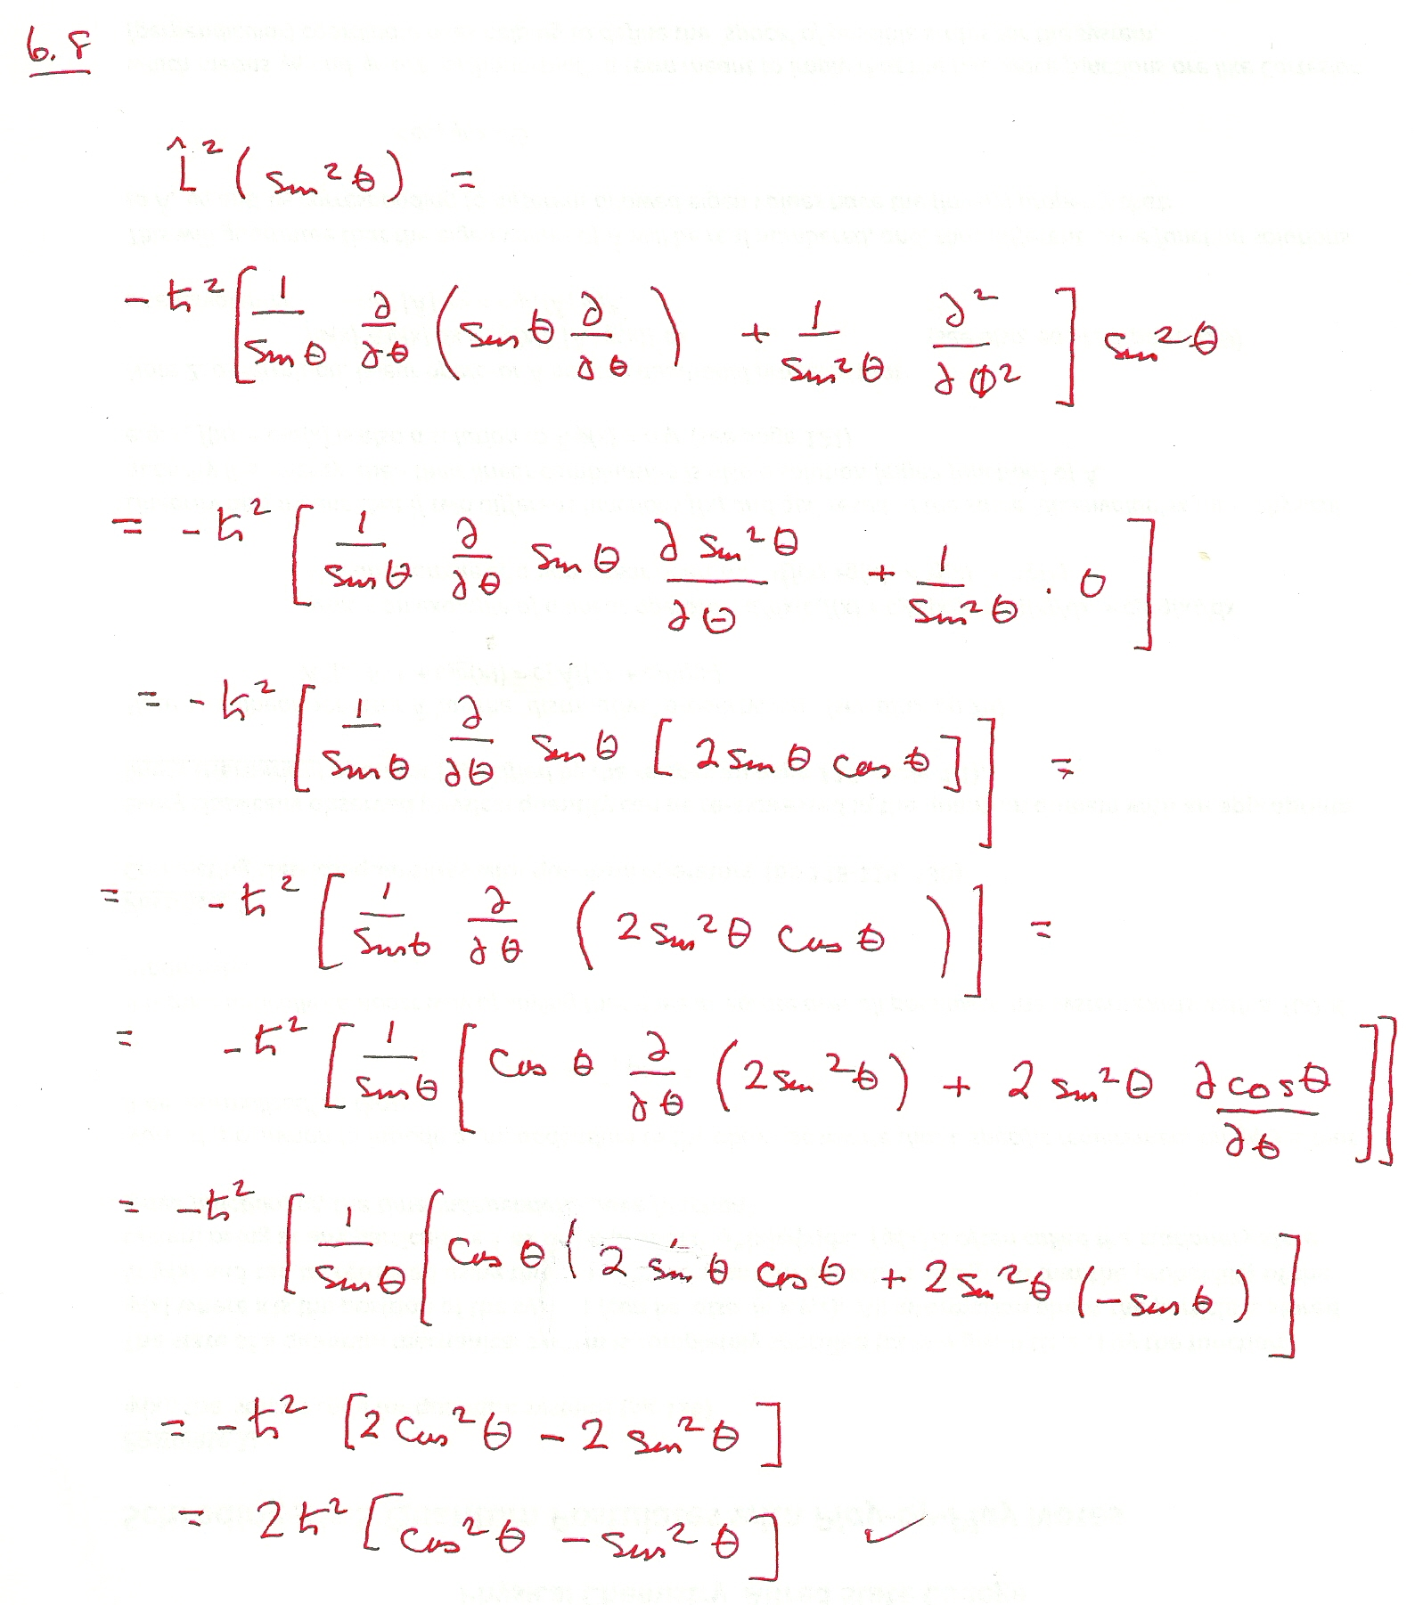

4

(4

***- -***

-

2

***-***

5.9 Compute **Lop2**(cos θ*sin φ)

***ħ2(2 sin φ cos θ + sin φ cos θ/ sin2 θ (Details attached)***

