**Chem 6854: Physical Chemistry**

**Homework Assignment #4**

40 points total

Show all work !

Due Friday 21 February

Problems 4.1 and 4.2 are designed to illustrate how the simple 1D particle-in-a-box model mirrors behavior in systems like the 1 electron H spectrum, and, how it presages the sharp differences in electronic vs nuclear energies.

4.1 Given me =9.1*10-31 kg, h= 6.626*10-34 J*s, c=2.998*108 m/s and a box length L=a= 2*10-10 m (typical molecular bond

length), use the particle-in-the box energy to :

a)compute the wavelengths(in nm) of emission for the six transitions

n=2🡪1 n=3🡪1 n = 4🡪1

n=3🡪2 n=4🡪2 n =5🡪2

*The 1 D energy for the particle in a box is captured in equation 3.21 page 81.*

*E= h2n2/8mL2 for n=1,2,3…*

*Plugging in the specific values for the box length, electron mass and h :*

*E= (6.626*10-34)2n2/(8*9.1*10-31*(2*10-10)2)=1.508*10-18n2 in J*

*An emission involves the electron falling from a higher to lower n. The energy released is:*

*ΔE(emission) = Einitial –Efinal = 1.508*10-18(ninitial2 – nfinal2­)*

*To determine the equivalent emission wavelength, λ we equation ΔE(emission)=hf*

*1.508*10-18(ninitial2 – nfinal2­) = hf = hc/λ =>*

*λ= hc/[1.508*10-18(ninitial2 – nfinal2­)] in meters = 6.626*10-34*(2.998*108/1.508*10-18)*

*(ninitial2 – nfinal2­)*

*λ= 1.317*10-7 m = 131.7 nm*

*(ninitial2 – nfinal2­)] (ninitial2 – nfinal2­)]*

*We can now tabulate calculations for the ‘Lyman’ and `Balmer’ series of an electron in a box the length of a bond.*

*Lyman for e- in bond Balmer for e- in bond*

*ninitial nfinal λ(nm) n­initial nfinal λ(nm)*

*4 1 8.78 5 2 6.24*

*3 1 16.46 4 2 10.98*

2 1 43.90 3 2 26.34

b) plot the `spectral’ lines above on a graph of lines vs nm.

Verbalize the trend in the line spectrum as ninitial increases.

*As ninitial increases, the wavelengths bunch up and approach a limit.*

Is it consistent with the observations for an H atom in Figure 1.5, page 11 ? Why ?

*Yes. The H atom spectrum shows a series limit just like the above calculation*

4.2a. Repeat the exercise above but change the mass m to that of a proton=1.67*10-27 kg and assume a box length L=2*10-15m (about the diameter of the nucleus).

We more directly derive λ for emission as below, as an alternative to the approach above

*ΔE= [h2/8mL2](ninitial2-nfinal2)=hc/λ=> λ= (hc*8mL2/h2) = 8mL2c/h*

*ninitial2-nfinal2) ninitial2-nfinal2)*

*plugging in the values for m,c,L and h and correcting to nm we get:*

* *= 2.42*10-5nm*

*(ninitial2-nfinal2)*

*Lyman for p+ in nucleus Balmer for p+ in nucleus*

*ninitial nfinal λ(nm) n­initial nfinal λ(nm)*

*4 1 1.61*10-6 5 2 1.15*10-6*

*3 1 3.02*10-6 4 2 2.02*10-6*

2 1 8.07*10_6 3 2 4.84*10-6

4.2b. Does the difference in wavelengths of emission between the proton and electron domains make

sense? Why or why not.

*Make sense. The far lower wavelengths for the proton in the nucleus reflect the massive energies connected with cramming sub atomic particles in to confined, nuclear dimension spaces. Nuclear energies are staggeringly bigger than electronic, as our calculations confirm.*

Problem 4.3 is designed to illustrate how the quantum world evolves to become the classical world as the quantum number n approaches large values…an expression of the `correspondence’ principle.

4.3a. Use Maple to help you plot the particle-in-a-box probability density:

(2/L) sin2(nπx/L) vs x

where L=1 over the range from x=0🡪1 for three cases:

n=2,20 and 200. Provide separate plots of each case

n=2 n=20 n=200

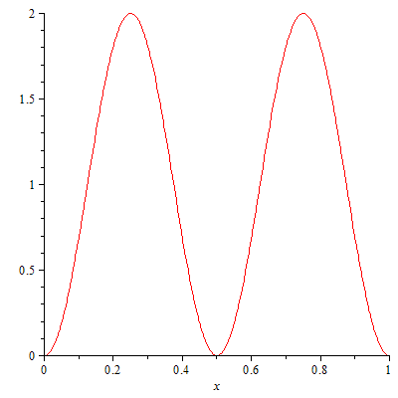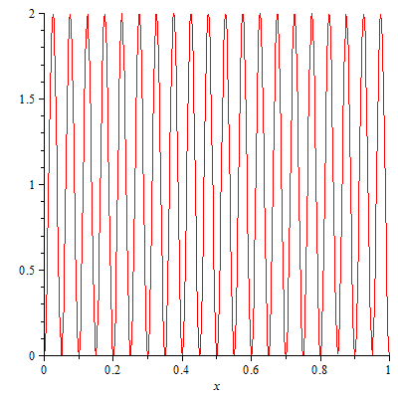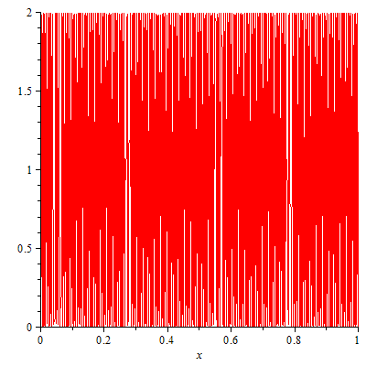

4.3b. The trend in your 3 plots is an example of the `correspondence’ principle. (see page 86).

Explain how this is so.

*As the quantum number rises, the spacing between peaks and troughs begins to vanish and the apparent probability of the particle being in the space any where in the space approaches being constant and non=zero, as a classical particle would behave.*

The next three problems provide mathematical exercise and (hopefully) insight into some common properties of integrals often encountered in quantum calculations. The hoped-for `lessons’ are in parentheses below)

* 1. Problem 3.14 page 98(odd-even trig functions integrate to zero over symmetric ranges)

*Simply substitute ½ sin(2nπx/a) for sin (nπx/a) cos(nπx/a) in the integral, which becomes:*

*a*

*∫½ sin(2nπx/a)dx = -½ (a/2nπ) cos(2nπx/a)|a = -½ (a/2nπ) cos (2nπ) + ½ a/2nπ* cos(0)*

*0 0 = -½ (a/2nπ) + ½ a/2nπ = 0 √*

*The intent of this particular exercise is to illustrate that integrals of odd*even trig functions (even=> f(x)=f(-x) as it is for Cos(x), odd => f(-x)= -f(x) as for sin(x)) are null.*

* 1. Problem 3.15 page 98 (∫ψ dx = 0…so ψ can’t be by itself a measure of probability density)

*First apply the identity (Euler’s equation) to e±2πinx/a = c1cos(2πnx/a) + c2 sin (2πnx/a)*

*Next, integrate over the limits 0🡪 a*

*a a*

*c1 ∫cos(2πnx/a) dx + c2 ∫sin (2πnx/a) dx*

1. *0*

*= c1 (a/2πn) [sin (2πnx/a)]|a  -c2 (a/2πn) cos(2πnx/a)|a*

*0 0*

*= c1(a/2πn) [sin(2πn) – sin(0)] –c2(a/2πn)[cos(2πn) – cos(0)]*

*= c1(a/2πn)[0-0] - c2(a/2πn)[1-1] = 0 except at n=0 where the a/(2π*0) is undefined*

*The intent of this problem is to illustrate that just the wave function (which is ~ e±2πinx/a) cannot serve by itself as a measure of probability . It helps underscore why the product ψψ* must be used as a measure of probability, since it does not disappear over integration from 0🡪a*

* 1. Problem 3.17 page 98(eigen functions of different quantum states cannot overlap to form a new state) Hint: Use Integral tables or Maple for 4.6 to simplify your proof.

Our task is to compute ∫sin(nπx/a)*sin(mπx/a) dx in general and then consider two different cases:

Case 1: n=m

a a

∫sin(nπx/a)*sin(mπx/a) dx = ∫sin2 (nπx/a) dx = a[(-cos(nπ)sin(nπ) +nπ] (Maple result)

0 0 2nπ

Since n=1,2,3… sin(nπ) = 0 for all n and the first term disappears leaving just a nπ/2 nπ =a/2

**Case 2: n ≠ m**

a

∫sin(nπx/a)*sin(mπx/a) dx = a(ncos(nπ)sin(nπ) – msin(nπ)cos(nπ)) (Maple result)

0 n(m2-n2)

Since n=1,2,3… sin(nπ) = 0, and the entire expression goes to 0.

The intent of this problem is to show a universal property of eigen solutions to quantum mechanical systems: the individual solutions (n=1,2…) do not overlap and are `orthogonal’. Another way to see the result above, is that the individual wave functions for n=1,2…provide a sort of Cartesian axis system defining the space of solutions available to the system. Most interesting is that:

∫(∑cnψ(n,x))* (∑cnψ(n,x) dx = ∑cn2 = 1 where no cross terms appear since <ψn|ψm> = 0 if n≠m. Each cn2 can be thought of as the probability of the system appearing at state n. Interpreting the physical meaning of this leads to interesting dilemmas of interpretation, the most famous of which is the Schrodinger cat problem.

The last problem extends the particle-in-a box solution to a circular rather than linear particle-in-a box

4.7 Problem 3.28 page 100

*a) to check whether ψ(θ)=Ae-inθ satisfies the differential equation 1*

1. *–ħ2/2I d2ψ/dθ2 = Eψ if n=± (2IE)1/2/ ħ*

*we substitute ψ(θ)=Ae-inθ into 1 as below:*

*–ħ2/2I d2 Ae-inθ /dθ2 = E Ae-inθ*

*–ħ2/2I (-in)A d e-inθ /dθ = E Ae-inθ*

*–ħ2/2I (-in)2Ae-inθ = E Ae-inθ*

*ħ2 (n)2/2I = E*

*n2= 2IE/ ħ2*

***∴ n = ±√2IE/ ħ or E=*** *ħ2n2/2I for arbitrary n*

***b) Aeinθ = C1cos nθ + C2 sin nθ . For the particle ‘s wave to not destructively interfere with itself around the ring,***

***ψ(nθ) = ψ(n(θ+2π))***

***Using the identities shown here the above condition means: C1cos (nθ) + C2sin (nθ)***

***= C1 cos (n(θ+2π)) + C2(n(θ+2π))= C1 cos (nθ+2πn) + C2(nθ+2πn)***

***=C1cos(nθ)cos (2πn) +C1sin(nθ)sin(2πn) + C2cos (nθ) sin(2πn) + C2 sin(nθ)cos (2πn)***

***The equality can exist only if n is an integer since if that is so:***

***=C1cos(nθ)cos (2πn) +C1sin(nθ)sin(2πn) + C2cos (nθ) sin(2πn) + C2 sin(nθ)cos (2πn)***

***=C1cos(nθ)*1 +C1sin(nθ)*0 + C2cos (nθ) *0 + C2 sin(nθ)*1 = C1cos (nθ) + C2sin (nθ) √***

***c) We have already established in 4.7a, that the general solution for E=*** *ħ2n2/2I. Now we can further use the result of 4.7b to reduce the values of n to ±1,2…*

***2π***

***d) A2 ∫e+inθe-inθ dθ =1 = A2*2π=> A= 1/√2π***

***Note: Since benzene is approximately circular system of free flowing pi electrons (~no V(x))***

***this circular solution could be used to model a 6 electron system where the HOMO n=3 and I=ma2 where the radius of the benzene molecule is= a and m=electron mass. Predicted HOMO🡪LUMO (n=4) absorption should happen atΔE(J)= (16-9)*** *ħ2/2I=7 ħ2/2I. Setting a= 2.0*10-10 meters, m=9.1*10-31kg, ħ=1.054*10‑34 =1.07*10-18J=>185 nm Obs band for benzene near 180 nm (Takahashi, J. Chem. Phys. 57(6) 1972 pp 2526-2531)… a pretty good match from simple theoretical considerations.*