**Exercise 1: Complex Number Manipulations**

Physical Chemistry 6854

Alfred State

**Key Complex Number (Z) Facts (see also: Math Chapter A: pp 31-37)**

**Z** defined: **Z**= a +bi where a and b are real numbers

**Z\*** defined: **Z\*** = a-bi

Euler equivalent: **Z**= reiθ ( proof via page 36 problem A-10)

Helpful factoids: tan θ = b/a and arc tan (b/a) = θ

r = (a2 +b2)1/2

θo/180 =x*π radians ex. 90o = π/2 radians

DeMoivre’s equation (cos θ + i sin θ)n = cos nθ + i sin nθ (proof via page 35 problem A-7)

Magnitude of **Z = |Z| = √(Z* Z) = √(a2 +b2)**

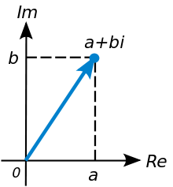

*Graphical representations of Complex Number plane*

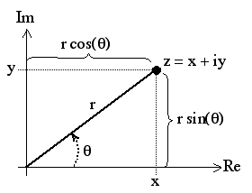

b

a+ bi

a

**|Z|**

* 1. Find the real and imaginary parts of the expressions below (see also problem A-1 p. 35)

(remember: cos 0=1, cos π/2 = 0; sin 0 = 0, sin π/2 = 1)

a) e3πi

b) e-1 -iπ

c) (3 + i)e-iπ

1. (1 +i)4

1.2 If **Z** = 2x + 3iy find

1. Re (Z*)

1. Re (Z2)
2. ) Im (Z2)

1.3 Convert the complex plane expressions below to their equivalent Euler form (reiθ)

1. 8i
2. 4 – 3i
3. -1 – i