**Complete H Atom Wave Functions for n= 1,2,3**

**eiφ Form (Table 6.5)**

**sin φ /cos φ form (Table 6.6)**

From McQuarrie Text pp 208 and 218

**eiφ form**

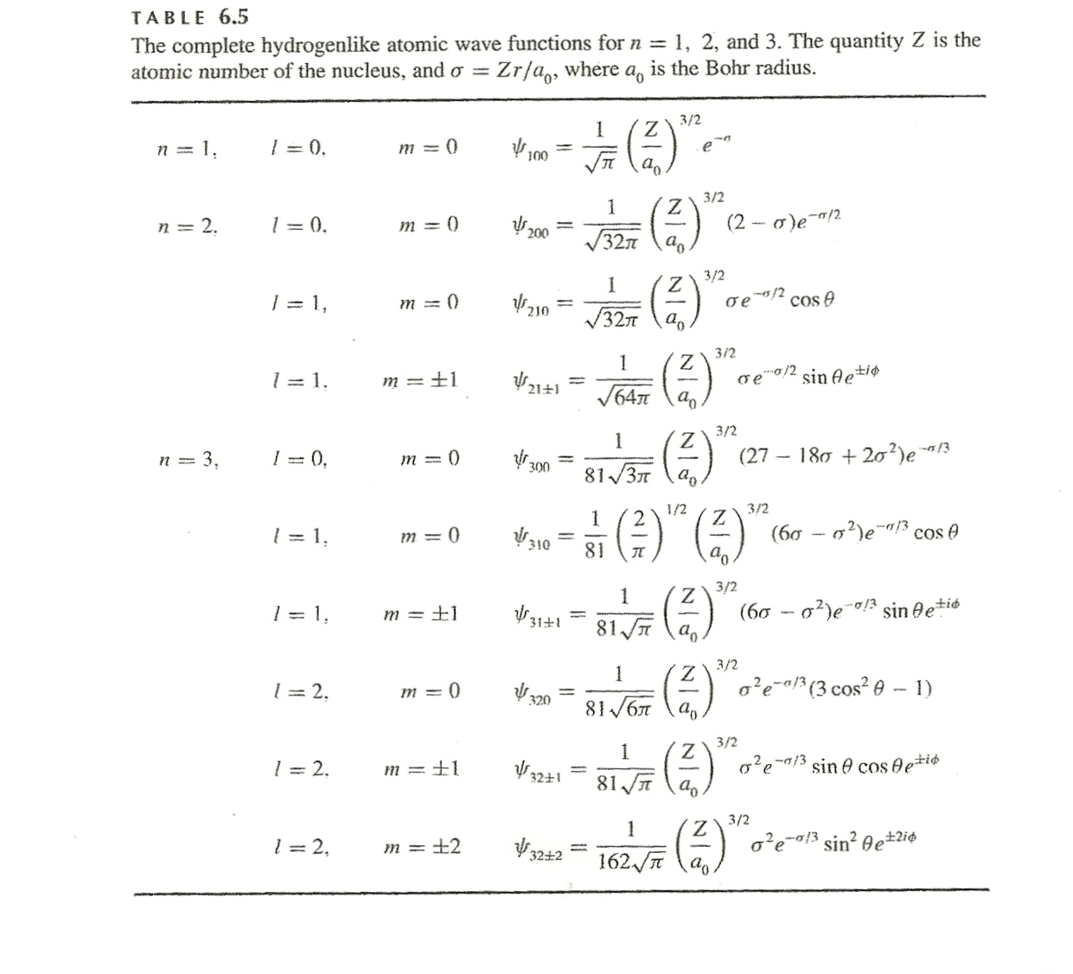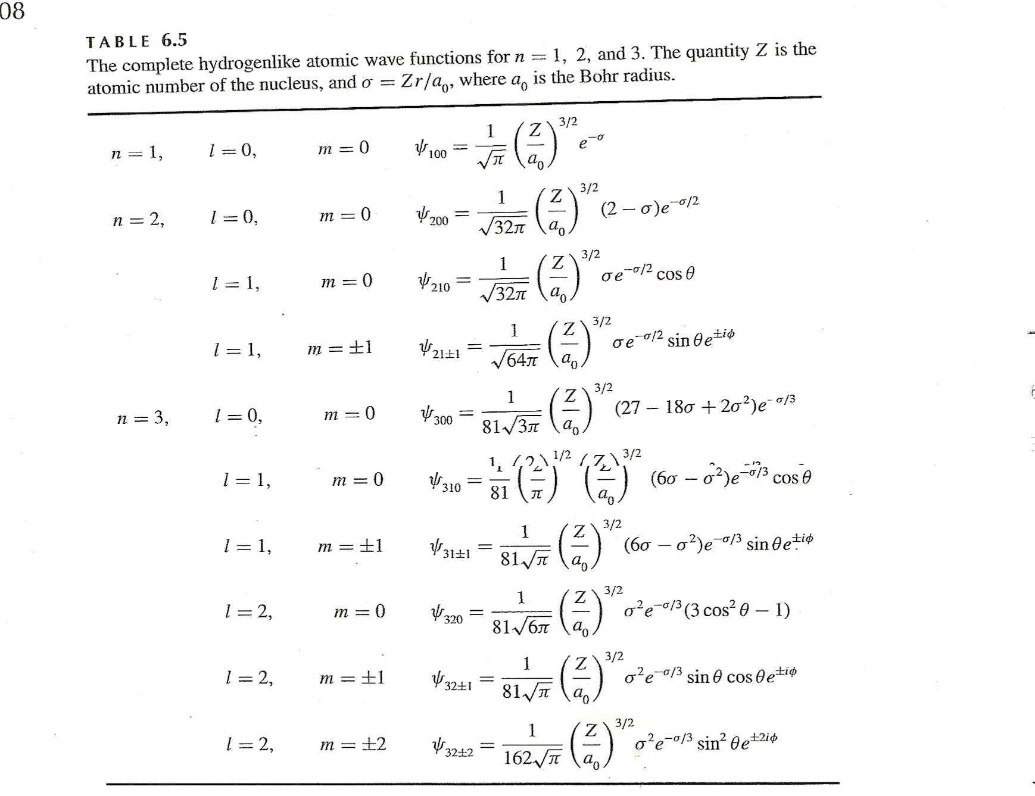

**sinφ/cos φ form (combos of e±iφ see pp 218)**

