**Laboratory Supplement on NMR**

**Organic Chemistry II Chem 4524 SUNY Alfred State**

**Overview of Nuclear Magnetic Resonance Spectroscopy**

**(see also: McMurry pp 368-376; 383-396)**

**1. The Basic NMR Effect**

The basic `NMR’=nuclear magnetic resonance effect involves the coupling of a permanent magnet of strength H, to the nuclei of atoms which exhibit non-zero nuclear moments, (1 H,31 P, 13C and 19F in particular). It is analogous to how the gravitational field of the earth `couples’ to the spinning of a top and causes it to `precess.’ For the `nuclear spin’ coupling:

**Rate of precession ~ energy of a nuclear spin state**

~ **Field strength** **(of magnet)** * ***coupling strength***(of nuclei)

We can change the direction of precession by input of light of frequency f (called the `Larmor’ frequency in NMR) which causes reversal of the spin direction and reversal of the precession’s direction.While low in energy the chemical environment (neighboring electrons) cause small changes in the energies of the spin state because they `shield’ the nuclei from the effects of the field. This creates very small-but measurable`shifts’ in the Larmor frequency called `*chemical’ shifts* which allow us to distinguish and identify (in the case of 1H NMR) different hydrogens within a molecule, provided we can produce sufficient resolution and stability in the NMR instrument. Mathematically, this is all said in the compact form below:

ΔE = constant *H*I*γ

= constant*[H a*(1-s)]* μ Joules

= hf (application of Planck’s equation)

Rearranging:

**1** ΔE/h= f = constant*Ha*(1-s)* μ = `Larmor’ frequency,

which varies with s, the degree of shielding provided by the chemical environment.

When one plugs in measured values for moment and constant, derived from experiment

for two common NMR-active nuclei, 1H and 13C:

**1a** For 1H f = 4.265* 107* Ha(1-s) Hz Ha in Tesla (T)

**1b** For 13C f = 1.156*107 * Ha(1-s) Hz *(1 T=107 Gauss)*

Some definitions:

*f=`Larmor’ frequency

*h=Planck’s constant, f= frequency of light causing transition

*Constant depends on nuclei identity...for hydrogen, the constant= 1.11*10-26.

..measures how fast it spins

*Ha= experimentally applied field (measured in Tesla units,, T)

*H=magnetic field strength sensed by nuclei

*s=`electronic screening constant’ (usually very small 3*10-5-10-7..e.g. 30 to 0.1 ppm)

*I=nuclear spin number (has values of 1/2, 1,3/2...)

*γ=gyromagnetic coupling constant...measures how strong the coupling is to the magnetic field per unit spin

*μ= I*γ = `nuclear moment’ ...measures the degree of coupling...how strongly nuclei `interacts’ with field

**2. NMR Transition Frequencies and the ppm Scale**

**Typical NMR Frequencies**

The foregoing equations are often represented qualitatively with a simple energy level

diagram as shown below:

**H=applied magnetic field**

**I** precesses counterclockwise around **H**

ΔE

**I** precesses clockwise around **H**

We can use equation **1a** above, assuming the magnetic field strength, H=1.4092 T, the

field strength of the Alfred State EML-360 NMR, and, assuming 1H nuclei are being measured, to estimate the frequency of light which will create the transition above

in the absence of shielding (s=0):

At s=0 and H=1.4092:

f=4.265*107*(1-s)*Ha =4.265*107*(1-0)*1.4092 = 4.265*107*1.4092 =6.10238*107 ~ 60 MHz

**Chemical Shielding Effect & the Chemical Shift (=ppm) Scale**

The key reason NMR is so popular is connected to its ability to measure the effects

of chemical shielding. This effect, simply put, is that the interaction of the 1H nuclear spin with the applied magnetic field, is altered by the chemical environment nearby. Specifically, the presence of electrons around and near 1H, acts to shield it from the applied field and decreases the magnitude of ΔE. The shielding effect, s, is typically very small and in the range: 0.0000000-0.0003, which spans the entire range from a `naked’ 1H, (free of electronic shielding) to the most shielded situation commonly available for chemical compounds. If we plug these values of s into **1a,** one can get a sense for why Alfred’s NMR spectrometer requires constant retuning:

*At s=0 (a `naked’ proton): fmax = 60.10238 MHz (at Ha* = 1.4092 T)

*at s=0.00003 (~maximum shielding) fmin = 60.10054 MHz (the TMS limit)*

Because of the miniscule magnitude of the effect, the NMR scale is usually measured on a relative, rather than absolute basis using `TMS” = tetramethylsilane, as the reference



against which all other organic compounds are measured.

The 1H in TMS are the most heavily shielded of easily

obtained references, an effect created mostly by the Si electrons. TMS defines the lower bounds or `zero’

of the so called NMR ppm scale, e.g.:

TMS=tetramethylsilane

**2 chemical shift=δ(ppm) = [f(sample) -f(TMS)] *106**

**f(TMS) (f in MHz)**

**3. Typical Chemical Shifts**

We can use equation **2** to compare the chemical shifts of typical hydrogen species

in organic compounds. The entire range covers only 31 ppm, as shown below for the Alfred State NMR magnet

**EXAMPLES OF CHEMICAL SHIFTS, δ(ppm) in Alfred EML-360**

**proton species (...H) frequency, f(MHz) δ(ppm) Δf(Hz)**

**bare proton 60.10238 31 1840**



**60.10147 15.5 930**

**benzyl alcohol**



**60.10105 8.5 510**

**benzene**

C2H5O-**H 60.10086 5.3 320**

**ethanol**

**C5H11-H 60.10067 2.2 130**



**60.10054 0 0**

**(zero reference)**

TMS

**(tetramethylsilane)**

Despite the small range in chemical shift values, the high resolution afforded by modern NMR instruments allows chemists to identify and analyze trends in ppm shifts in terms

of basic chemical notions like electronegativity and hybridization. These trends allow

(along with a separate NMR effect referred to as multiplet splitting) often very specific identification of compounds. Some typical NMR correlation tables are attached.

**4. Quantitative Analysis with NMR**

Because NMR peaks are highly resolved, it is often possible to look at a complex mixture and still measure individual component’s NMR signals without worrying about interference.

The ability to integrate these peaks provides often simple pathways for analytical

work.

For example, consider the hypothetical nmr spectrum of an unknown composition of A and B below. (Subscripts just label the several peaks assigned to A or B)

observed area ratio

**area A1/area B1=2.1**  A1

unknown mix B1 A2 B2

of A +B

By measuring known solutions of A+B in a fashion similar to GC analyses, one might

generate data as below (via integration of the area under B1 , B2, A1 and A2 )

Calibration of Standard Mixtures of A+B

vol %A vol %B area A1  area A2  area B1 area B­2

10 90 3 1.5 6 13

50 50 16 8 3 6

90 10 33 14 0.6 1.2

As with GC data, we now can compute area ratios vs vol % ratios, and compute the best fit, as below:

**y=%A/%B x=area A1 /area B1**

0.11 0.5

1 5.3 %A/%B= 0.162*(area A1/area B1) + 0.082 9 55 r2=0.999

Since the unknown mixture provided an area ratio of A1/B1= 2.1, we can compute

the ratio of %A/%B so:

%A/%B= 0.162*(area A1/area B1) + 0.082

%A/%B= 0.162*2.10+ 0.082 = 0.42

=> %A= 0.42*%B

100 = %A + %B = 0.42%B + %B= 1.42%B=> %**B=100/1.42 = 70.4%**

**%A= 100-70.4= 29.6%**

1. **Qualitative Description of How a CW Varian 360 NMR Works**

The original design of an NMR uses a room temperature magnet and a fixed `**CW**’ =**C**ontinuous **W**ave radio frequency excitation, fCW, of around 60 MHz to measure proton chemical shifts. With reference to the attached Figure, it works roughly like this.

The sample tube containing the organic liquid to be studied, is inserted down the central axis of an rf transmitter coil which is located symmetrically between the two poles of a permanent magnet. As already described, the permanent magnet splits the spin states of the 1H nuclei into an upper counterclockwise (ccw) level and a clockwise (cw) level. To minimize inhomogeneities of the magnetic field and sample tube, the sample is also spun at 30-60 revolutions/sec.

The light source is an rf transmitter set at a **fixed** frequency of around 60 MHz.

Fixing the nmr frequency at first blush seems illogical. How can one `scan’ to determine the energy difference between cw and ccw levels if the probing frequency is fixed at a single value ? The answer is that in NMR the magnetic field, rather than the probing frequency is `swept’. This is done by applying an AC signal across sweep coils which are wrapped around the magnet housing. Changing the magnetic field changes the ΔE between the two spin states in proportion to the increase or decrease of AC signal’s magnetic field. This tactic is employed rather than simply varying the light source frequency since varying field coil strength is technological easier to do at the levels of precision required.

Thus, as the field coils sweep, the energy levels of the CW vs CCW state vary in their distance from one another, as shown below. At one particular sweep strength, the energy of the gap will equal hfCW and the nuclei will absorb that energy and spin flip from CW🡪CCW, to produce an NMR absorption.

ccw spin

ΔE

cw spin

fCW = 60 MHz resonates here

FIELD COILS INCREASING IN STRENGTH -🡪

The energy absorption is picked up as a change in signal strength transmitted

from transmitter to receiver coil, and as we scan through, a momentary dip in transmitted energy is registered at the inner, receiver coil as ΔE. This is picked up and amplified at an rf receiver, then fed to a chart recorder which is moving its x axis in concert with the rf sweep coil.

absorption

SCANNING-🡪 dip as displayed by chart recorded

**6. Low and High Resolution Features of NMR Spectra**

A practical goal of NMR work is to tune the instrument so as to maximize its ability to distinguish dips which are close together during a sweep. This process is compactly referred to as `*optimizing resolution*.’ The attached Figure represents the results of scanning ethanol (=drinking alcohol) when the optimization attains a 1 ppm=1/106 and 0.1 ppm= 1/107  resolution. The former value is considered `low’ resolution, while the latter is

~ high resolution.

At low resolution, the NMR spectrum shows 3 distinct peaks. These correspond to the

three different 1H present in ethanol: hydroxyl (OH), methylene (CH2) and methyl (CH3)

HO-CH2-CH3

hydroxyl methylene methyl

Hence, even a poorly tuned NMR can provide valuable insights into the likely structure of an unknown., since the number of non-equivalent H are resolved.

At high resolution, extra structure (often called hyperfine structure or multiplet structure) is revealed for each of the three main peaks. Multiplets are created by 1H on the carbon sites adjacent to the H giving rise to the peak. If there are **N** nearest neighbor H ***the number of multiplets a given peak will split into* = N+1.**

To illustrate this simple rule, note that in ethanol, methylene H have 3 nearest neighbor H (from the methyl group). From the above relationship, w expect methylene H to split into N+1=3+1=4 peaks, exactly as observed. Similarly, the methyl H have 2 nearest neighbor H (from the methylene group) and so we expect N+1=2+1=3 multiplet peaks, again as observed.

This rule does not uniformly apply when H is connected to O, since hydrogen bonding

effects obscure and often blur multiplet structure. However, as the chain length of the alcohol goes up, splittings of and by the hydroxyl can occur.

The source of these effects, briefly speaking, is that the individual nuclear spins of the nearest neighbor H of a particular proton further shield or de-shield that proton. The effects are statistical since to a high degree of accuracy, the odds for a nearest neighbor H ‘s spin being `up’ or `cw’ = that for the spin being `down’ or `ccw’ =1/2. Thus, the nuclear shielding effects can be viewed as the net effect of spin up and spin down combinations on the nearest neighbor H. If we consider the case of 2 H on the methylene

carbon, their spin orientations can be distributed in the following configurations

adds null subtracts...from applied magnetic field

The practicality of these effects lies in their capability of providing further hints

as to the structure of unknown compounds . Details will discussed during lecture.

**7. Practical Issues**

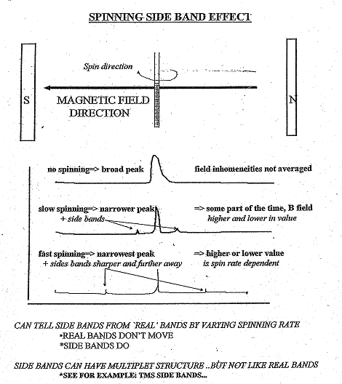

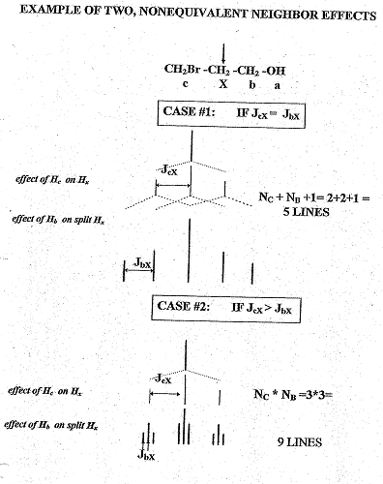

**1H spin decoupling removes hyperfine splittings and allows ID of non-equivalent H**

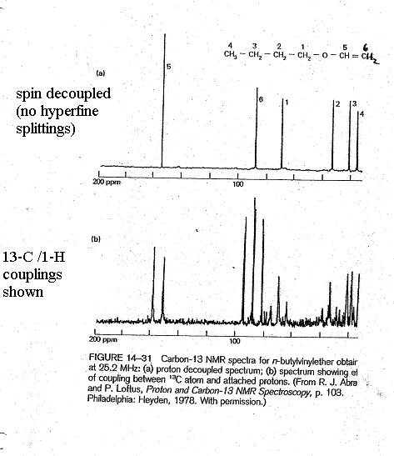

**13C NMR Identifies non-equivalent C**

**(no hyperfine splittings here**)

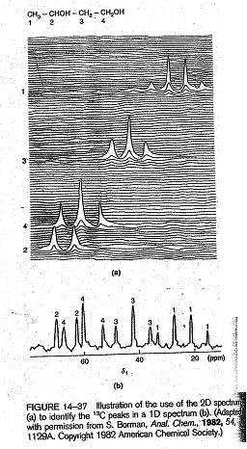

**Two-dimensional NMR helps resolve difficult to identify (1D-overlapped) nuclei**