Lab Practicum Exam: Chemistry 4524 Organic II Alfred State College 2015

Your name: _________________________________________________ ___ /61

1. **Scenes from Organic Procedure Disaster films**

**Disaster Scene 1**

Jack Chemist wants to carry out an esterification to make ethyl butanoate.



Ethyl butanoate

He proposes the following procedure:

“ *Mix 0.03 moles of 1-butanol (d=0.8 g/mL) and 0.03 moles of acetic acid (d=0.85 g/mL) together and then add ~5 mL of M sodium hydroxide as a catalyst. Immediately distill into a receiving flask. Wash the lower organic layer with concentrated sulfuric acid (d= 1.8 g/mL) and discard the upper layer of the wash. Add MgSO4 to dry the lower layer.”*

**List 3 errors in Jack’s procedure:**

1. __________________________________________________________________
2. __________________________________________________________________
3. __________________________________________________________________

**Disaster Scene 2**

Jill Chemist wants to solvent extract her reaction mixture which contains water-soluble sodium benzoate and water-insoluble benzyl alcohol. She proposes the following procedure:

*“Add ~15 mL of CH2Cl2 (d= 1.3 g/mL) to the reaction mixture. Pour the resulting mix into a 125 mL separatory funnel and shake vigorously with the stopcock closed and the glass stopper firmly in place to prevent loss of product. Add ~ 10 mL of water (d=1.00 g/mL) and shake as just described. With the glass stopper still in place, draw off the lower aqueous layer and set it aside.*

*Draw off the upper organic layer, which contains benzyl alcohol into a beaker and add chromic acid to insure the alcohol remains un-oxidized. To the lower aqueous layer, which contains sodium benzoate, add ~10 mL of 2 M NaOH to convert the benzoate to benzoic acid. Drive off the water by heating vigorously and collect the final benzoic acid crystals.”*

**List 3 errors in Jill’s proposed procedure:**

1. __________________________________________________________________
2. __________________________________________________________________
3. __________________________________________________________________
4. **Old School Mates**

Decide which of the classic techniques listed to the right best suits the goals below (use #):

1. Purifying a mildly impure crude solid product ________
2. Baeyer test
3. Solvent extraction
4. Refractive index
5. Steam distillation
6. Fractional distillation
7. Retrograde rotation
8. Recrystallization
9. Hanon practice
10. Separating two compounds with similar structure but moderately

different aqueous solubilities _________

1. Separating two compounds with very different boiling points_________
2. Separating two compounds, one of which forms a water soluble salt when

acidified________

___/10

1. **Let the Punishment Fit the Crime: Instrumental Method Matching**

Your organic lab has the following methods in-house:

1. GC-MS
2. GC
3. Abbe Refractometer
4. ATR-FTIR
5. NMR
6. Mel-Temp
7. Baeyer test solution
8. Bromine test solution

Indicate with the letter assigned to each method:

1. Which method(s) above provide a quick confirmation for the presence of a C=C double bond?
2. What method is best applied if you just want to confirm the purity of a liquid compound you think you’ve identified?
3. Which method provides an efficient way to decide what functional groups are present in a product?
4. Which method allows you to both separate and identify components of a mixture of organics?
5. What method is traditionally applied to ascertain the purity of a purportedly pure solid ?
6. Which method can allow you to deduce the precise arrangement of atoms and groups in an unknown, pure liquid given its empiric formula ?
7. Which method provides mixture identification via retention times (and was not operational until the Spring of this year)?

**4) IR Analysis**

1. What band (cm-1) is a strong indicator of the presence of an alcohol ? _________________cm-1
2. The above band is: (circle your choice)

i)Weak and sharp ii)strong and sharp iii)a multiplet iv)strong and broad

1. What’s the easiest way to decide whether a compound has C=C bonds present vs. just C-C bonds from an IR spectrum?
2. Weak overtone bands in the 1900-2000 cm-1 region are strong indicators of the presence of:
3. A sharp, strong singlet IR band appears at 1695 cm-1. It is most suggestive of the presence of:
4. Alcohols b) aromatics c) ketones or aldehydes d) alkanes e) alkynes
5. What observation suggests you have an un-substituted, simple cycloalkane like cyclohexane?
6. Strong bands at both 1470 and 1380 cm-1 b) A band at 1470 cm-1 but not at 1380 cm-1

c)a band at 1380 cm-1 but not at 1470 cm-1 d) sharp ring breathing mode at 1600 cm-1

___/13

**4) IR Analysis (continued)**

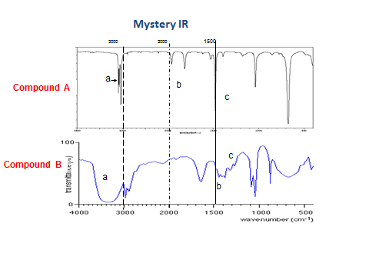

c d

c

b

**Compound A**   **Compound B**

a =bands above 3000 cm-1(~3050 cm-1) a =band centered at 3450 cm-1

b =bands 1800-2000 cm-1 b= band below 3000 cm-1 (2890-2950 cm-1)

c =band 1500 cm-1 c =band at ~1460 cm-1 (c band 2-3X as big as d band)

d =band at 1380 cm-1

What class of compounds are A and B likely part of ?

Compound A class________________ (2 pts) Compound B class____________________ (2 pts)

Pick from the list of possible compounds below, the most likely identification of Compound A and B

Ethyl benzene propyl ethyl ketone octane acetic acid methanol

Toluene methyl ethyl ketone hexane formic acid ethanol

Phenol diethyl ketone pentane benzoic acid isopropanol

Benzene acetone iso-butane 1-butanol

Compound A= ______________________ (2 pts) Compound B =___________________________ (2 pts)

**5) NMR Antics**

1. If Hx has 5 nearest neighbor protons, what is the multiplet splitting for Hx ? __________
2. What motion creates the NMR effect ?

i)precession of electron moment in molecule’s magnetic field

ii) precession of proton moment in external, fixed field magnet

iii) rotation of protons around externally applied electric field

iv) spin-spin magnetic interactions between electrons and protons of molecule

1. What is the physical source of the multiplet (hyperfine) splitting of peaks seen in 1H NMR?

i)differences in chemical environment ii) Carbon interacting with H magnetically

iii) inhomogeneities in the NMR magnet field iv)nearest neighbor proton magnetic fields

increasing or decreasing the local field

**____/11**

**5) NMR Antics (continued)**

1. A compound with the empiric formula C5H12 has a single NMR peak with no hyperfine splittings.

What is the structure of the compound ? (2 pts)

1. The 1H NMR below is a ketone with empiric formula C5H10O

How many non-equivalent H are implied ? _________________

Singlet doublet

(7 in multiplet)

4 2.1 1.1 ppm 0 (TMS)

What is the ketone’s structure? (3 pts)

1. A 13C NMR for a compound with the empiric formula C4H10O reveals the following lines:

δ **18.9 CH3**

δ **30.8 CH**

δ **69.4 CH2**

Draw the likely structure of the compound here🡪

(2 pts)

___/8

**6)GC-MS Reckonings**

1. What is meant by the `parent mass’ in mass spectroscopy ?
2. What is meant by the `cracking pattern’ in mass spectroscopy?
3. What initially separates the compounds of a mixture injected into a GC-MS?
4. The ~ sample size injected into a GC-MS is:

i)around 1 mL ii) around 1 L iii) around 0.1 mL iv) < 1 μL v) 10-10  L

1. A pure compound with the formula C5H12 produces a simple MS spectrum with the major mass peaks listed below. Assign the fragments likely to be causing the peaks.

Mass (m/e) amu fragment assignment ( 1 pt each)

72

71

57

42

27

1. What is the likely structure of the C5H12 compound above ? (3 pts)
2. **A Final Reckoning (7 points)**

A compound (call him Stinker) has been carefully isolated during the course of an organic synthesis. He exhibits the following spectral data:

Stinker’s FTIR spectrum

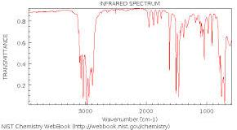

____/12 3000 2000 1470 1385

Stinker’s NMR spectrum

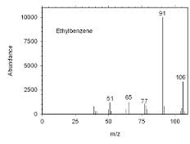

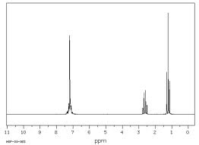

unresolved multiplet (5H)

triplet

(3H)

quartet(2H)

Stinker’s Mass Spectrum

Parent mass

Stinker’s refractive index, nD25 is recorded as 1.4959. He has a density of 0.8665 g/cm3 and a recorded boiling point of 136oC. Stinker is poorly soluble in water and despite his nickname has a somewhat pleasant if cloying odor. Stinker does not react to Br2 or form a brown precipitate with the Baeyer reagent. He was purportedly `birthed’ in two steps via an electrophilic substitution followed by a reduction. Both these reactions are famous enough to have names.

Draw or name Stinker’s identity here:

___/7

STINKER