**Chem 4524 Spring 2012 Organic Chemistry II**

NMR lab Dry Lab Assignment #1: 1H NMR Molecular Structures

Alfred State College

Your name:____________________________________________________________

* 1. The following compounds have only a singlet NMR signal at the indicated δ vs TMS. Draw the structure

of the molecule implied by the simple NMR spectrum observed. (2 pts each, 6 pts total)

1. C8H18 δ=0.9 singlet
2. C5H10 δ=1.5 singlet

c) C8H18  δ =2.2 singlet

1.2 Deduce and draw the molecular structure of the organic compounds based on the 1H NMR spectra and molecular formulas provided below. (3 pts each, 15 pts total)

1. C6H12

|  |  |  |
| --- | --- | --- |
| δ vs TMS | Splitting count | #H |
| 0.9 | 3 | 3 |
| 1.6 | 1 | 3 |
| 1.7 | 1 | 3 |
| 2.0 | 5 | 2 |
| 5.1 | 3 | 1 |

1. C4H6Cl4

|  |  |  |
| --- | --- | --- |
| δ vs TMS | Splitting count | #H |
| 3.9 | 2 | 4 |
| 4.6 | 3 | 2 |

1. C4H6Cl2

|  |  |  |
| --- | --- | --- |
| δ vs TMS | Splitting count | #H |
| 2.2 | 1 | 3 |
| 4.1 | 2 | 2 |
| 5.7 | 3 | 1 |

1. C5H10O

|  |  |  |
| --- | --- | --- |
| δ vs TMS | Splitting count | #H |
| 1.0 | 2 | 6 |
| 1.3 | 7 | 1 |
| 2.3 | 1 | 3 |

1. C3H8O

|  |  |  |
| --- | --- | --- |
| δ vs TMS | Splitting count | #H |
| 1.1 | 2 | 6 |
| 3.3 | 1 (broad) | 1 |
| 3.8 | 7 | 1 |

1.3. The observed NMR for compound X with the formula C8H10 O is below.

1. Assuming it is an alcohol what is the likely organic structure of the compound ? (note that the

peaks at 4.9 and 1.6 are expanded to show splitting in insets. (2 pts)

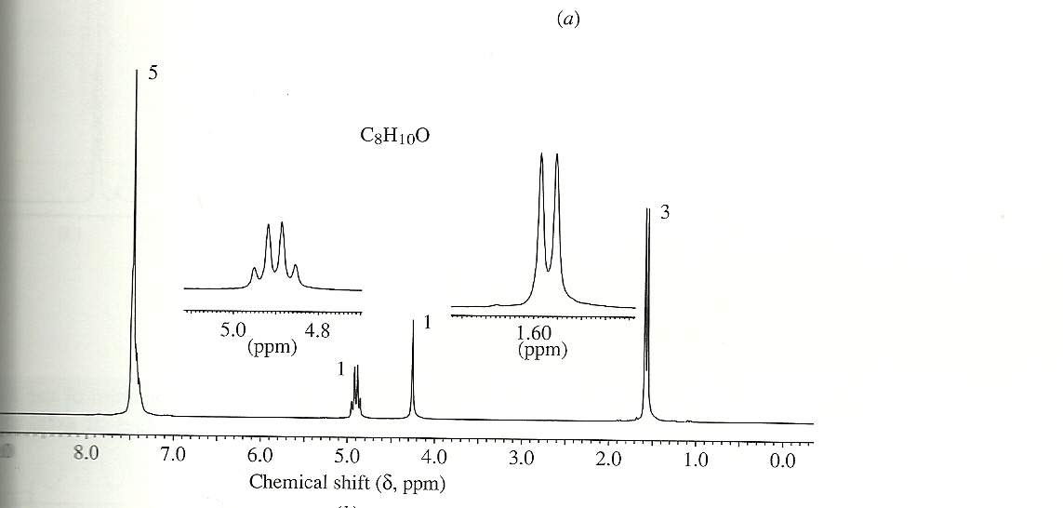

d

b

c

Compound X’s molecular structure

a

1. Label the non-equivalent H in X’s structure with their NMR signal a🡪d (2 pts)