**Laboratory #4: NMR Dry Lab #2 assignment**

**13C and Molecular Assignment from Real Spectra**

**Due Week 6 30 pts total**

**Your name:____________________________________________________**

**Textbook 13C NMR Assignments (10 pts total/2 pts each)**

13C NMR is even more convenient than 1H NMR in that the former yields only singlets and a signal for each non-equivalent C in a structure. Use this simple fact to assign the molecular structure for the C6H14 isomer based on the listed 13C NMR below:

2 pts 2 pts

**δ 13.7 CH3  δ 8.5 CH3**

**δ 22.8 CH2  δ 28.7 CH3**

**δ 31.9 CH2  δ 30.2 C**

**δ 36.5 CH2**

Determine the structure of the C4H10O isomers below based on their listed 13C NMR data

**δ 18.9 CH3 δ 10 CH­3**

**δ 30.8 CH δ 22.7 CH3**

**δ 69.4 CH2 δ 32.0 CH2**

**δ 69.2 CH**

**Compound X =**

**Think benzene ring**

**CH CH3**

**C**

135 131 20 ppm

The above 13C NMR spectrum is recorded for a compound X with the molecular formula C10H14.

Draw its likely structure of X in the box provided.

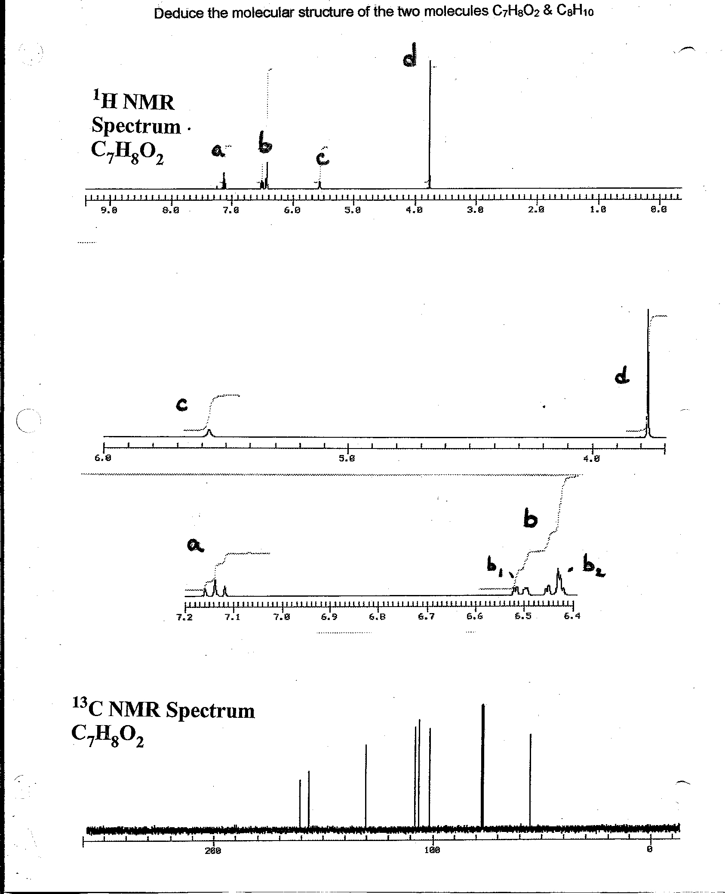

**b**

**3 different H here (X,Y,Z)**

**X=doublet Y=doublet Z=overlapped singlet**

10 points for each correct ID

**Expansions of regions for signals a,b,c and d below**

**(hint: the 3 non-equivalent H in region B are highly resolved H on a benzene ring….)**

This peak is a **reference** not part of molecule

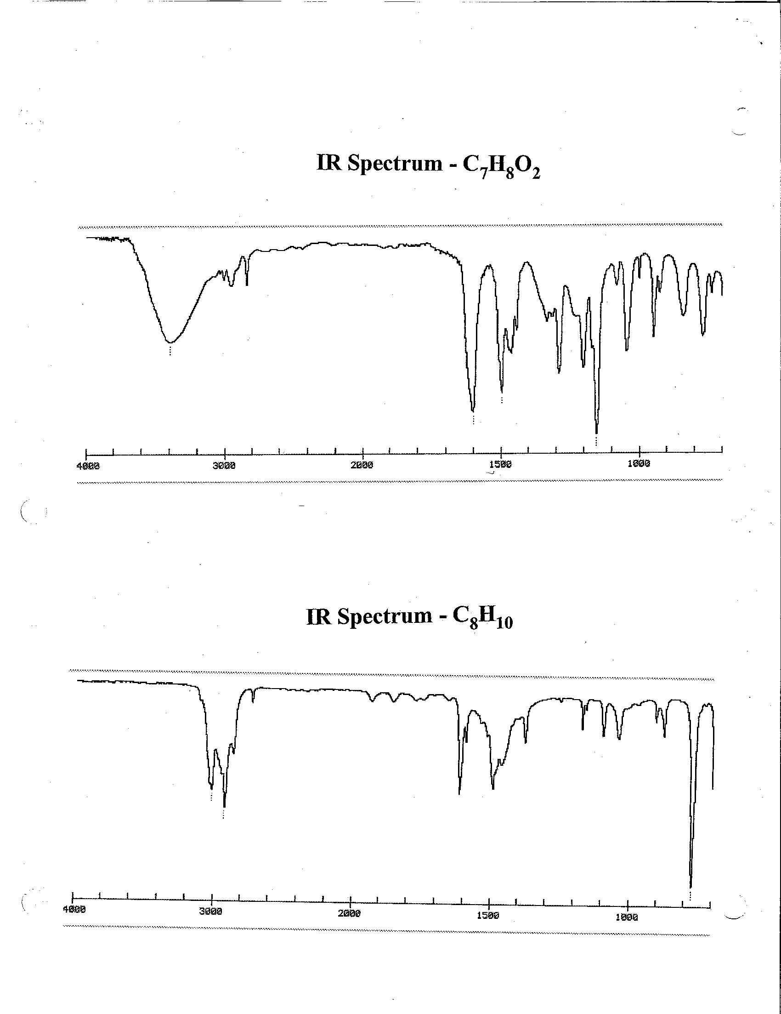

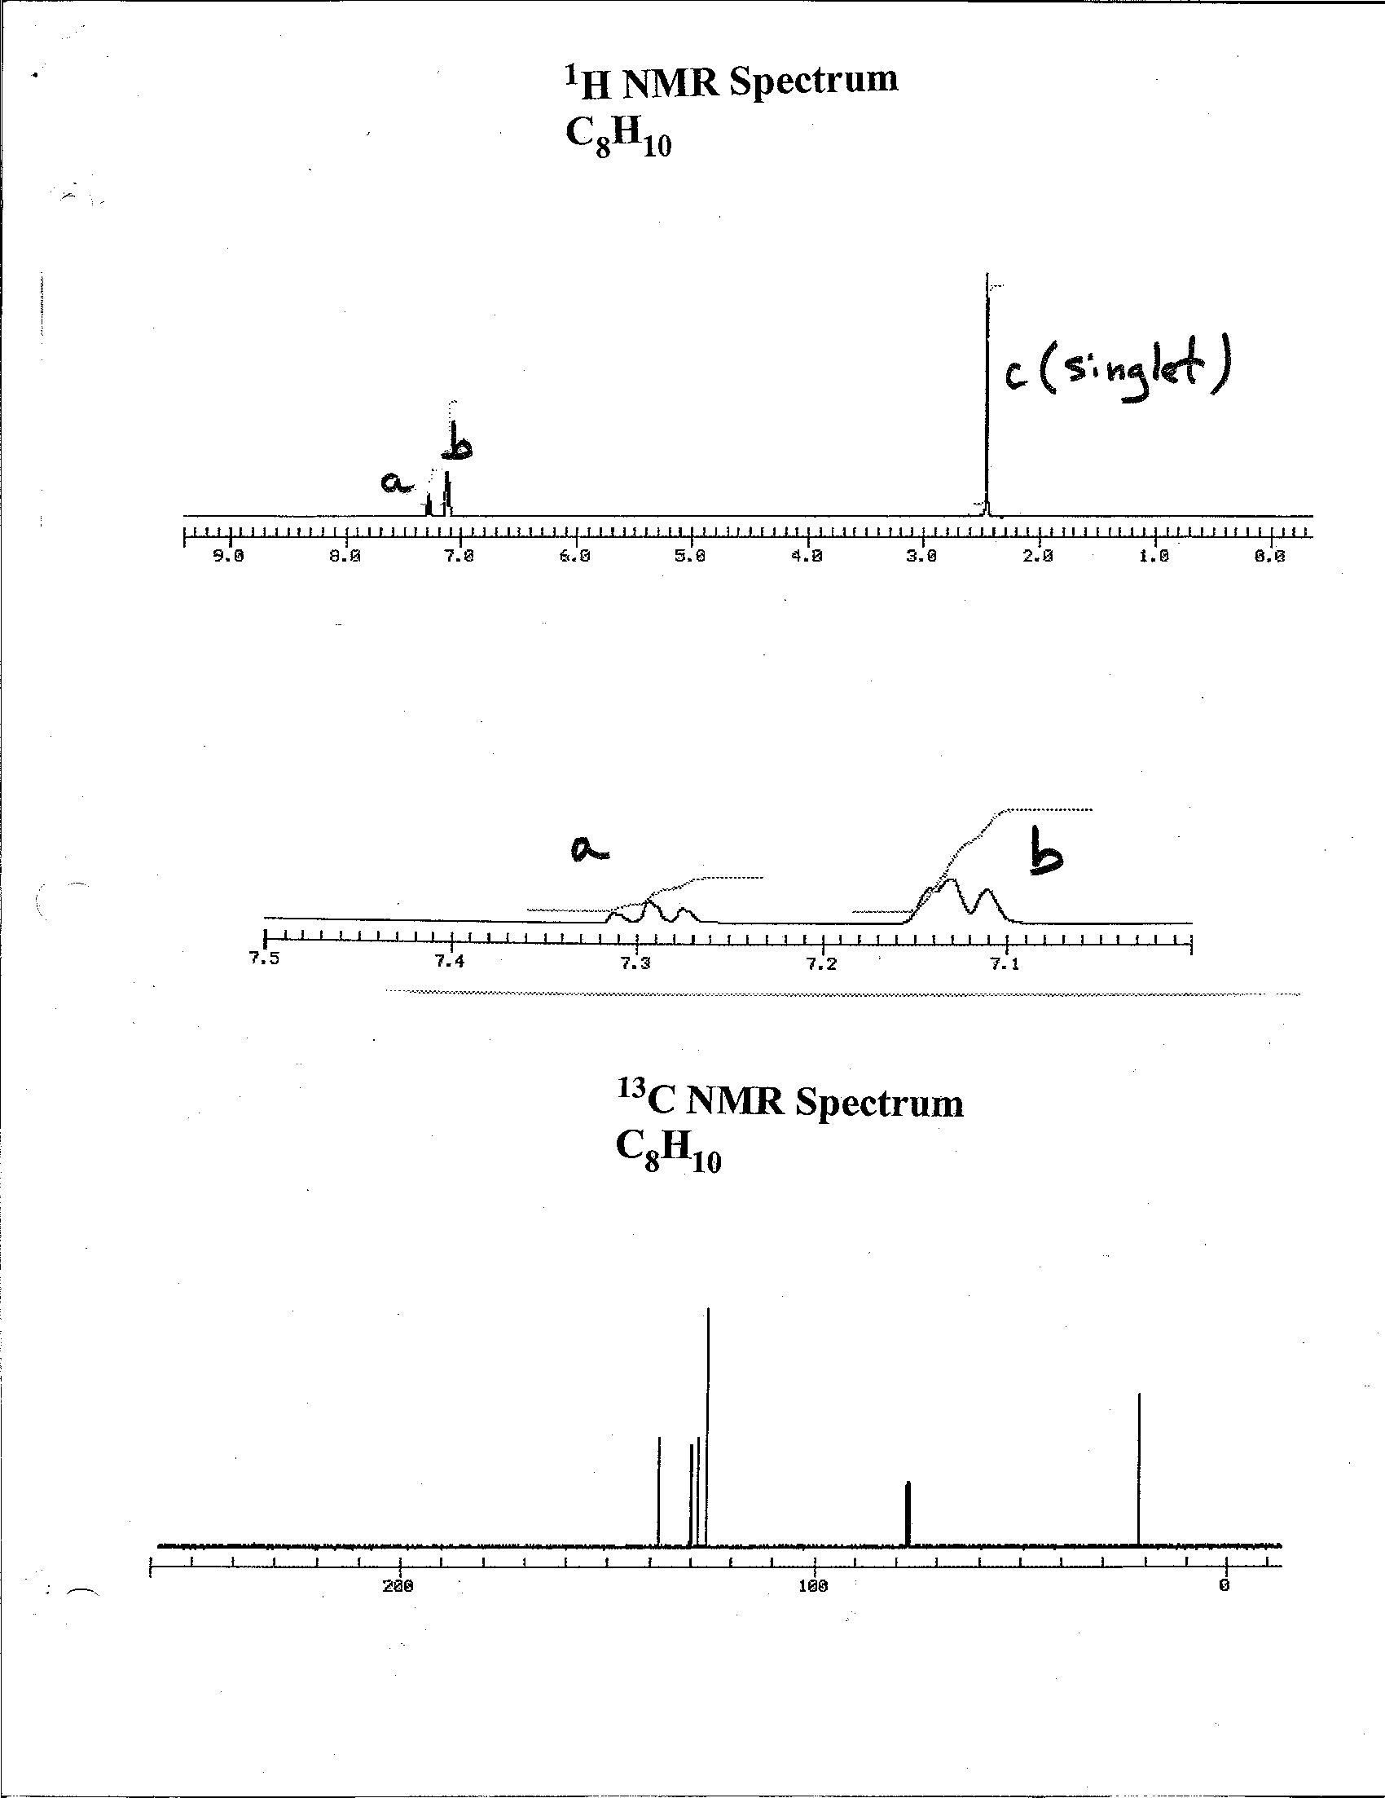

Expansion of a, b peak bundles

singlet

triplet

There are two separate peaks here, a single (b1) and a doublet (b2)

**b1,b2**

This is a reference peak not part of unknown

**b2, b1** expanded