NMR exercise 3 :
3.1 ¹³C Spectral analysis

Assuming spin-decoupled spectra:
1) How many non-equivalent C should trans-2-hexene have ? ____________

2) How many non-equivalent C are in (benzene): ___________

3) How many non-equivalent C in 1,3-dimethylcyclohexane ____________

4) guess the structures of the two compound of empiric formula C₄H₁₀O with the 13C spectral features listed below:
Compound 1 Compound 2
10 ppm (CH₃) 31.2 (CH₃)intensity = 3
22.7 CH₃ 68.9 (C) intensity= 1
32.0 (CH₂)
69 (CH)

3.2 More ¹H Analysis (a quick check on your understanding)

C₈H₁₀ 1.2 ppm triplet 3H
2.6 ppm quartet 2H
7.1 ppm broad singlet 5H

C₆H₁₄ 0.8 ppm doublet 12H
1.4 ppm septet 2H

3.3 General Spectral Analysis
Determine the structure of C₈H₁₀O using the IR and ¹H NMR below
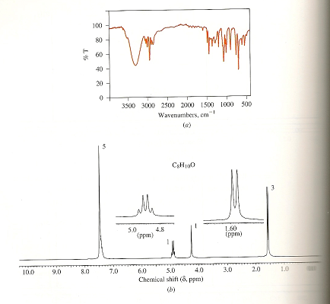

Parent mass=86=MW?
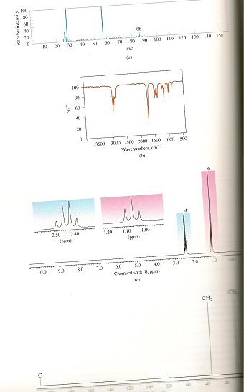
What is my structure ?
(text pg 573-4, problem 13.43)

CH₃
IR
¹H NMR
¹³C NMR

