**HOMEWORK ASSIGNMENT #1 ORGANIC CHEMISTRY II ___/25 pts**

(due Wed 29 Jan 2014)

Your name:________answers_______________________________________

1. Suggest a simple, one step route to the polymer: (CH2-CHCl)n, (2 pt)

HO-OH/light

n CH2=CHCl (CH2-CHCl)n with OH end marker (see below)

radical polymerization



…… etc

1. If the substituted alkenyl halide, CH2=CHCl is treated with Br2 in wet CCl4, predict the most likely product. (Make sure to draw the structure explicitly with expected addition group orientation) (2 pt)



*Br attaches to side with Cl in intermediate carbocation preferentially to avoid placing it near the electronegative Cl, which destabilizes a carbocation*



1. Provide a simple, 1 or 2 step pathway to the compound shown to the right:

(2 pts)



Product

**4.) Fill-in the boxes (11 pts)**



a)

acetic acid



no peroxide

+ HBr **-bromo-2-methylpentane**

b)  Br2 CCl4/wet

2-methyl-2-pentene +

**3-bromo-2-methyl-2-pentanol**





c)

OsO4

**syn or anti? (circle choice)**

2-methyl-2-hexene

1 pt 1 pt

d)

HOOH

n CHCl=CHCl light

**{-CH-CH-}n**

**| |**

**Cl Cl**

**B2H6 H2O2/OH-**



e) **1-pentanol exclusively (>90% yield)**

**___/17**

**Classify the reactions written below into one of the alkene reaction categories: (5 pts)**

1. Carbocation based addition (C+)
2. Bridgehead (halohydrin) addition (B)
3. Radical-based addition ( R )
4. Organometallic/redox based addition (O/R)
5. Specials (=SP=ozonolysis and allylic substitution)

**C+**

1. Conc H2SO4 + ethylene, then H2O 🡪 ethanol _______
2. NBS + isobutylene 🡪 3-bromo-2-methylpropene ____R_or SP__



1. CHCCl3 with OH- + 2,3-dimethyl-2-butene🡪 __R_____
2. Anti-2,3-dibromobutane forms ___B____
3. Anti-diol formed ___O/R____

**Suggest three different ways to make 2-butene (3 pts)**

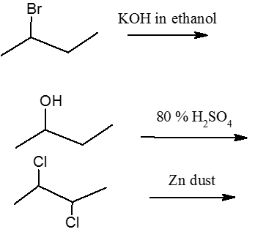



**___/8**