HOMEWORK ASSIGNMENT #7 ORGANIC CHEMISTRY II

Making ringies with thingies

due Friday 8 April 25 pts

**7.1 Modern Dancing ( 9 pts total/3 pts each)**

**Starting from alcohols with 4 or fewer carbons, acetone, and benzene or phenol, suggest a synthetic route to the compounds below**







**7.2. Different strokes to the same folks**

**Starting from each of the compounds below, prepare phenyl ethanol. (2 pts each/8 pts total)**





**phenyl ethanol**

**homework 7 chem4524 (cont.)**

**7.3. Willie Nelson problem (On the road again…..)**

**Starting from benzene and 1-chlorobutane, suggest a route to the syn-diol below (4 pts):**

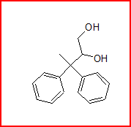

**7.4 Naming ( 1 pt each/4 pts total)**



**IUPAC name**



**IUPAC or common**



**IUPAC or common**



**IUPAC or common**