PRACTICE HOMEWORK ASSIGNMENT #10 ORGANIC CHEMISTRY II

(the last %^$# one !!)

Your name:____________________________________ _

Playing in Carbonyl Hell

1)







+ HCl

=(Ar)3P

Can be any RCH2Cl species (in general) A





A + Reaction name ?

_Wittig______

2) Run a Periodate cleavage on isopropyl ethyl ketone





3)





+ H2O (each case)



__immine________ name of above class

__enamine_______ name of above class

4) Run a Baeyer-Villager oxidation on 2-butanone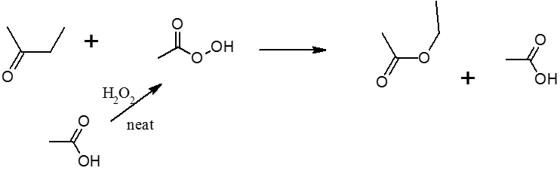__/9

LiAlH4/THF then H2O



5)

CN‑







6)

Br2

Acetic acid __α-H______ substitution

7a) Run a Wolff-Kishner reaction that produces pentane





7b) in a single step, convert benzaldehyde to toluene

8)





Hell-Volhard-Zellinsky reaction hellish name of this reaction

9) Correctly oxidize methanol then run a Cannizzaro reaction on the product.



___/10

10. Write:

Three different oxidations of acetaldehyde



1)



2)

3)

Two different oxidations of acetone



1. Baeyer-Villiger oxidation
2. Periodate test reaction



A Wittig reaction involving 2-chloropropane and diethyl ketone



An alpha-substitution of Br on acetone



Make an immine from acetone



Make a carboxylic acid from CN- and acetone



Make acetic acid directly from acetone



Periodate test

___/11