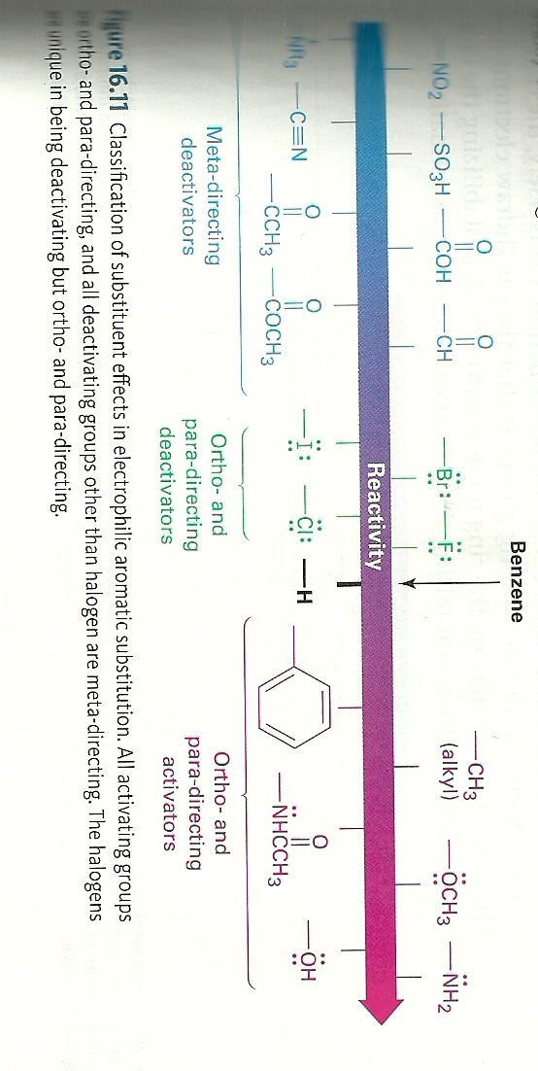
Substituent directing effects ala’
McMurry text, Figure 16.11

From Organic Chemistry, Carey, 6th edition page 518: Director Properties of Aromatic Substituents
(see also : text pp 464-473)
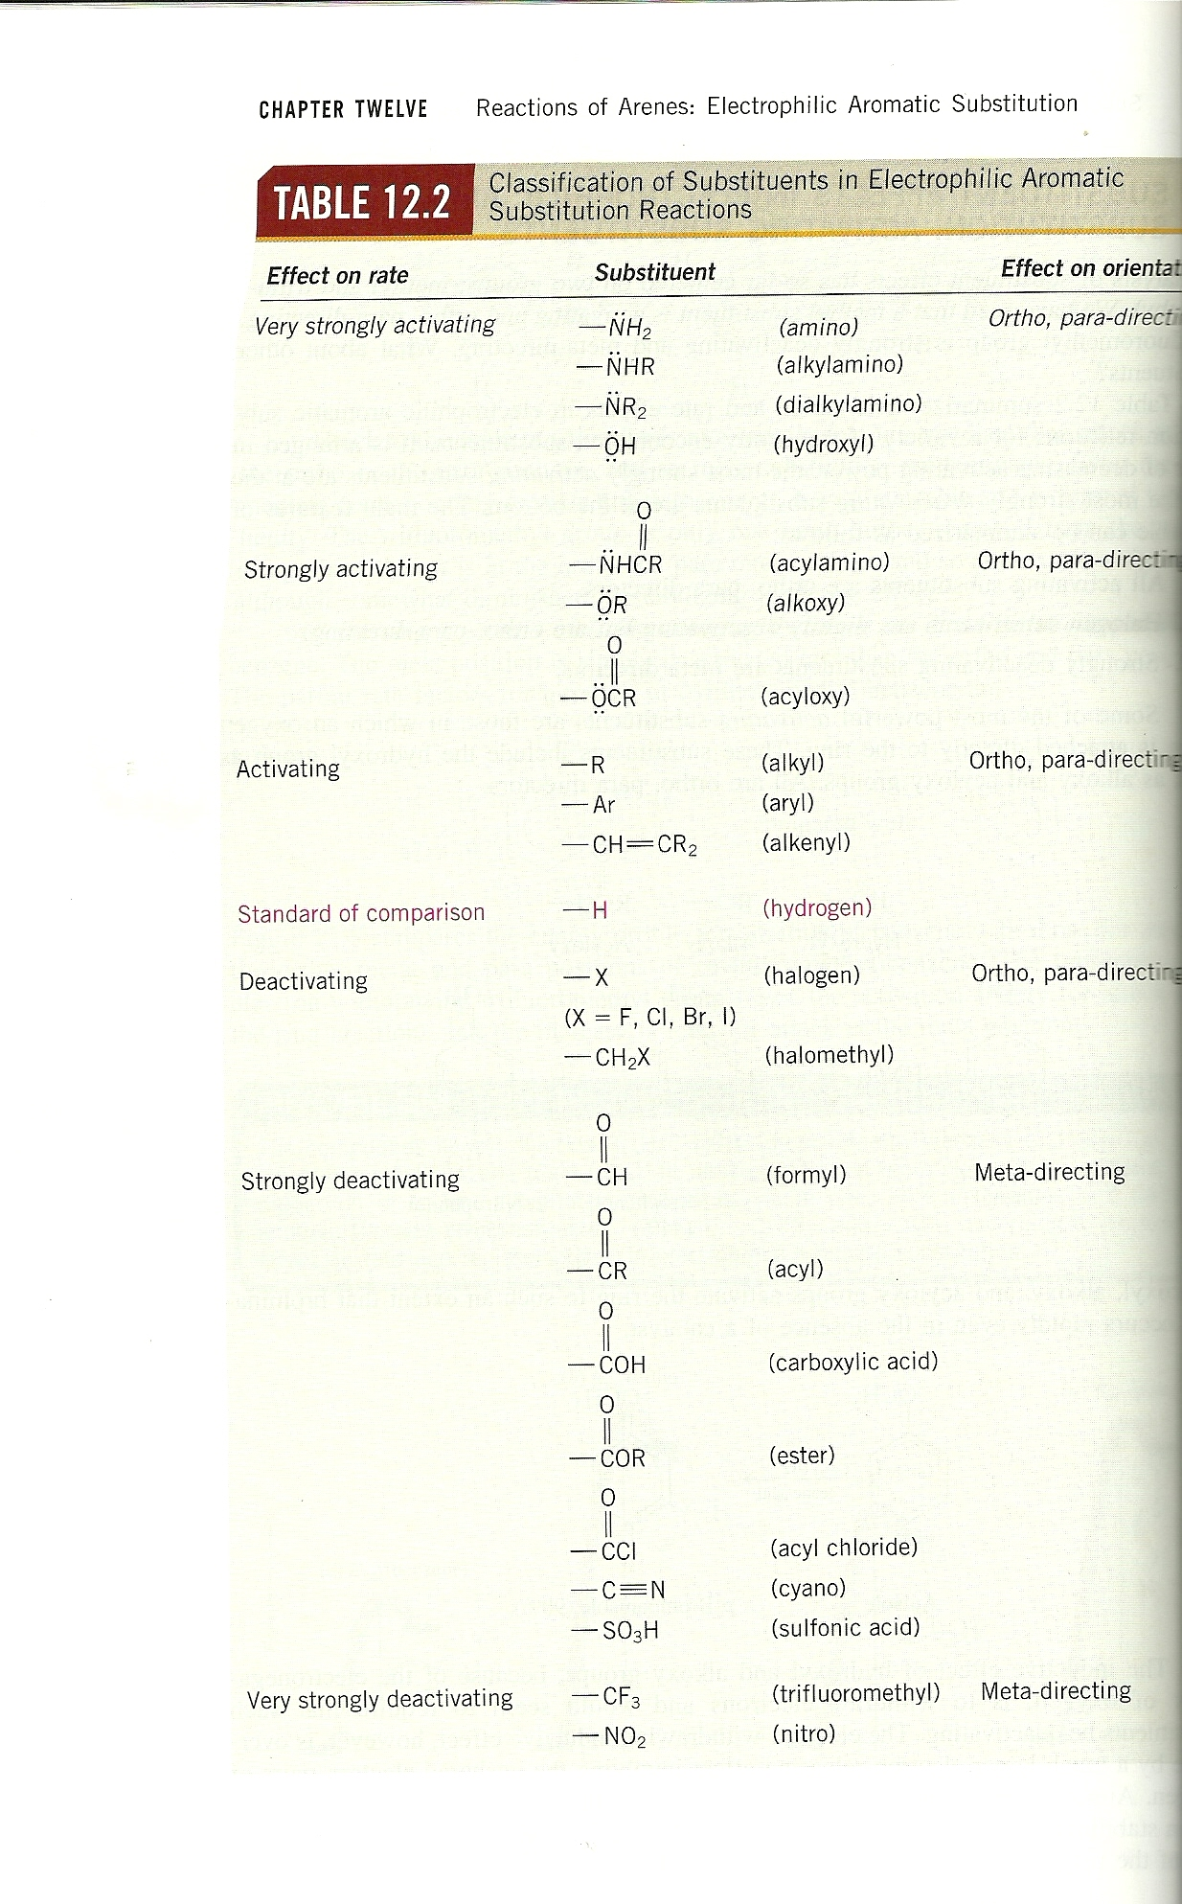
Electron
donating

ors
Electron
withdrawingg

