**2.1. Ring Nomenclature (part 1: 9 pts)**



Provide the name or structure for the compounds below: (3 points each)





3-isopropylbicyclo[3.2.0]heptane _2-methyl-3-(1-methylpropyl)____ 5-methylbicyclo[1.1.1]pentane

bicyclo[3.1.0] hexane_**_________**

**2.2 Ring Nomenclature (part 2: 15 pts )**

a) Provide complete names for the structures below: (3 pts each)







trans (ax,ax) -1,2-dimethylcyclohexane cis (eq,ax)-1,4-dichlorocyclohexane cis (ax,ax)-1,3-dichlorocyclohexane

b) Draw the ring flipped version of the molecule below: (3 pts)



Ring flip



c) Given the structures below:



A B C D

2

1

1. Which structure is most stable ? __D________
2. Which structure can’t exist ? _______A______



1. Given structure B, sketch on diagram to the right

where a 3rd methyl group produces the most stable

ring structure when attached to position 4,

___/24

**2.3. Reaction Enthalpy Calculations (9 pts/ 3 pts per problem)**

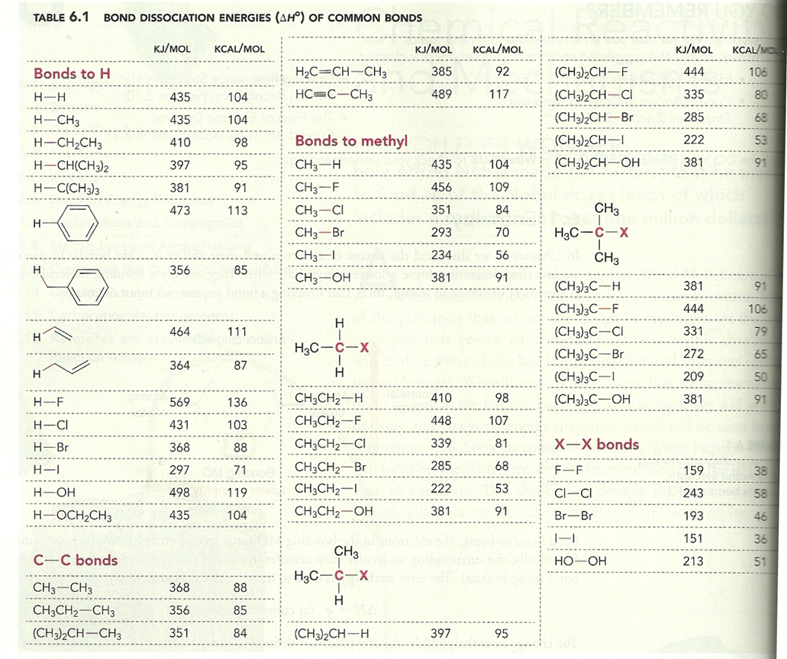

Compute the net reaction enthalpies in kJ/mol for the reactions below using the table above and indicate whether the proposed reaction is endothermic, exothermic or neither. (show work)

1. (CH3)3C-OH + H-OH🡪 (CH3)3C-H + HO-OH __+285____ exothermic endothermic neither

+381 +498 -381-213=+285

1. (CH3)2CH-I + CH3CH2-OH 🡪 (CH3)2CH-OH + CH3CH2-I ___0_____ exothermic endothermic neither

+222 + 381 – 381 -222 =0

1. CH3-F + H2 🡪 CH3-H + H-F _-113____ exothermic endothermic neither

456 +435 - 435 - 569 =-113

____/9

**2.4. Thermodynamics, Kinetics and Reactivity**

1. Label all the indicated positions on the energy diagram below.

Transition state

intermediate

Eact (energy of activation)

ΔG (free energy)

name the axis or time or extent of reaction or progress of reaction

Reaction coordinate

1. Circle the portion of the diagram above that reflects thermodynamic change
2. The plot above most precisely indicates that the process described is (circle your choice)

**Exergonic Exothermic Endergonic Endothermic**

1. Briefly describe Hammond’s postulate (2 pts)

**Endergonic reactions have transition states that look like products. Exergonic reactions have transition states that look like reactants**

Which rate equation (R) is connected to a unimolecular elementary step:

1. R= Eact([X] b) R= k[A][B] c) R= k[A]a[B]b d) R= k[X]
2. An exothermic process often results in a_____decrease_______ in ΔS.
3. Using the four energy diagrams below, answer the following questions:

Potential

**A B C D**

1. Which process(es) are endergonic?____B______________
2. Which process(es) show little net change in thermodynamic potential ?_______C________
3. Which process is likely to be the slowest ?____B_______
4. Which processes are simple, one-step mechanisms ? ______A,C_____

HCl + F- 🡪 HF + Cl‑





ΔS >0 ~0 <0

ΔS >0 ~0 <0

ΔS >0 ~0 <0