Name________________________________________

|  |  |  |
| --- | --- | --- |
| _____/50  Ch 4, 6a | _____/50  Ch 5, 6b | _____/100  Total |

Note: Electron pairs might not be shown. Formal charges are 0 unless indicated.

1. **Ring Nomenclature (part 1: 9 pts)**

Provide the name or structure for the compounds below: (3 points each)

|  |  |  |
| --- | --- | --- |
|  |  |  |
| 3-isopropylbicyclo[3.2.0]heptane | ____________________________  ___________________________ | _________________________ |

1. **Ring Nomenclature (part 2: 15 pts )**

a) Provide complete names for the structures below: (3 pts each)

|  |  |  |
| --- | --- | --- |
|  |  |  |
| ______________________________ | _________________________ | ____________________________ |

b) Draw the ring flipped version of the molecule below: (3 pts)

Ring flip



c) Given the chair structures below:



A B C D

2

1

Which structure is most stable ? __________ Which structure can’t exist ? _____________

Given structure B, sketch on diagram to the right

where a 3rd methyl group produces the most stable

ring structure when attached to position 4,

___/24

1. **Reaction Enthalpy Calculations (9 pts/ 3 pts per problem)**

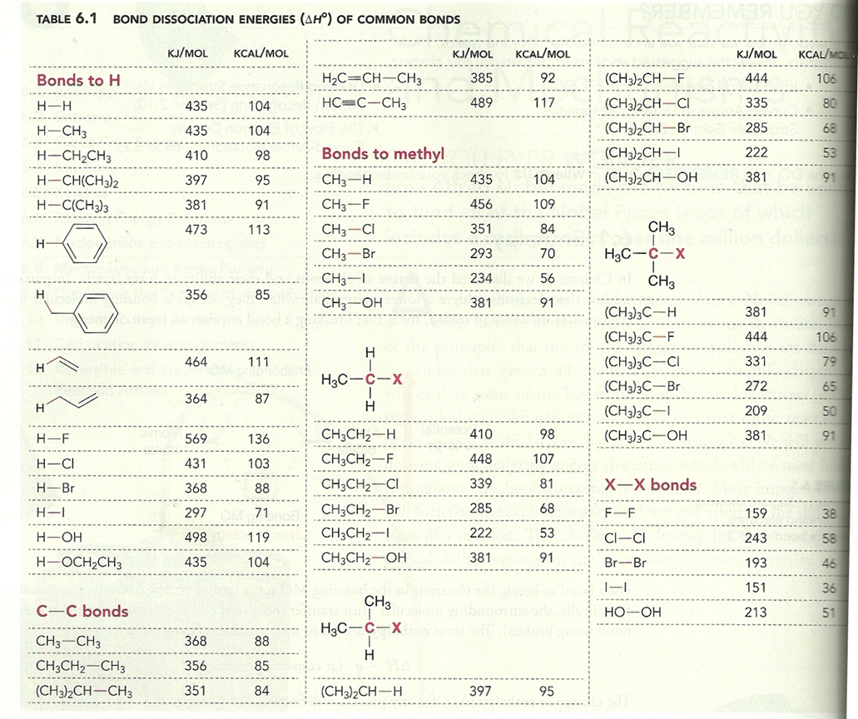

Compute the net reaction enthalpies in kJ/mol for the reactions below using the table above and indicate whether the proposed reaction is endothermic, exothermic or neither. (show work)

|  |  |  |  |  |
| --- | --- | --- | --- | --- |
| (CH3)3C-OH + H-OH🡪 (CH3)3C-H + HO-OH | _________ | exothermic | endothermic | neither |
| (CH3)2CH-I + CH3CH2-OH 🡪 (CH3)2CH-OH + CH3CH2-I | _________ | exothermic | endothermic | neither |
| CH3-F + H-H 🡪 CH3-H + H-F | _________ | exothermic | endothermic | neither |

____/9

1. **Thermodynamics, Kinetics and Reactivity**
   1. Label all the indicated positions on the energy diagram below.

name the axis

* 1. Circle the portion of the diagram above that reflects thermodynamic change
  2. The plot above most precisely indicates that the process described is (circle your choice)

**Exergonic Exothermic Endergonic Endothermic**

* 1. Briefly describe Hammond’s postulate (2 pts)
  2. Which rate equation (R) is connected to a unimolecular elementary step:

1. R= Eact([X] b) R= k[A][B] c) R= k[A]a[B]b d) R= k[X]
   1. An exothermic process often results in a________________ in ΔS.

Using the four energy diagrams below, answer the following questions:

Potential

**A B C D**

* 1. Which process(es) are endergonic?__________________
  2. Which process(es) show little net change in thermodynamic potential ?_______________
  3. Which process is likely to be the slowest ?___________
  4. Which processes are simple, one-step mechanisms ? ___________
  5. For the following reactions, identify if entropy is >0, ~0, or <0 by circling the correct answer.

|  |  |  |
| --- | --- | --- |
|  |  | HCl + F- 🡪 HF + Cl‑ |
| ΔS >0 ~0 <0 | ΔS >0 ~0 <0 | ΔS >0 ~0 <0 |

____/19

|  |
| --- |
| _____/50  Ch 5, 6b |

Name________________________________________

Ch 5 Stereochemistry, Ch 6b Drawing Mechanisms

1. Circle all the chiral centers of the following compound, penicillin. (4 pts)



1. Determine if compound is chiral or achiral, and label meso if appropriate. (3 pts)



1. Identify the configuration of each chiral center and explain your answer (identify the priorities). (2 x 3 pts, 6 pts)



1. Determine the relationship between the two compounds (enantiomers, diastereomers, same compound, constitutional isomers). (4 pt)

|  |  |
| --- | --- |
|  |  |
|  |  |

_____/17

1. Draw the following in a chair conformation (only one form). (5 pt)



1. Identify the alkenes as cis/trans or E/Z, and show the priorities. (4 pts)



1. Identify the Nucleophilic and Electrophilic site(s) in the following compounds. (3 pt)



1. Identify the mechanistic pattern in each of the reactions below. (5 pts)

|  |  |
| --- | --- |
|  | ___________________________________ |
|  | ___________________________________ |
|  | ___________________________________ |
|  | ___________________________________ |
|  | ___________________________________ |

______/17

1. Draw curved arrows to explain the reactions below. It might be helpful to identify the type of reaction first. (9 pts)

|  |
| --- |
|  |
|  |
|  |

1. Identify the most, middle, and least stable carbocations. (3 pt)



1. Predict if carbocation will rearrange. If it will rearrange, draw the mechanistic arrows and draw the product. (4 pts)



______/16