supplement #11: Reaction Of Alcohol to Form Alkyl Halides

**Sn1 And Sn2 Mechanisms**

***Chemistry 3514 Organic Chemistry I***

**11.1. Overview**

We explored our first major synthetic pathway, free radical chain propagation by studying the details of the photoreaction to alkyl halides (RX) starting from alkanes (RH). Here we focus on a second major pathway, often termed the SN1/SN2 mechanism. We do so by studying how to make RX from alcohols, ROH. This will also be our first major lab synthesis.

H2SO4 & heat/reflux

***Example of the overall reaction:*** **C2H5** -**OH + HBr ` C2H5Br + H2O**

(Viewable as an acid/base reaction) “BASE” “ACID” “SALT” WATER

**11.2. The Facts: What the Experimentalists Tell Us**

0. The overall reaction requires acid conditions and some refluxing (heating) to run.

1. reaction rate vs ROH follows the order: 3o > 2o > 1o

2a. For 2o and 3o alcohols, ***only*** the concentration of ROH determines the rate (=>unimolecular)

2b. For 1o alcohols, ***both*** the HX and ROH concentrations determine rate (=> bimolecular).

3a. For 2 & 3o alcohols, rearrangements occur.

3b. For 1o alcohols, no rearrangements occur.

4a. For 2 & 3o alcohols, the identity of X (I, Br, Cl or F) is irrelevant to rate

4b. For 1o alcohols, the rate increases modestly as: I > Br> Cl>F

5a For 2 & 3o alcohols, polar, protic solvents work best

5b. For 1o alcohols, modestly polar, aprotic solvents work best (reverses order of 2 & 3o)

6a. For 2 & 3o alcohols, `racemization’ occurs stereochemical effects described later

6b. For 1o alcohols, `inversion’ occurs.

**11.3. Explaining The Facts: the SN1 and SN2 Pathways**

Since the behavior of the halogenation reaction seems to vary as a function of the alcohol type

(2 and 3o ROH seem to react differently than 1o ROH), two different mechanisms are suggested. Both, however, begin with the acid/base reaction of H+ (often derived from added H2SO4), e.g.:

**step 0 H+ + ROH ROH2+** common to both SN1 & SN2 (see footnote 1)

step **2 & 3o ROH** step **1o ROH**

1a ROH2+ R+ + H2O **slow** 1 ROH2+ + X- RX + H2O **slow**

primary carbocation

1b R+ ------> R+ (rearranged) fast

2 R+ + X- RX **fast**

**SN1 mechanism SN2 mechanism**

(**S**ubstitution **N**ucleophilic **Uni**molecular ) (**S**ubstitution **N**ucleophilic **Bi**molecular)

1The text assumes (in my opinion, erroneously) that the H source in step 0 is HX, but this is plausible only if non-aqueous media are used. For an SN1 mechanism, the generic H source implied in my step 0 is more sensible, since water may be the likely solvent . HX dissolves easily in this and other polar solvents, making it unlikely that HX will be sufficient concentration to attack ROH directly.

*Supplement 11: SN1 vs SN 2 (cont) chemistry 3514 alfred state college*

**An example of a `rearrangement’**



**11.4. Visualizing the Mechanisms: Activated Complex Pictures**

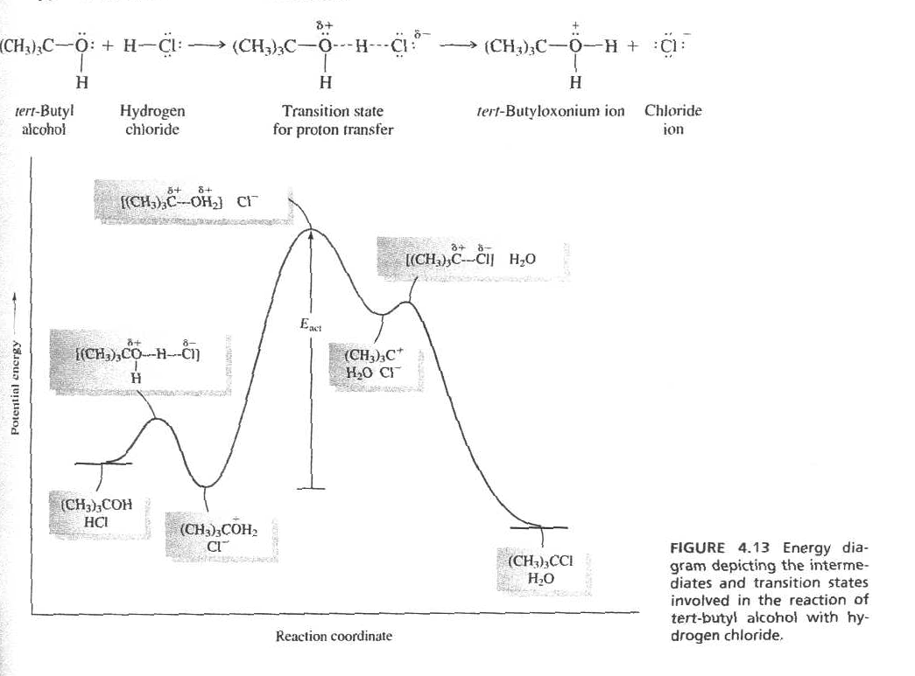

**The SN1 (CARBOCATION) Picture for 2 & 3o Alcohols**

*Supplement 11: SN1 vs SN 2 (cont) chemistry 3514 alfred state college*

.....slow, rate determining

X- +OH2

energy

*five coordinate transition state*

*reversible*

*protonation Activation Energy Diagram of Acid-Catalyzed SN2*

ROH2+  (-H2O)

ROH (+X-)

(+H+ ) RX

reaction coordinate--------->

**The SN2 Picture for 1O Alcohols**

Some other details regarding SN 1 and SN 2

A) Bigger R groups for 1o slow the reaction (a `steric’ effect)

B) The reaction rate reverses again at methane, a 0o C, so the variation of rate looks so

**reaction**

**rate**

SN1 SN2

3 2 1 0o