**Liquid-Liquid Extraction:**

**Separate and Not Equal**

**1. Introduction**

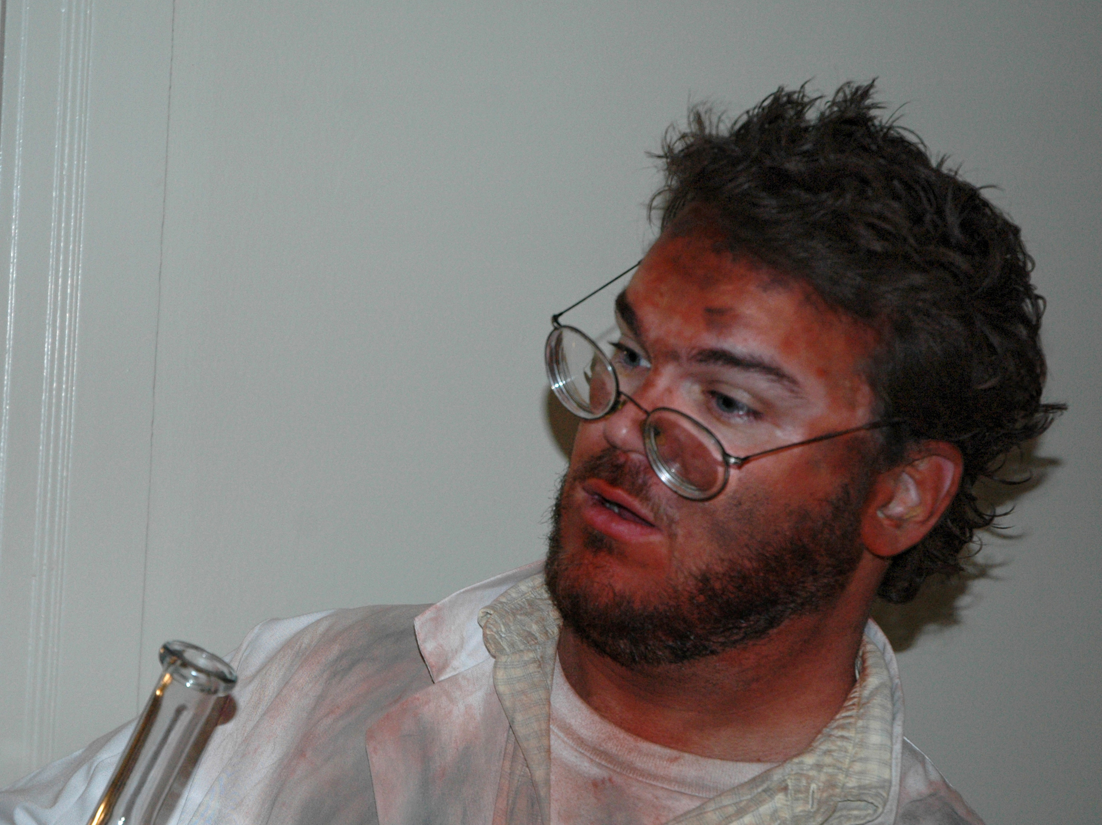

As it turns out, your lab partner, Bubba, is an idiot.

You weighed out 1.0 gram of pure, solid acetanilide (see **Figure 2**) when Bubba (who came in 18 minutes late and has again read the wrong lab) erroneously thinks he needs to sprinkle 1.0 gram of solid benzoic acid on your sample and does so while you were on a much needed bathroom break.

Both you and your lab instructor are, predictably, furious. Worse, the instructor informs you that the sample of acetanilide you weighed out is all you’re going to get.

*“…And don’t leave Bubba unattended again,”* she snarls.

Since the experiment using the acetanilide is a biggie worth tons of points, you need to figure out how to undo Bubba’s boo boo or risk flunking lab.

**Figure 2: What Bubba managed to**

**mix together**



*Acetanilide Benzoic acid*



**Figure 1: Bubba after yet *anothe*r**

**unfortunate lab boo boo**

So what to do (besides beating Bubba into meat pudding)? The answer is actually beautifully simple and the focus of the technique you explore this week in lab: **liquid-liquid (also called solvent) extraction.**

**2. Liquid-Liquid Extraction: The Basic Idea sans Icky Numbers**

**Yay!**

**No math !**

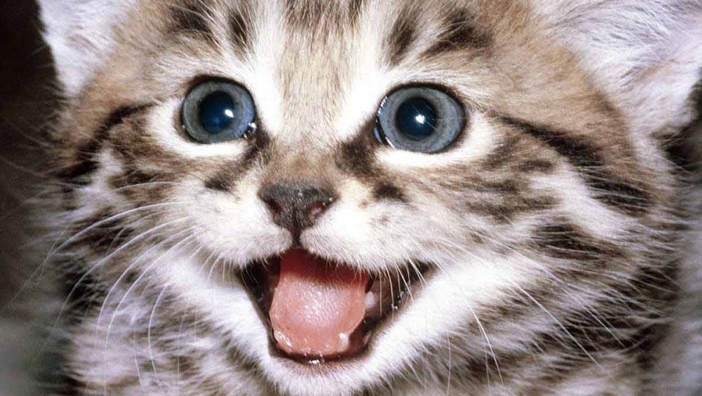

Molecules are racist.

They tend to associate and aggregate only with other molecules that are much like themselves and both push out and segregate those not like them from their neighborhood.

You can witness how this molecular scale social engineering plays out by mixing corn oil and water, two materials clearly not on the same page. As seen in **Figure 3,** neither water or oil want anything to do with each other. They immediately split up into their separate enclaves. This bigoted behavior reflects one of the oldest rules of thumb in chemistry: “***Like dissolves like,***” or, in even more obvious language (duh): **“*oil and water don’t mix.”***  That water lives downtown and oil

uptown reflects their densities (water: 1.00 g/mL, corn oil: 0.93 g/mL.). The less dense oil floats on top of the denser water.

A mismatched pair of neighbors indeed.

But mutual immiscibility does have its advantages. Let’s consider another mismatched solvent pair, methylene chloride, CH2Cl2, (d=1.33 g/mL) and

water, H2O, (d=1.00 g/mL). Just like our oil and water

s

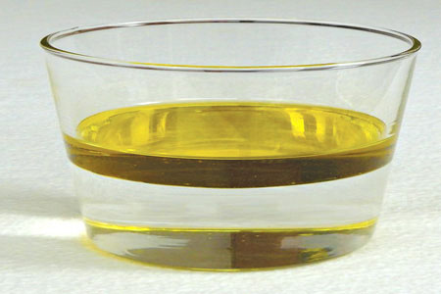

**Figure 3: Corn Oil and Water**

scenario, these two solvents lie far apart in character. Water is small, fleet of foot, very polar, and possessed of H-bonding interactions. Methylene chloride is fat, lumbering, not very polar, and can’t even spell H-bonding.

They completely don’t get along. The arrow in **Figure 4** show the demilitarized

zone between the two solvent ghettos (which is a bit hard to see since both liquids are colorless and clear.) This time the denser CH2Cl2 is downtown.

Now, suppose you accidentally drop something into the water that really doesn’t want to be there, like I2. I2 is entirely non-polar, fat, and worse yet, a molecule of color. (Ok, ok I’m pushing the social analogy a bit too hard…but you get the idea.)

**Figure 4: CH2Cl2 and Water**

H2O

CH2Cl2

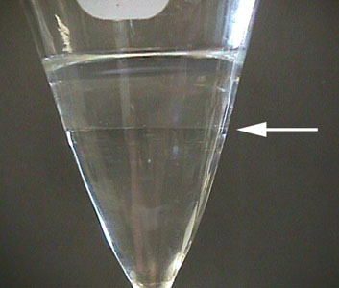

You can see what this means visually in **Figure 5**, where the

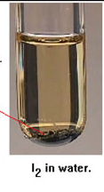

obese I2 can be seen not socializing much with folks in buff,

color-free, water land. As indicated by the red arrow, much

of the I2 refuses to even mix as evidenced by the crystalline

I2 hunkered down at the bottom of the test tube in sullen

protest**.**

Let this unhappy mixture come in contact with the

CH2Cl2 however, and it’s love at first sight. The

Halogen-rich, fat methylene chloride molecules view I2 as a long lost first cousin and open their chemical arms to its’ brethren in warm welcome.

**Figure 5: I2 in Water**

As seen in **Figure 6**, after a quick shake of the separatory funnel, I2 has eagerly moved out of the water to settle and hang everywhere with CH2Cl2.

If we now mechanically drain the bottom layer we have extracted the I2 from the water and can even recover the I2 as solid by evaporating off the CH2Cl2.

Such separation cuts both ways. Suppose something ionic, like table salt (NaCl) gets dumped in with the I2 now happily wallowing in CH2Cl2.

NaCl detests organic solvents, displaying a real ionic

bigotry towards all things carbon. But water, now there a molecule NaCl would willingly be pals with.

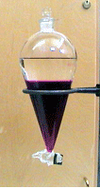

**Figure 6: Separation of I2 from Water into CH2Cl2**

CH2Cl2 from I

**Figure 7** pictorially illustrates what happens if the I2 + NaCl solution of CH2Cl2 is exposed to water and briefly shaken.

**Figure 7: Schematic of Separation of I2 + NaCl in CH2Cl2-Water Mixture**



“*psst..*

*organic solvents suck!”*

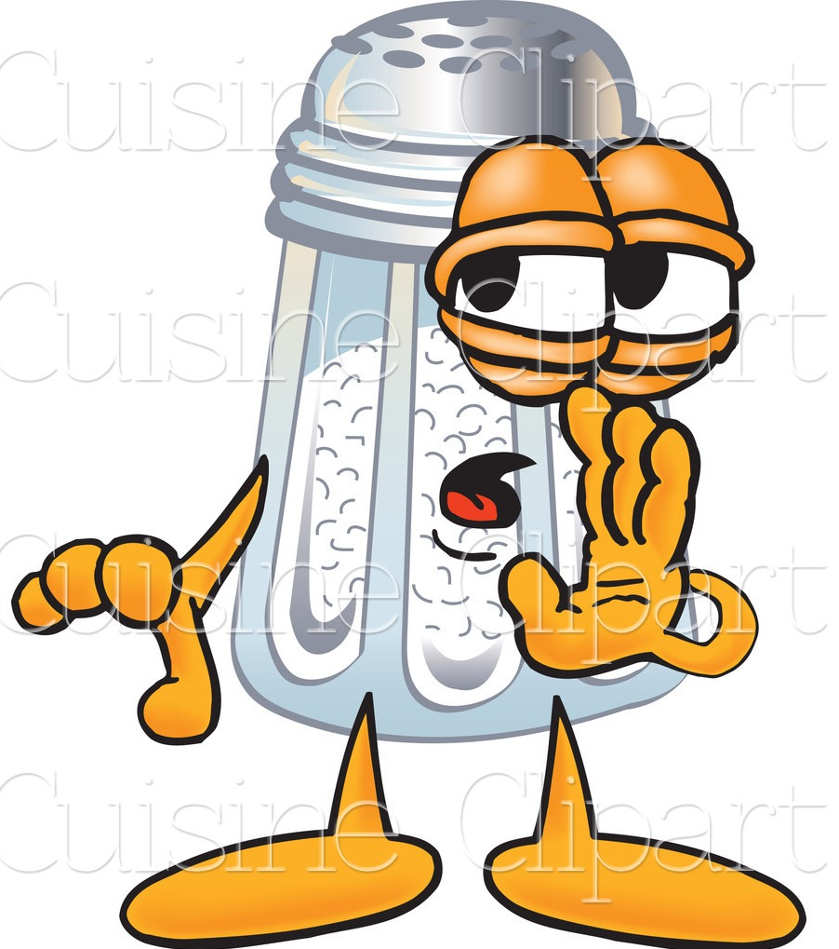

**NaCl**

**I2**

**water**

**CH2Cl2**

NaCl and I2 quickly part ways with NaCl moving uptown and I2 going back downtown. We have now separated two species and with little more than a quick shake of the water/CH2Cl2 mixture.

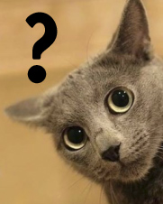

**3. Can We Now Solve the `Bubba Boo Boo’?**

The slick separation described above might offer a

way to fix Bubba’s dumb mistake.

But there’s a problem.

Recalling the structure of the acetanilide and benzoic acid (see **Figure 2**) you can see that the largest piece of both molecules is the non-polar phenyl ring. So both are likely to prefer living downtown with mildly non-polar CH2Cl2.

Now you might initially object. Benzoic acid is, after all, an acid. It should ionize. But benzoic acid is a wimp of an acid. A 1.0 molar aqueous preparation gives up less than 1% of itself as ions at room temperature. Like I2, benzoic acid in water would rather sulk at the bottom of a beaker un-dissolved.

But what if we sex-changed benzoic acid with a strong base, as shown in **1** below?

Side Notes

acid =benzoic acid pKa =4.2

conjugate acid =H2O pKa = 14

weaker acid (higher pKA ) always favored





**1** + Na+ OH- 🡪 + H2O

Now we’re talking. We’ve `salted’ out the acid using a strong base and turned it into a highly water soluble ionic compound, sodium benzoate, the conjugate base of the acid. Incidentally, we could have done the reverse trick with the acetanilide by adding a strong acid like HCl, since acetanilide is a weak base. (Hint: see Post Lab HW4, p. 114 of your lab manual.)

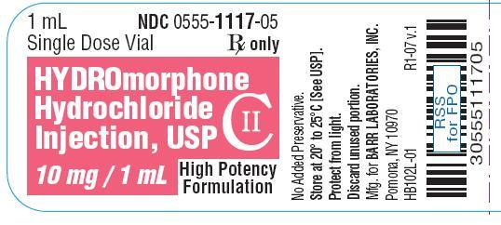

FYI- lots of amide-based drugs, both legal and illegal, are

so treated to make them soluble in water (and easily

accessible to your druggie blood stream.)

But let’s stick with **1** for now and maybe do drugs later. Maybe.

We proceed by placing Bubba’s mistake, the acetanilide and benzoic acid mixture, into a beaker (or a sep funnel) and add ~ 25 mL of CH2Cl2. Once both components appear dissolved, we mix in about 25 ml of 1 M NaOH (~0.025 mol), which is more than enough to completely titrate out 1 gram of benzoic acid (= 0.0082 mol). Stirring (or gentle shaking) will be necessary since –as we already know- water and CH2Cl2 don’t mix well.

Eventually, two layers will appear. The upper layer will contain water, sodium benzoate (and un-reacted NaOH). The lower layer will contain just acetanilide and CH2Cl2. By mechanically separating the two layers, we parse the benzoate salt from the acetanilide and can recover the latter by distilling off the low boiling CH2Cl2.

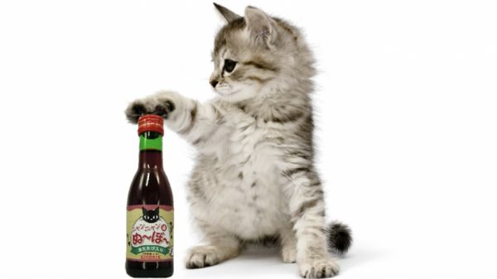

Game over! **Beer time!**

Well, almost. Your parsimonious instructor

wants the benzoic acid back too. Now what?

Recall that we made sodium benzoate by adding a base to benzoic acid, creating the conjugate base of the benzoic acid, sodium benzoate. So why not put the acid-base car in reverse and add a strong acid (HCl) to the benzoate? As seen in **2**, this returns the benzoate salt back to its original benzoic acid source. Since benzoic acid is essentially insoluble in water, it falls out of aqueous solution like a dead cat from a tree and we can filter it out and dry the solid benzoic acid.





**2** H+Cl- + Na+Cl- +

[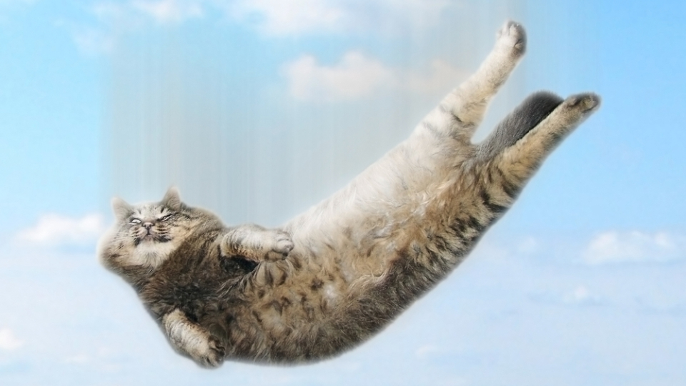](http://www.google.com/url?sa=i&rct=j&q=&esrc=s&source=images&cd=&cad=rja&uact=8&ved=0ahUKEwjuo_39xcfTAhVr4oMKHVRhC3sQjRwIBw&url=http://www.whitewolfpack.com/2012/03/why-cats-can-survive-falls-that-would.html&psig=AFQjCNF3LSNnaS6hiYX5Ls4eMpSCPBIPAA&ust=1493482352197687)

Now, **beer time**! Bubba buys.

4. **Liquid-Liquid Extraction: Numeric Details**

**NO !**

**I hates**

**math!**

[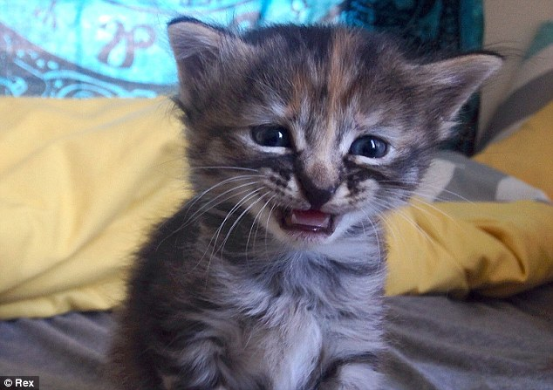](http://www.google.com/url?sa=i&rct=j&q=&esrc=s&source=images&cd=&cad=rja&uact=8&ved=0ahUKEwi46urEx8fTAhVq3IMKHVL0CsUQjRwIBw&url=http://www.dailymail.co.uk/news/article-2685136/Move-Grumpy-Cat-Meet-kitten-no-purrrmanently-sad.html&psig=AFQjCNGjPR7yHP8tgoFH9kyToMuUagPDhA&ust=1493482884316205)

Ok. I lied. Molecules aren’t complete racists. As it turns out

even the most bigoted molecules can stand being around

molecules from different cultures at least a little. One way

to quantify molecular tolerance is the partition coefficient, **k.**

(see page 101 of your lab manual), which, continuing the racial

theme, can be thought of as the apartheid coefficient.

The **k** measures the ratio of a solute’s concentration in two solvents which themselves don’t socialize at all, like water and methylene chloride. To make things more concrete, we’ll define **k** for a substance (call it Bob) distributing between these two solvents using **3**:

**3** **k** = **solubility of Bob in CH2Cl2 (g/mL)**

**solubility of Bob in H2O (g/ml)**

Now if Bob is something like acetanilide, we really don’t need to worry about **k**. It’s essentially **∞**: every bit of acetanilide ends up in CH2Cl2. Conversely, if Bob is sodium benzoate, **k=0** and everything ends up in H2O. Major racists.



But what if Bob is *sort* of soluble in both? Suppose Bob is phenol, a white, slightly volatile crystal at room temperature.

Now, Bob has an OH like water, but also an organic end in the phenyl group. This means Bob can probably stomach hanging out with either water or CH2Cl2.

To see what this means for how we decide to separate it out using CH2Cl2 and water, let’s assume we have a 200 mL solution of water containing 2 g phenol. We want to get it out of there and into the methylene chloride. Suppose the relevant (fictitious) solubilities making up **k** for phenol in CH2Cl2 and water are:

**4** **k**= solubility of phenol in CH2Cl2 (g/mL) = 3 g/100 mL CH2Cl2 = 3

solubility of phenol in H2O (g/mL) 1 g/100 mL H2O

Now, since your chintzy lab instructor has restricted you to a maximum of 50 mL of CH2Cl2, do you use it all at once and try to get the phenol out in one fell swoop?

(**Plan A**).

Or, do you incrementally step your way to final separation by washing the 200 mL water sample containing phenol several times with say, four 12.5 mL volumes of CH2Cl2? (**Plan B**). (See also, the guided practice calculation on pg. 101-2 of your lab manual for another example of this.)

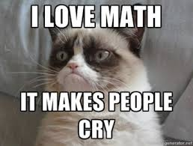

The only way to know is to do the math.

**4.1. Plan A: One big wash**

Let’s define x as the grams of phenol ending

up in the CH2Cl2 layer. That means 2-x grams

will remain in the water layer. Let’s plug these into **4** along with the relevant volumes [V(CH2Cl2) = 50 mL; V(H2O)=200 mL].

One big wash: **k**= 3= (x/50)

(2-x)/200

Doing the math, x=0.86 g which is ~43% of the initial phenol in the water.

**4.2. Plan B: Four little washes**

We’ll need to do 4 calculations using the results from each one previous to continue forward. We’ll generate four x values, x1-x4, representing the x extracted in CH2Cl2 for each 12.5 mL wash. Here, the amount of phenol remaining in the water for each succeeding wash is reduced by the amount extracted previously into CH2Cl2. The sum of the x represents what we separate in total in CH2Cl2.

The first wash: **k** = 3= x1/12.5 => x1 = 0.32 g

(2-x1)/200

The second wash:  **k** = 3 = x2/12.5 => x2 = 0.26 g

(2-0.32-x2)/200

The third wash: **k** = 3 = x3/12.5 => x3 = 0.22 g

(2-0.32-0.26-x3)/200

The fourth wash: k=3= x4/12.5 =>x4 =0.19 g

(2-0.32-0.26-0.22-x­­4)/200

Summing x1 +x2 +x3 + x4 we separated a total of ~ 1.0 g phenol or 50% of the initial phenol in the water.

**No !!**

Alas, neither **plan A** or **plan B** gets all the phenol out, but the ’lots of little washes‘ approach is clearly better (50% vs 43%)- if more work.

An even a better idea is to find another immiscible solvent pair with a larger **k** for phenol. **Table 1** (and **Figure 8**) shows the computed % of the phenol extracted by either **Plan A** or **B** as we use solvent pairs with bigger **k**. *Now* more beer is in order!

**Table 1: Effect of k on Plan A and Plan B % Separation of Phenol**

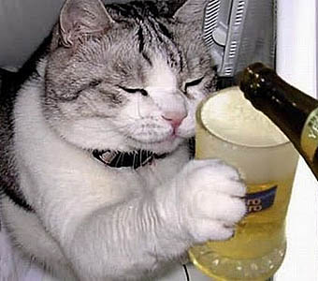

**k Plan A % separation Plan B % separation**

3 43.0 50.0

5 55.5 66.3

8 66.7 80.2

10 71.4 85.7

15 78.9 92.9

20 83.3 96.1

30 88.2 98.5

**Excel is a wonderful thing.**

50 92.6 99.7

**5. Some Practical Notes on Liquid-Liquid Extraction**

**Figure 9: Sep Funnel**

**5.1 Anatomy of Separatory Funnels**

stopper

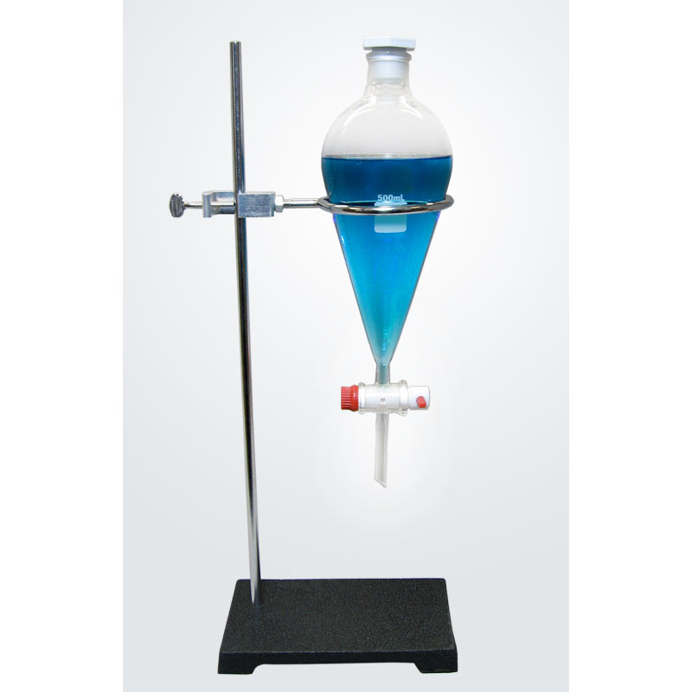

Separatory (Sep) funnels are pretty self-explanatory.

**Figure 9** illustrates a typical 250 mL version with the stopcock turned in the *closed* position (stopcock turned horizontal to table.) It’s common to set the funnel in an iron ring while you’re off fussing with something else. Make sure the ring’s diameter is smaller than the fattest part of the funnel body. The iron ring diameters vary a lot.

Several kinds of stoppers are commonly found here at Alfred. They’re shown in **Figure 10**. Glass stoppers need silicone grease to be liquid tight. Teflon stoppers (white one on far right of **Figure 10**) usually don’t.

body

stopcock

liquid exit channel

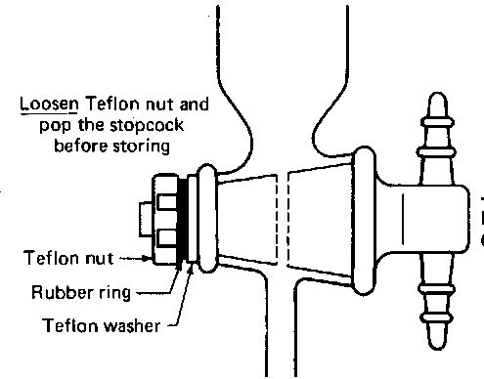tap

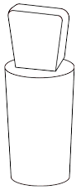

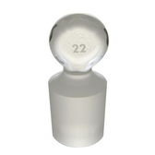

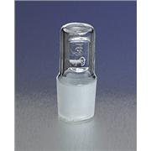

C:\Users\fong\AppData\Local\Microsoft\Windows\Temporary Internet Files\Content.Word\stopcock.jpg

funnel tip

**Figure 10: Common Stoppers**

**for Sep Funnels**

**Figure 11: Cross Section of Stopcock**

**in *Open* Position**

A common problem encountered in using the sep funnel is when the funnel suddenly seems ‘stuck’ and nothing comes out. This is often because you forgot to take the stopper out of the top. If you don’t, as the liquid pours out, you eventually create a partial vacuum in the funnel which prevents more liquid from coming out.

Less commonly, you manage to gunk up the **liquid exit channel** (See **Figure 11**) of the stopcock with some solid or gummy junk you managed to get into the funnel. This means you’ll need to pour the contents of your funnel temporarily into a beaker and take apart the stopcock by unscrewing the Teflon nut and removing the white Teflon washer and black Viton rubber o-ring. Then, you gently pull on the tap to remove it. You can de-gunk the exit channel and/or the exit tip using a fine wire or a stream of an appropriate solvent. Once clear put the pieces back in the order shown in **Figure 11**.

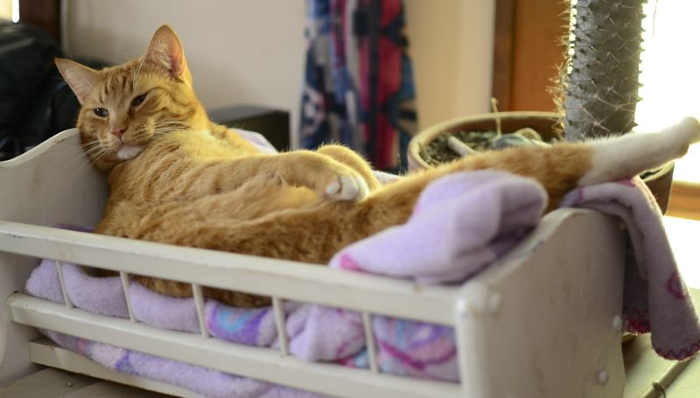

**5.2. Proper Sep Funnel Technique**

I often refer to the proper technique

of using your sep funnel as ***“rocking***

***the baby.”***  Here’s what I mean.

With the stopcock ***closed***, fill the funnel with your mixture. Pick up the funnel, and, just as with handling a real baby, use ***two*** hands. Let one hand hold baby’s `butt’ (the fat end with stopper and neck of the sep funnel body) firmly so that the stopper can’t fall out. (**See Figure 12.**) The other hand will then hold the `head’ end of `baby’ by placing that palm **lovingly just above the stopcock so that the lower glass end of the funnel fits** snugly against your palm. Initially, you hold the baby’s head higher than his butt as shown in **Figure 12**. Make sure the hand holding the butt doesn’t feel liquid leaking past. No baby peeing allowed!

**head**

Also, make sure that the fingers of the hand holding the head can easily reach and twirl the stopcock tap so you can quickly turn the tap on or off.

Point the funnel tip away from your lab partner (and your lab instructor) then ***gently*** `rock’ the funnel back and forth a few times- head up and then down etc. **Do not `shake’ the baby** like some deranged child abuser.

Now `***burp***’ the baby by turning the stopcock tap to open. Reclose, gargle, rinse, repeat until little if any burping occurs (as evidenced by an audible whooshing of gas from the funnel.)

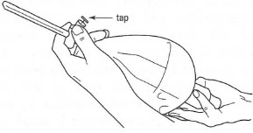

**butt**

**Figure 12: `Rocking the Baby’**

Once you’ve decided you’ve washed enough. Carefully place the funnel back into iron ring, remove the stopper and deliver the lower layer to a flask or beaker. You might need to re-wash either the upper or lower layer by re-rocking and burping the baby, depending on the specifics of your experiment.

I’d like to underscore one more time the need to rock ***gently***. Shaking your mixture like a meth-addicted dog with a dead squirrel can entrap air and create detestable emulsions. Examples are captured in Figures **13A-C** below:

**Figure 13: Examples of Unwanted Emulsions**

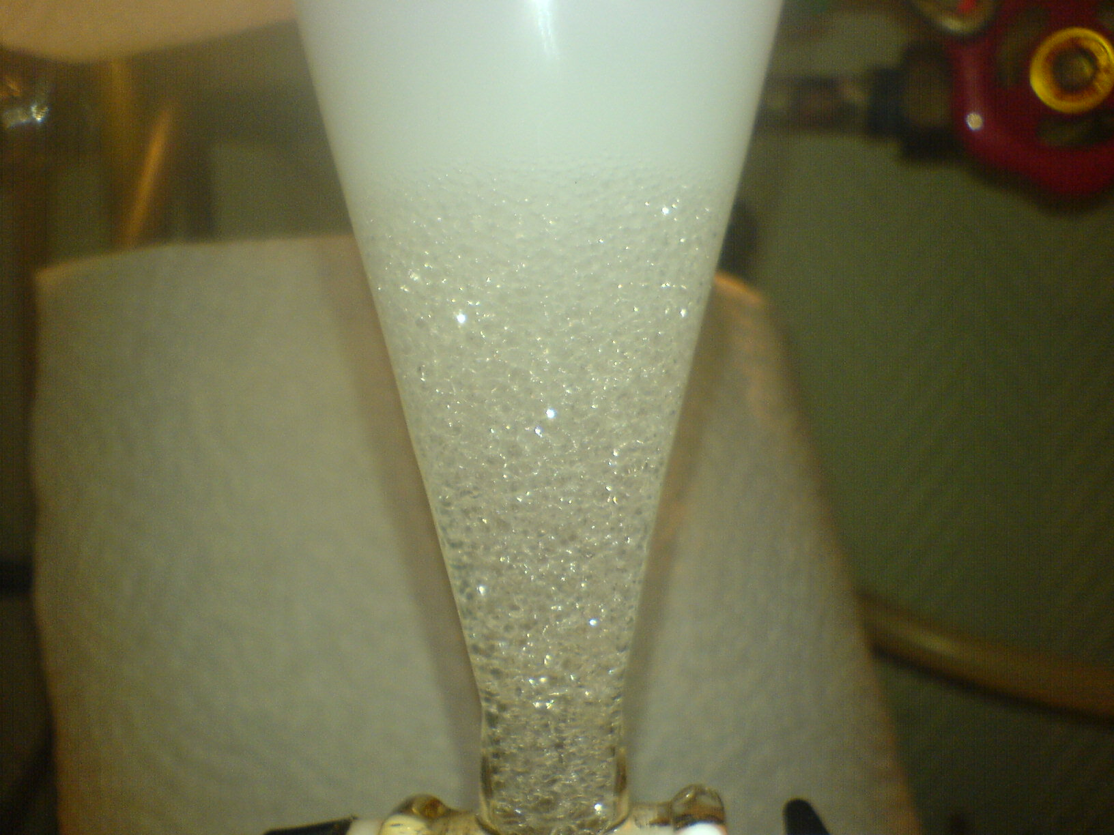

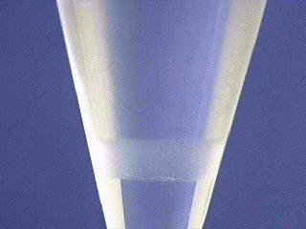

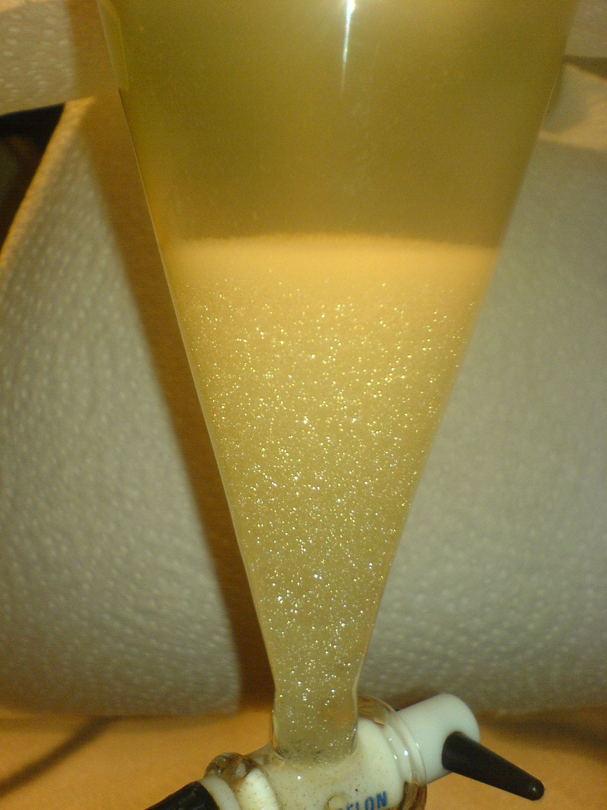

**A B C**

The three examples above range from not awful (**A**) to bad (**B**) to *omg* ugly (**C**). The bubbly, soapy emulsions typically form because the two solvents (or one of the solvents and one of the products) form a spherical bubble with one inside and one outside the (often air-filled) sphere. The foamy appearance is particularly accelerated by overly vigorous shaking. This traps the air in and between the bubbles. The air can make the emulsions seem to expand and grow like something out of science fiction movie.

There are several possible, but not-guaranteed fixes.

(see: <http://chem.chem.rochester.edu/~nvd/pages/tips.php?page=workup>)

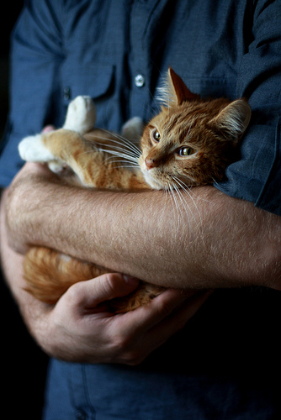

The best idea, though, is to treat the baby with

kindness and gentleness. Rock, don’t shake.

And pet a cat to acquire good karma.