**Polarimetry and Optical Rotation:**

**Observing Twisted Chemistry**

**1. Introduction**

As already discussed in your lab manual’s chapter on **Stereochemistry**,

molecules are divided into two camps: those ***without*** paws (hands), and those ***with***.



Those ***with*** are referred to as ***chiral***.

In Greek, that’s written χειρ, but is

pronounced `kheir’. Unsurprisingly,

this means hand. It just looks more

technical and geeky in pidgin Greek.

***Cat exhibiting chirality***

I would have preferred ***podiality*** since

in Greek paws is written ποδια and pronounced **podia**. Not enough cat lovers among chemists, alas. Anyways, your lab manual has thoroughly covered the models, language and its importance. I’m going to concentrate on something else.



Specifically, how do you observe ***chirality*** in the flesh and out in the wild?

**2. The Main, Measuring Gadget: the Polarimeter**

Like a lot of things in chemistry, just mechanically measuring something is often a whole lot easier than explaining what got measured. So, let’s just start with how we empirically detect the presence of a chiral molecule with the doohickey that does the detecting: the **polarimeter**.

**Figure 1** captures the basic idea. FYI, it hasn’t really changed much in design since 1850 when chemist Jean-Baptiste Biot jiggered up one of the first polarimeters using a candle source to look at things like sucrose dissolved in water and turpentine.

**Figure 1: Schematic of Classic Polarimeter Design**

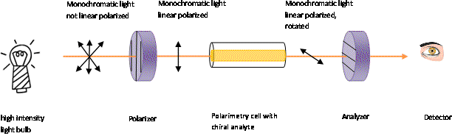

**α**

**B**

**A**

**Na-D line filter**

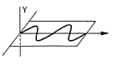

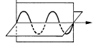

Here’s how it works.

White light from the light bulb (or candle) is first filtered through a ***`Na- D’ line filter*** to produce a single (***monochromatic***) wavelength at 589.3 nm, the color of dandelions (and urine.)

This yellow light, still ***not `linearly polarized’***, is then passed through a `***Polarizer***’ which selects out ***only*** yellow light vibrating in the plane of the page and perpendicular to the direction of the light beam as seen at **A**. Now it’s ***linearly polarized.***

The filtered, ***linearly polarized*** light at **A** next travels down a tube (the ***Polarimetry cell***) filled with a solution of chiral molecules (the `***analyte***’). By the time it completes the trip, the orientation of the light’s polarization has rotated away from the initial orientation at **A** to become **B** because of an (as-yet-to-be-explained) interaction with the chiral molecules. This ***doesn’t*** happen if the molecules ***aren’t*** chiral.

Todetect the rotated light coming out, you pass the light through ***another*** polarizer identical to the first (but called the **Analyzer**) and turn it until the angle it makes with the vertical (defined by the initial ***Polarizer***) matches the angle, **α**, the beam makes with it at position **B**. If **α** is not zero, the analyte is chiral. If **α** = 0, the analyte is achiral.

Note that the `detector’ for all of this is not some fancy,

**No I phone!**

**Just eyes!**





whiz-bang I-Phone app, but the good, old human eye.

In early polarimeters the eye recorded only blackness

or weak light until α was attained by turning the **Analyzer.**

At **α**, however, yellow light blazed forth unfiltered

through the **Analyzer**.

A sketch of what you might have seen in these first instruments if you lived back in 1850 is drawn in **Figure 2**, where we assume **α** = +10.0o .(The `**+**’ means you have turned the Analyzer **clockwise** from the initial perpendicular defined by the **Polarizer.** Obviously then, **‘-‘** means a **counterclockwise** rotation). Here, **θ** is the experimentally adjusted angle between **Polarizer** and **Analyzer**.

**Figure 2: What the Eye Would See Through a Simple Polarimeter vs. θ: α = +10o**



**θ 0o +5o +10o +15o +20o**

The **+/-** sign of the angle **α** is an intrinsic property of any chiral molecule, like maleness or femaleness. Reproducing the limonene molecules from page 70 of your lab manual you can see the (**+/-**) embedded in the names for both.



R-(+)-Limonene S-(-)-Limonene

The R-(+)-Limonene will reliably cause the polarization to twist clockwise in the polarimeter, while L-(-)-Limonene will always make it twist counterclockwise. No sex changes allowed! Be careful ***not*** to assume R always implies (+) and S always implies (-)!

Lactic acid comes in R and S forms too, but their official names, as seen below, reverse the (+) and (-) relative to R and S. The two designations (+,-) and (R,S) are completely independent of each other.

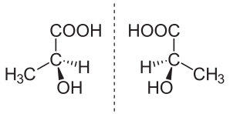

S-(+)-Lactic Acid R-(-)-Lactic Acid

**3. Specific Rotation: αDT**

So far, the angle **α** described above was measured without reference to the experimental conditions of the analyte in the polarimetry cell. We didn’t specify either a concentration, **C**, of the chiral compound, nor how long, **d**, the cell is. But it figures they have to matter. In fact, both change the observed value of **α** in sensible ways.

The higher **C** is, the more the observed angle **α** increases since there’s more chiral material interacting with the light. A longer cell (**d** increasing) also increases the polarization angle since the light spends more time traveling (and twisting) through the analyte.

There’s also the identity of the chiral analyte to consider. Everything else being equal, some chiral molecules twist the tail of the polarized light harder than others. This molecule-specific characteristic, independent of **C** or **d**, is called the **specific rotation**, **αDT,** where the subscript **D** makes explicit reference to the use of the Na-D (589.3 nm) wavelength .The superscript **T** is the reference temperature (usually 20o-25o C) . The specific rotation is obtained from the measured **α** via **1:**

**1** **αDT = α (in degrees) at T**

**d(dm) *C(g/mL)**

(If you don’t remember, 1 dm= 0.1 M=10 cm, which is the usual length of polarization cells.) **Table 1** illustrates the wide range of **αDT** various sugars exhibit.

**Table 1: Specific Rotations, αDT** , **at T=20oC for Selected Sugars1**

|  |  |
| --- | --- |
| **sugar** | **αDT(o dm‑1 mL g-1)** |
| **D-glucose** | **+52.7** |
| **D-fructose** | **-92.0** |
| **sucrose** | **+66.5** |
| **D-ribose** | **-23.7** |
| **lactose** | **+52.3** |
| **L-arabinose** | **+104.5** |
| **L-sorbose** | **-43.4** |
| **maltose** | **+136.0** |

**1CRC 77th edition**

**4. Why Polarization Happens**

[](http://www.google.com/url?sa=i&rct=j&q=&esrc=s&source=images&cd=&cad=rja&uact=8&ved=0ahUKEwicvsKNj9nTAhWI0YMKHXrxAqoQjRwIBw&url=http://amalatul.blogspot.com/&psig=AFQjCNESmGQWqrOtPt45ue3ClH2sPsP1BA&ust=1494086168947038)

If you aren’t curious to explore the details of ***why***

**Noooooo ! Don’t’ do it !**

linearly polarized light gets rotated by chiral

molecules, skip right over this section, loser.

In fact, most Organic texts and lab manuals do

exactly that. It’s really more a Physics thing

and, to be honest, before I wrote these little

Organic technique chapters, I didn’t know ***why***

polarization happened either. But curiosity

doesn’t ***always*** kill the cat (or the student.)

At least, I hope so. Here goes.

Key to the whole business is refractive index, **n**. If you’ve had the right Physics classes you know that **n** is a unitless measure of how much a specific material slows down the speed of light through it compared to vacuum. Succinctly:

**2** **n = c/v**

The **c** is the speed of light in vacuum, and **v** is the speed of light through some substance like glass. The value of **c** is ***always*** **> v**, so **n** is ***always > 1.***

Without going through the proof (leading to Snell’s Law), when there is change in refractive index as light travels through two different media, the difference in indexes causes the refraction effect. It’s what causes part of the pencil in **Figure 3** to appear magically offset in the water versus where it is in the air above.

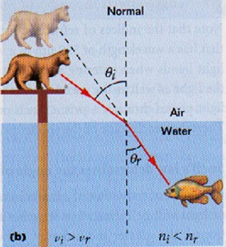



**Figure 4:** **Incident and Refracted Angles of**

**Light Going from Lower to Higher n**

**Figure 3: Refraction Effect**

**Figure 4** shows how the light’s trajectory changes moving from air to water. The ***key idea to grasp*** is that **as the light travels from lower to higher refractive index,** **the light bends towards the normal** to the air-water boundary. Of course, the fish doesn’t know squat about refraction. Her eyes simply follow the light rays she sees back in a straight line, placing an apparent cat ***above*** where the real cat is.

This `bending’ towards the optical normal as light passes from lower to higher index underlies a similar refractive index effect for our chiral molecules.

The above pictures tacitly assume materials without chirality, so the light beam’s polarization remains unchanged whether in air or water. To explain how light’s polarization `tips’ right or left through a chiral substance, it is common to view the original plane polarized light in **Figure 1**, as the **vecto**r **sum** of two perpendicular and `circularly’ polarized (and spinning) components, as drawn in **Figure 5**.

**Plane Polarized Light**

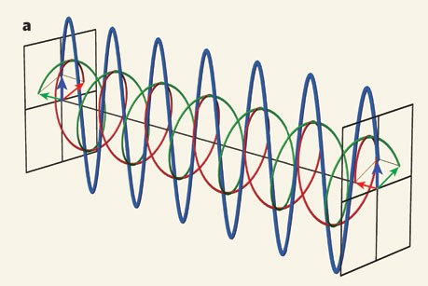

**right handed circular wave**

**left handed circular wave**

**Figure 5: Plane-Polarized Light and Its’ Left handed and Right handed**

**Circularly Rotating Components.**

Now as long as both the **left** and **right** hand circulating waves move with equal but opposite rates of spin around the central axis, their sum leaves the **Plane Polarized Light** unchanged in orientation. This is the situation with achiral media.

But let’s say the light in **Figure 5** encounters a **right handed** chiral molecule going from air into the analyte cell. Just as in the simple refractive index case, the index of refraction for the **right handed circularly polarized light** will be higher than it is for the **left handed circular light**. That is, the **right-handed polarization rotation rate** will spin slower than that of the **left hand polarization**.

It’s sort of like the **right-handed circularly polarized light** is stopping to give high fives to all its’ right handed molecular buddies



as it moves through while the **left handed**

**circularly polarized light** does less of this kind

of fraternizing.

Analogous to the simple refraction effect,

this means the slower rotating (**E+)**

**right-handed polarization componen**t bends

**towards a normal**, defined by the **x** axis

in **Figure 6**.

**Figure 6: Circular Birefringence:**

**Differential Circularly Polarized**

**Refraction**

Since the net magnitude of the plane polarized

light can’t change here, the (**E-**) **left-hand**

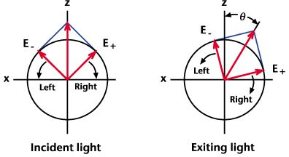

**polarization** gets dragged clockwise as the

**right hand polarization** rotates in positive

direction towards the normal as seen in the

right hand panel of **Figure 6**.

Another way to think about the effect is

to imagine that the two oppositely polarized

circular light waves are like the **left** and **right**

front wheels on a front wheel drive car.

If both are turning at the same rate, then you’ll stay on the straight and narrow

(no polarization). However, if the **right wheel** is rotating *slower*, your car will start to `pull right’ and drag you off the straight and narrow. Likewise, a *slower*, **left-spinning front wheel** drags you left. In physics-speak, the difference in speeds creates a `**phase shift’**, which is a fancy way to express the fact that you just drove off the road into a ditch, or, into an on-coming semi.



The difference in **left** and **right handed** circularly

polarized light’s refractive indexes is called

***circular birefringence*** by we true nerds.

Now, if you’re still with me, and even started to Google stuff about the effect, you may encounter a related but distinct phenomenon involving our **left** and **right handed** circular light components called ***circular dichroism****.*

This is an effect wherein **left** and **right handed** circular light ***absorbs*** in the material differently. If you get into that, then **Figure 6** gets a make-over and ***ellipses*** appear as seen in **Figure 7**. Now, the net linearly polarized light vector **can** change magnitude, unlike the situation in circular birefringence, where no absorption is present so the vector sum stays fixed in length.

You can see that **EL + ER** has changed length

**Figure 7: Circular Dichroism:**

**Differential Circularly**

**Polarized Absorption**

in the right hand panel o**f Figure 7** from its’

initial condition on the left. In this example,

the **right handed circularly polarized**

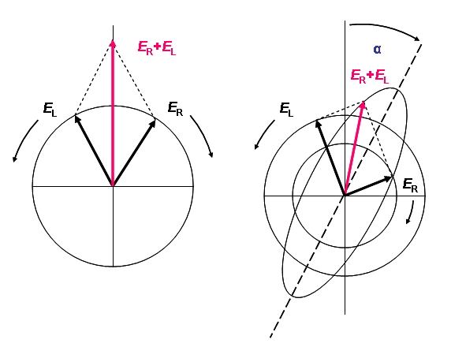

light is being absorbed more than the **left hand**

**circularly polarized** light: **ER < EL.**

What we would see in our polarimeter would,

however, be similar to what we would see with

**circular birefringence,** e.g. a polarization angle

**α≠0** except that the intensity of light at the

**Analyzer** would be reduced, since absorption

is occurring.

**incident light exiting light**

Now if you went ***that*** far into looking things up, you’ve got a serious problem and need help. Take a breath now, then go pet a cat.



**5. Practical Notes on Measuring α**

**Ist sehr gut** !

[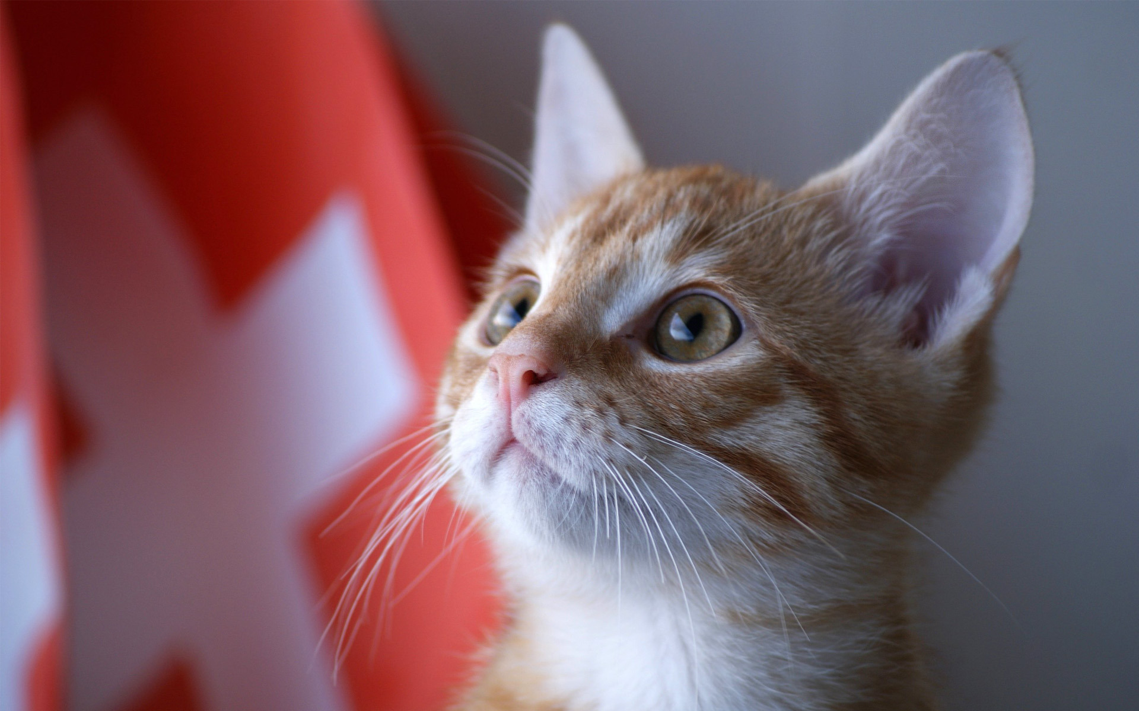](http://www.google.com/url?sa=i&rct=j&q=&esrc=s&source=images&cd=&cad=rja&uact=8&ved=0ahUKEwj_xtju8eXTAhUK6YMKHagEA5QQjRwIBw&url=http://www.zastavki.com/eng/Animals/Cats/wallpaper-28901.htm&psig=AFQjCNGo29dtG91DDPU56Cwx8-Ocqx9LNA&ust=1494525046944709)

Alfred’s lone polarimeter is a venerable device made in the

1960s by the now defunct Swiss instrument company, Kern.

Like a lot of things Swiss, it’s made well. After nearly 60

years, the `zero’ of the instrument is still spot on. The particular design of our Kern polarimeter is a `crossed Nichols’ type, which improves a bit on the optics of the original 1850 design. (More on this later in **5.3**.) **Figure 8** shows our instrument in the flesh.

**Analyzer**

**Figure 8:**

**Alfred State’s Kern Crossed Nichol Polarimeter**

**Adjustable mirror**

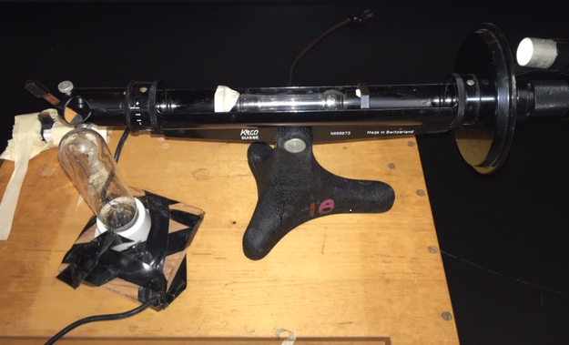

**Polarizer & Na-D filter**

**1.0 dm cell in sample chamber**

**White light source**

**5.1. Filling the Polarimeter Cell**

The standard 1.0 dm cell we use is shown in **Figures 9A** and **9B.**

**Figure 9B:**

**Polarimeter cell assembled**

**Figure 9A:**

**Polarimeter cell parts**

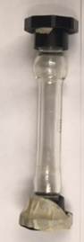

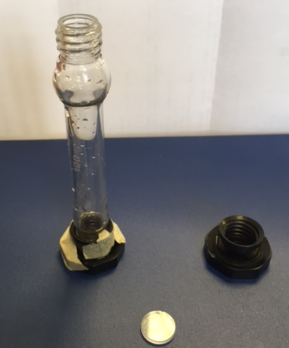

**1.0 dm**

**Threaded cell window cap**

**masking taped end is always left closed**

**Cell window**

The `bottom’ of the cell (masking tape end) is always left closed. The top end is where the **cell window** is placed after the cell is filled with analyte. The **threaded cell window cap** is then carefully screwed over the top to press the window in place.

Filling the cell requires that you ***over fill*** so that a dome of the analyte solution bulges **above** the open cell end. Also, no bubbles should appear anywhere *inside* the cell. Once this is achieved, carefully slide **the cell window** horizontally along the top of the cell, slicing off the dome so that no bubbles appear at the window, then screw the **cell cap** in place. You need a complete column of liquid with no trapped air inside for the polarimeter to see a good image.

**5.2. Setting Up the Polarimeter**

To make a measurement place the source as close as you can to the adjustable mirror (as shown in **Figure 8**) . Next, you have to deal with our `definitely not very safe’ electrical connection to the source. You can see what I mean in **Figure 10**.

**Figure 10: Our definitely not very safe**

**Polarimeter source switch**

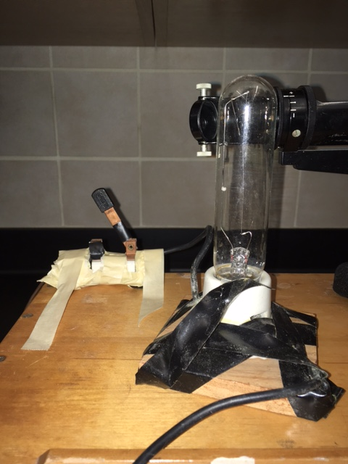

The connection to the source is through

**White Light Source**

an open **knife switch**. I’ve never gotten

around to upgrading it. Tape it down

**masking**

**tape**

where you don’t have much chance of

accidentally touching it while using the

polarimeter (unless you like jolts of AC.)

Plugging it in and closing the switch turns

the light on.

**Open knife switch to AC power**

To get a good measurement requires

that the light through the polarimeter

is maximized.

Here’s how you do it.

Make sure no sample cell is in the sample chamber. Close the hatch to eliminate stray light. Next, turn the **Analyzer rotation wheel** (see **Figure 11**) until the you see the red pointer on the ***bottom wheel*** as you look through the **Vernier** (See **Figure 12**) aligned beneath the big red 0 on the *top wheel* (the **α=0** condition.)

Next, while looking down the polarimeter **eyepiece**, move the **adjustable mirror** at the

front polarizer (and perhaps the lamp) until

the brightest possible yellow light appears across all three panels as seen through the polarimeter **eyepiece**. (See **Figure 13**.**)**

You’re now ready to make a measurement.

**5.3 Finding α**

Put the cell you filled with your chiral solution into the sample chamber and close the hatch with the Vernier angle still set at **α**=**0.** Unless you managed to put in an achiral material, what you see down the eyepiece is no longer

a continuous, yellow field across the three panels.

Your job is now to ***slowly*** and ***gently*** turn the **Analyzer rotation wheel** until you recover that

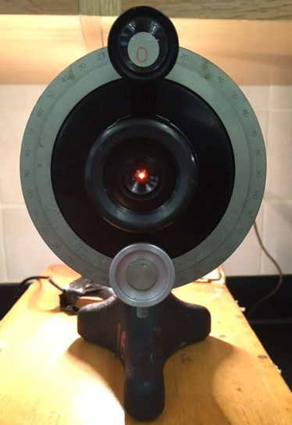

**Vernier**

**Eyepiece**

**Figure 13: View Through Eyepiece at α=0**

**and Maximum Intensity with H2O**

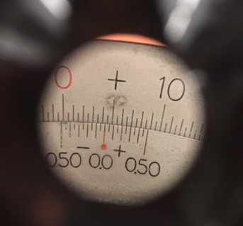

**Analyzer rotation wheel**

**Figure 11: Viewing Portion of the Polarimeter**

**Figure 12: What You See Through the Vernier**

continous and unbroken field.

The particular `crossed Nicols’ design of the Alfred polarimeter helps you achieve this by showing sharp contrasts between the three panels when you ***aren’t*** at the correct polarization **α** (the `***optical zero***’ ) for the sample you’ve placed in the cell.

Examples of when you are either too far negative, or, too far positive of the correct **α** are sketched in **Figure 14**, along with the desired, correct image you should see through the eyepiece. (FYI- it’s rarely as crisp and unequivocal as in the **Figure** below.)

**Figure 14: View Through Eyepiece of Alfred State Cross Nicols Polarimeter**

**Both In and Out of Phase with Correct α1**

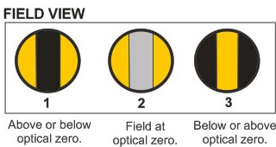

1



**alpha cat happy here**

**5.4. Measuring α**

The **Vernier** eyepiece is where you measure **α.**  We’ll use the example already displayed in **Figure 12**, which for convenience is reproduced in **Figure 15**.

**Figure 15: Measuring α at the Vernier**

First, make sure you know whether you’ve turned the **Analyzer wheel** clockwise (**+**) or counterclockwise (**-**). You’ve got obvious visual clues as seen in **Figure 15**; the red pointer is actually pointing up at `**+**’, hence (duh) you turned clockwise.

Now, count the number of larger *upper hash* marks (which are 1o units) starting from the **red upper zero** to where the red pointer on the lower wheel points. You should count **4.** However, the red pointer



**+4o**

**-0.20**

**+0.30**

is actually slightl*y past* the **4o** hash mark. The smaller, *upper hashmarks* delineate 0.5o units, so **α** in **Figure 15** is somewhere between +**4.00o** and **4.50o**.

To estimate the value more precisely we read the **`Vernier’** scale by matching the ***lower hashmarks*** (which run in both **+0.50** and **-0.50o** directions) to one of the hashmarks on the *upper scale* so that they line up with each other. This can be done on the **+0.50 side** ( ), or, on the **-0.50 side (** ).

If you prefer the **+0.50 side** of the lower wheel to line up the**Vernier**, then you see that from the lower wheel 0.0, the *third* ***large hash mark*** on the **+0.50 side** of the lower wheel lines up best. The ***lower wheel large hashmarks*** are in +0.10o increments, so we add **0.30o** to **4o** and find that **α=4.00o + 0.30o =4.30o.**

Alternatively, if you prefer the **-0.50 side**, the ***lower wheel hashmarks*** on this side line up best with those on the *upper wheel* at the *second* ***large hashmark*** on the

**-0.50 side** of the ***lower wheel*** , which means a **-0.20o** isadded to **4.5o** and we again see that **α= 4.50o -0.20o= 4.30o.** Before digital measurements, this `Vernier’ scale approach to achieve more decimal places was used everywhere.

One more practical note. The most common rookie mistake when measuring **α** is to impatiently turn the **Analyzer wheel** too fast left or right because you want to get it over with and get out of lab early. Don’t rush! The patterns illustrated in **Figure 14** go by deceptively quickly, often over less than a degree.

So, slow it way down, Buckwheat! Our, *observed* **α** rarely exceed ±15o. If you are wandering around the ±(30o-90o) range you have gotten yourself seriously stuck up the wrong tree.



“**Shit.”**