**Infrared Spectroscopy and Gas Chromatography:**

**How Chemists Know `Who Be What?’**

1. **Introduction**

In a perfect Organic world, you’d only synthesize totally pure, solid products with exactly the expected melting points. But in the real world your preparation is rarely pure and you often need to know what else came along for the ride.

?



And what if you’ve made a *liquid,* not a solid product?

Do you have solid(s) dissolved in a liquid, a pure liquid,

a mixture of liquids? How do you identify the components?

These questions were very, very hard to answer in the

19th century, when the only tools you had were a pile of

glassware, a Bunsen burner, dubiously pure chemicals,

and your collective experience and street smarts as a

chemist.

Fortunately, this is the 21st century. With the modern tools we’re going to explore next, you won’t have to split a gut like our chemical forebears to answer the question of: ***`What the hell did I just cook up in the lab today ?”***

1. **Infrared Spectroscopy (IR): A Brief Introduction**

If you could somehow zoom in and watch a single organic molecule with a super duper atomic microscope you’d soon think the molecule was undergoing an unending grand mal seizure.

Molecules are constantly shaking, spinning, wriggling and fidgeting at frequencies in the 1010- 1014 times per second range. It’s like they are permanently high on crack cocaine.

The IR method zeroes in on two classes of these molecular convulsions: 1) **stretching** vibrations and, 2) **bending** vibrations.

**Figure 1** illustrates the two classes for water.  **Stretches** occur when bonds between specific atoms lengthen and shorten around some equilibrium distance at ~fixed angles.

**Stretches** are generally *high*er in energy than **bends**. This make total sense.

It’s a lot harder to pull your arms out of their sockets, than it is to ‘gimme a Y’ bend your two arms like a cheer leader.

The practical IR energy scale, **υ**, is in `**wave numbers’** , with units of **cm-1.**

(See side note below).

**Stretches** occur in the `***diagnostic region’*** of **υ**: 4000-1500 cm-1.

**Bends** occur in the `***fingerprint region’*** of **υ** from 1500 cm-1 – 450 cm-1.

**Figure 3** is a simplified IR spectrum for vapor phase water showing both bending and stretching modes.

**Side Note: Why E is in cm-1**

E/photon =hf ***Planck’s equation in f***

f(s-) *λ(m) =c(speed of light) ***Wave equation for light***

f=c/λ=> E=hc/λ(m) =hc/(λ(cm)*100) ***Planck’s equation in λ(cm)***

Dropping out h,c and 100:

**E /photon ∝ 1/λ(cm) = υ (cm-1)**

**Figure 2: Kinds of Vibrational Bending Modes**

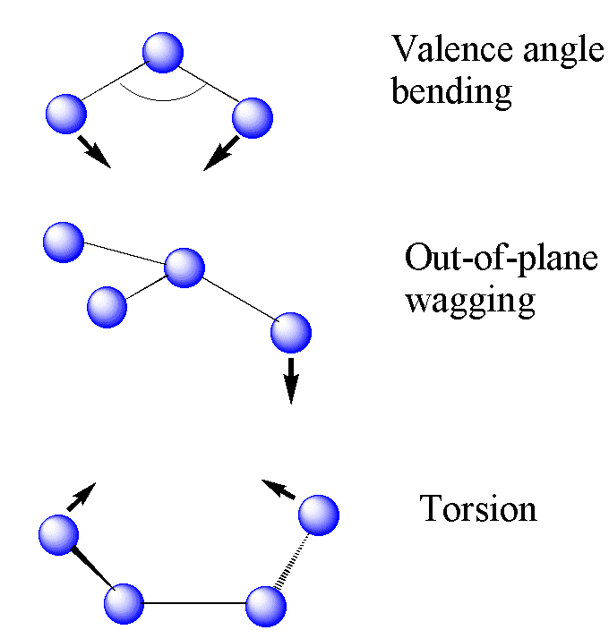

Conversely, **bends** leave the bond lengths alone, but cause angles between atoms to increase and decrease around some equilibrium angle.

With only 3 atoms, water can only do simple bond `valence angle’ bends. But molecules with higher atom counts can bend and pretzel in diverse ways much like a hyperactive yoga instructor.

Some examples of these other kinds of bends are sketched in **Figure 2** .

**Figure 1: Vibrational Modes of Water**

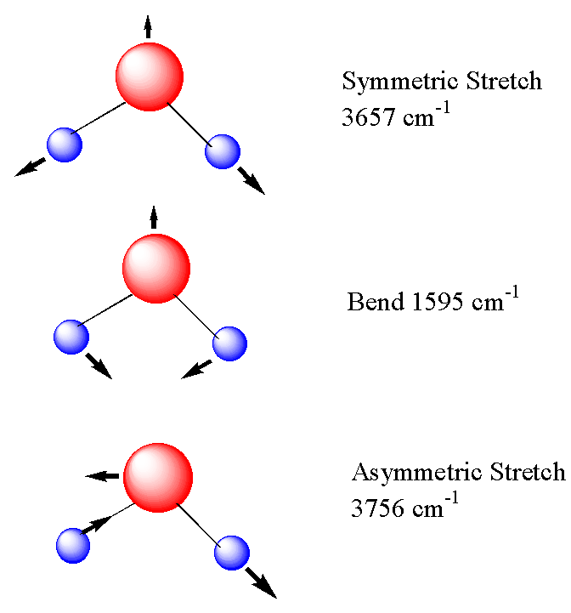

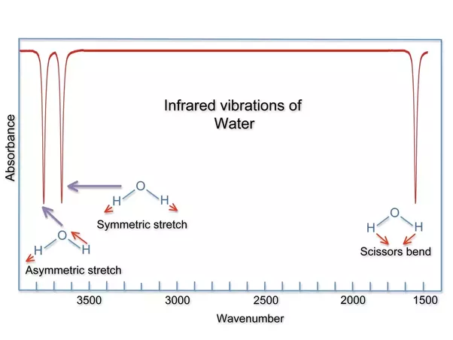

**Figure 3: Idealized IR Spectrum of Vapor Phase H2O**

**%T**

**cm‑1**



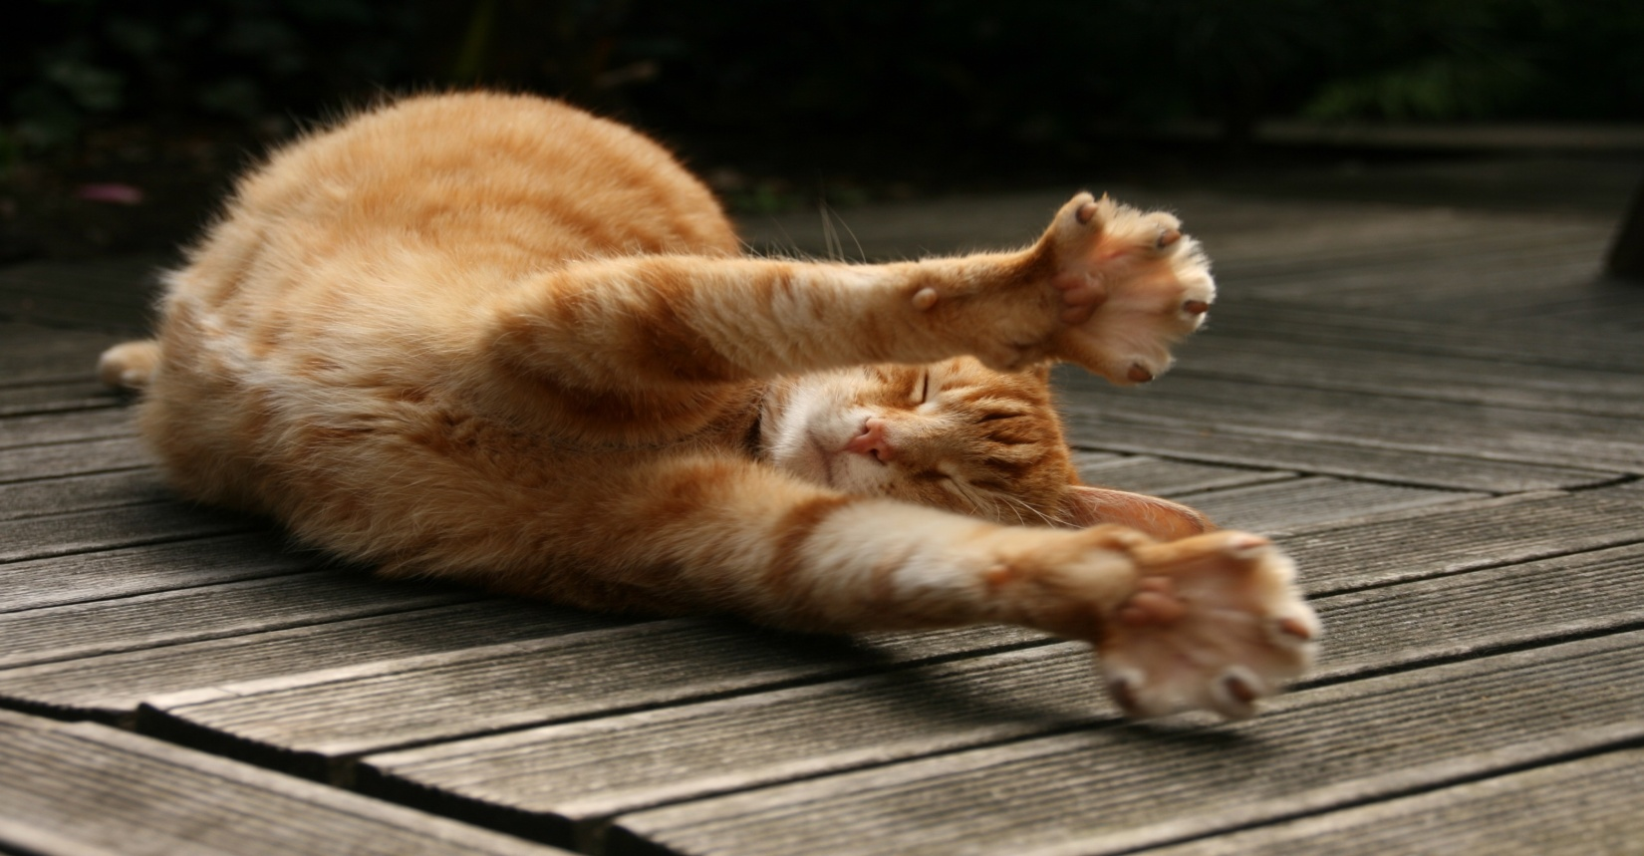

In the above spectrum the `x’ axis is **υ**(cm‑1) . The `y’ axis is in %T which is the percent of the initial intensity Io of IR light that gets through the sample at **υ**, e.g. %T =100*I/Io.

Note that IR spectra are traditionally recorded with the high energy end (**diagnostic region**) of the spectrum on the left and the lower energy (**fingerprint region**) on the right.

The use of the terms **diagnostic** and **fingerprint** region becomes clear when a series of related molecules’ IR spectra are compared. In **Figure 4** below, the IR spectra of methanol, ethanol and 1-propanol taken on one of ASC’s FTIR are displayed in a single plot.

As you can see, the spectra for all three in the **diagnostic region** are pretty much the same. The observed band centered at about 3300 cm-1 is the **O-H** stretching **υ.** It cries out: **me (probably) be alcohol1.** The collection of bands just below 3000 cm-1 are **C-H** stretches where **C** is singly bonded to another **C**. It screams: **me also be aliphatic**. So you can ***diagnose*** the ***functional*** class of the materials in all three to be **aliphatic alcohols**.

1or carboxylic acid or ester.

**Figure 4: IR spectra of methanol, ethanol and 1-propanol taken**

**on ASC FTIR (Carl)**

**fingerprint region**

**diagnostic region**

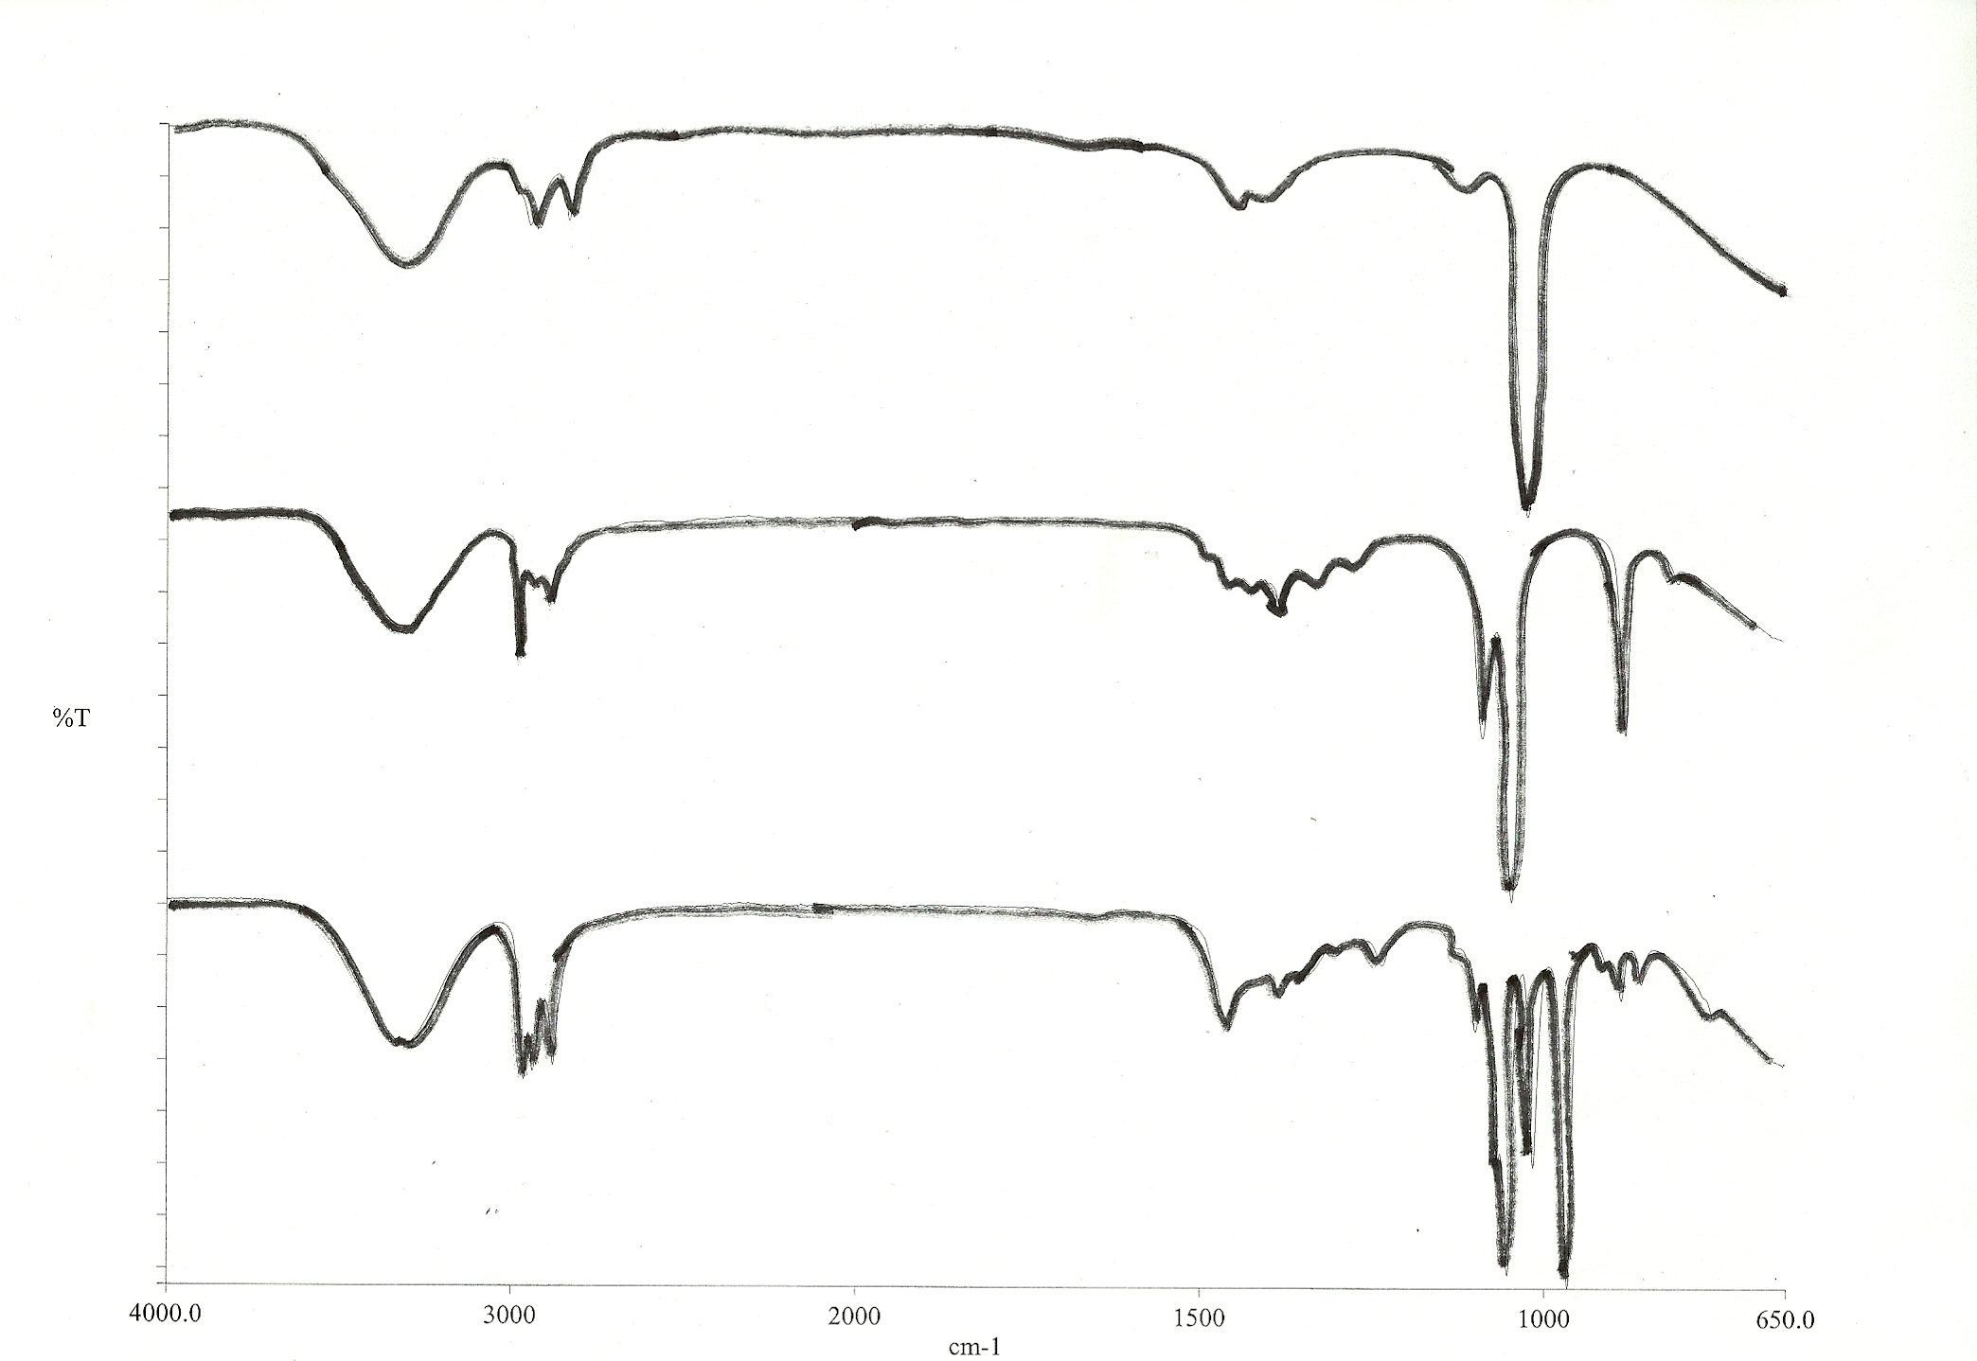

**C**-**C-H**

**stretch**

CH3OH

**O-H** **stretch**

resolution =4 cm-1

5 scans

4000-650 cm‑1

operator=Fong

5/16/17

`Carl’ ATR-FTIR

C2H5OH

C3H7OH

%T

4000 3000 2000 1500 1000 650

cm‑1

To *individually* identify the specific alcohol, though, you need to examine the **fingerprint region.**  Therein the spectral features of the three alcohols clearly diverge and are unique to the compound, just like ***fingerprints*** are for every human on the planet. **Fingerprint** bands are mostly caused by bends.

Your lab manual collects many characteristic functional group band positions on page 120. I’ve found the subset below worth committing to memory. We also have software libraries which can match experimentally observed spectra to library spectra.

**Table 1: IR Band Assignments Worth Knowing**

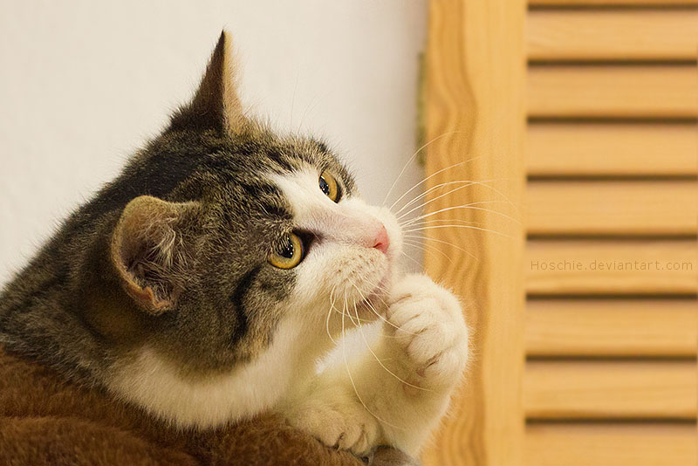

**motion υ(cm-1) shape**

**υ(OH)= ?**

**1700 cm‑1=> ?**

C-**C-H stretch=?**

**O-H stretch 3300-3400 strong, broad**

**C=C-H stretch 3010-3100 weak, sharp**

**C-C-H stretch 2960-2850 strong, sharp multiplet**

**aromatic overtones 2000-1650 very weak, multiplets**

**C=O stretch 1670-1760 strong, sharp**

**aromatic ring breath 1500, 1600 strong, sharp**

**CH2 bend 1430-1460 medium, multiplets**

**CH3 bends 1380-1410 medium, multiples**

1. **Some Practical Notes About IR**

***I gets headache when u calls them machines.***

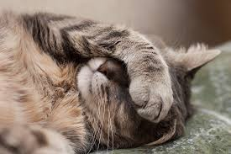

* 1. **The Instruments (not machines, maggots!)**

The ASC instrumentation lab sports three working IR. Two are older Perkin-Elmer (PE) Spectrum 1 instruments and one is a more recent PE Spectrum 100. All three are equipped with a special `ATR’ (Attenuated Total Reflectance) accessory, which is a

godsend since it greatly simplifies the business of sampling both liquids and solids. **Figure 5** is an example of one of our Spectrum 1 instruments with an ATR head.

All three are also `Fourier Transform’ (FT) instruments. That’s both good news and bad news.

The good news is that you can average as

many scans as you want into a single spectrum reducing spectral noise as much as you have time for, making for pretty spectra.

**solid sample pressure arm**

**ATR top plate**

**ATR head**

**Figure 5: PE Spectrum 1 FTIR with ATR**

The bad news is that each instrument is single beam, necessitating a background scan in addition to your sample scan. Since the background can move around with time, you’ll probably need to do one after just running 2-3 samples.

You’ll be shown how to run both a Background and a Sample IR when we’re actually on-site in the Instrumentation lab. It’s mostly just using the resident software to establish run conditions.

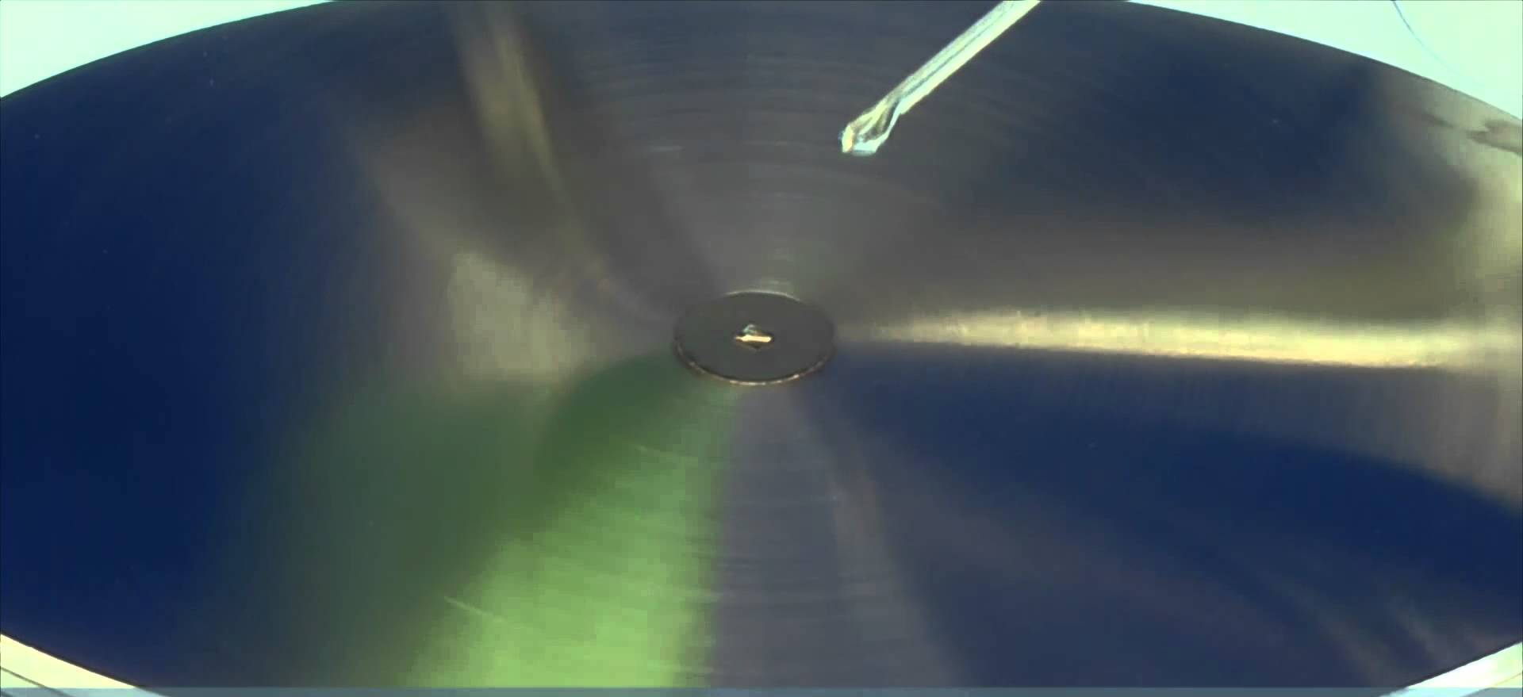

**sample goes here**

The only physical task you do is to place your

sample on the ATR. As indicated in **Figure 6**,

the little circle dead center of the ATR top plate

is where you put your sample drop or sample

powder. There is a small flat diamond crystal

beneath the hole through which the IR is

bounced off your sample and back into the

**Figure 6: Sample Placement on**

**ATR top plate**

instrument as illustrated in **Figure 7**.

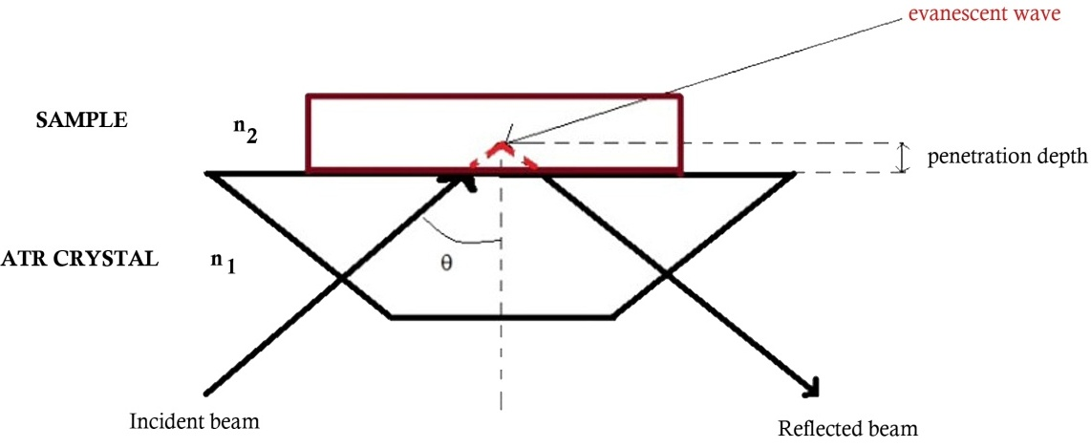

**diamond surface**

**Figure 7: Schematic of a `one bounce’ ATR beam path**

If your sample is liquid, you just need to make sure the drop covers the hole and doesn’t dry up too fast before you click the `*Run*’ button with the mouse.

If your sample is a solid, make sure you’ve ground it up in a mortar and pestle to produce a finely divided powder. Spoon a little over the sample hole and place the ***top cap*** of the ATR over your sample. (See **Figure 8.**) Align the ***solid sample pressure b*ar** (see **Figure 5)** so that the pressure bar’s pressure nib fits snugly into the cap well. Click on `***Monitor’*** and a green bar indicating the pressure being exerted on the top plate appears. Turn clockwise until the bar reads between 70-80. You can then run your IR scans.

In both cases, do not leave your sample on the sampling hole, maggots! Clean it up carefully by gently brushing the powder into a beaker, or, wipe the liquid away with a Kim-wipe and wash the surface with some acetone, which you also gently wipe away.

* 1. **Typical Problems Encountered Using ASC FTIRs**

The PE FTIR instruments are about as fool-proof as they get, but there are some quirks. The most common problems encountered are listed below.

1. The message “**top plate missing**” appears when you are using the instrument.

This usually means some ham-handed user has bumped or rubbed on the ATR top plate too hard . Since the plate is not bolted to the chassis but sits free, bumping or rubbing can create an interruption in the signal from the plate to the instrument and then to the computer. You’ll need to gently wiggle the plate to make sure it is snugly seated, then turn both the computer and instrument off.

Count to five, then turn the instrument on first. Wait till it shows green on all of the status lights on the right front of the instrument. Then count five and re-boot the computer.

1. You get the message `**non-existent network connection’** when you try to run the software. This occurs when the handshake signal from instrument through the LAN cable to the computer is briefly interrupted. The message is common if the instruments have sat idle for long stretches of time. Just as for `t**op plate missing’** you need to turn off both instrument and computer, then turn on the instrument, followed by the computer.
2. **No Background** appears. Silly rabbit- you forgot to run one **first**.
3. The instrument is running ok, but your spectra show funny blips and %T above 100. This usually means it’s time to run another Background.
4. The spectrum you ran shows huge and rapidly oscillating lines at the low end of the spectrum which go far above 100% and to 0. This is probably because you forgot to set the lower end of the scan to something **above** the 450 cm‑1

default. The moving mirror integral to the Fourier Transform method often slams’ to a halt at the low end, and vibrates briefly, creating the observed oscillations. Set the low end of the scan to something like 650 cm-1, re-run the Background and re-record your sample spectrum.

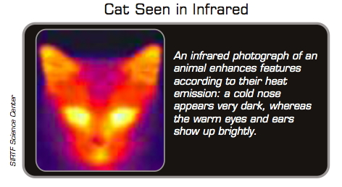

1. **Gas Chromatography (GC)**

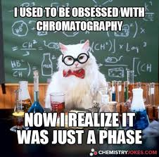

**4.1. Why GC ?**

The dirty little secret about IR is that it is terrible at

identifying components in a **mixture**. Unless the sample is pure, you have no idea whether the presence of an OH stretch, aromatic overtones and a C=O stretch means you have a single aromatic with both OH and a carbonyl, two compounds which collectively have the three functionalities, or three different compounds (if not more !)

What’s needed is a way to separate out individual compounds and identify them separately. This is exactly what GC is *great* at.

**4.2. The Basic Idea**

**Figure 8** illustrates the key components of a GC instrument.

In a nutshell what happens is that a small volume of your liquid mixture (typically < 1 μL ) is injected at the **Sample Injector** with a syringe**.**  Inside the **Sample injector**, the sample is heated to ~ 300oC (and hopefully vaporized), after which it is swept into the **Column** by a chemically inert carrier gas (He). The **Column** is a long hollow glass capillary chemically coated on the inside with something called the **stationary active phase**. **The stationary active phase is** where the main act of separation plays out.

As the mixture travels through the **Column**, the individual components go through a series of `hops’ down the length of the **Column**, repeatedly binding then unbinding to the **Column’s**  **stationary active phase** for a time specific to both the compound and the **stationary active phase**, as well as the column length and He flow rates.

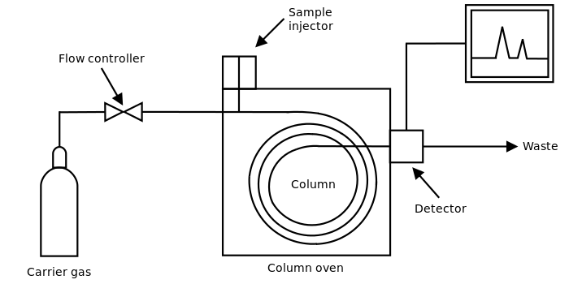

**Figure 8: Basic Schematic of a Gas Chromatograph**

**Figure 9** models the `hopping’ process theoretically taking place inside the **Column** for a single compound, **A**.

**Figure 9: Model of Separation Process in a GC Column for Compound A=**

**2) A flows to second site** **in time thA**

**+ He Stationary**

**Active**

**Phase**

**1)A binds here for time tA  3) A binds again**

**then releases for tA, then releases… etc. ,etc….**

The critical value that ultimately gets measured is how long it takes **A** to pass completely through the column and reach the GC **Detector.** That time is referred to as the `**retention time’ = tR.**

The **retention time** reflects the ***sum*** of ***all*** the hop times (**thA)** and binding times (**tA)**  compound **A** needed to exit the **Column.** It varies sharply with compound properties, He flow, column length **stationary active phase** and temperature. To drive home how this results in separation of components vary in time, consider the behavior of **compound B** flowing down the same column in **Figure 10**.

**Figure 10:** **Model of Separation Process in a GC Column for Compound B=**

**2) B flows to second site in time thB**

**+ + He**

**1)B binds here for time tb  3)B binds again**

**then releases for tB, for tB ,then releases… etc. etc. …**

It should be evident that **B** will spend less time in the column than **A** since the longer distances between bindings implies that **B** is less attracted to the **active stationary phase** than **A**. Thus it will spend less time sitting and more time traveling.

Think of **B** as the express bus through the column- few stops and only to load or off-load. By contrast, **A** is the local tourist bus, which stops at every little dusty hamlet in GC

column land for pictures, snacks, a coupla three beers and long

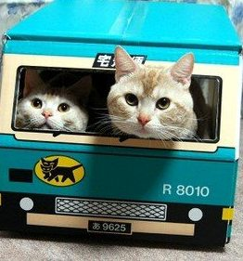

bathroom breaks. GC geeks refer to the distance of one hop in this

model as the **Height Equivalent of the Theoretical Plate ,** or **HETP.**

You’ll encounter this again when we learn to distill mixtures.

Once the components come out, they get detected by a myriad of different **Detector** types. Regardless of the **Detecto**r design though, the universal output is a chromatogram like the one shown in **Figure 11**.

**Figure 11: Gas Chromatogram of a Standard Blood-Alcohol Sample**

**pA**

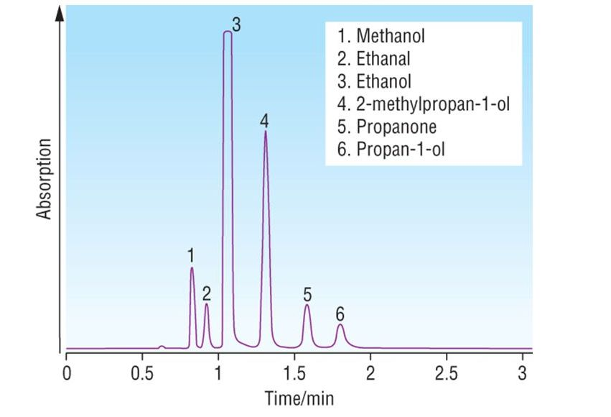

As long as the run conditions are not changed, the various compounds in the list above will always show up at the same times.

Thus, if you run an unknown through the column with the settings used for **Figure 11** and find just two peaks at tR= 1.05 min and 1.85 min, you can reasonably conclude that your unknown contains just ethanol (**3**) and propan-1-ol (**6**). With few exceptions in GC land, it’s a one-time- one- peak- to-a-compound world.

**4.3. Looking for Predictable Trends in Retention Time, tR , Order**

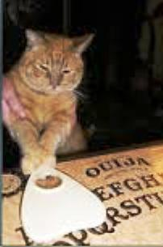

*“It’s hard to predict things, particularly the future. “*

*Yogi Berra*

Normally, you have a pretty good idea of what you’re looking for when you carry out a GC analysis. The sample in **Figure 11**, for example, is a standard mixture containing likely alcohols present in a DUI perp’s blood.

You’d ***never*** turn to GC *first* to ID a complete unknown since the method pre-supposes you already know the possible compounds to look for.

If you are relentlessly practical, then just knowing the possible compounds’ **tR**

from a standard mixture like **Figure 11** is all you’re interested in when analyzing an unknown. Who cares when the peaks come out, as long as they do it consistently?

But the curious among you might wonder ***why*** the order in **Figure 11 is** the way it is. And how do you know which peak goes with which compound in the first place ?

The answer to the second question is easy: you put each of the 6 compounds in **Figure 11** through the GC column ***by itself*** and measure its’ **tR** in pure form.

The first question is harder. One very rough rule of thumb is that the order often follows molecular weight. Indeed, the 1- and 2-carbon molecules (methanol, ethanol and ethanal) come out faster than those with 3-carbons (propanone and propan-1-ol).

But there are exceptions. Note that 2-methyl propan-1-ol is a ***4-carbon*** alcohol yet it has a smaller **t**R than either propanone or propan-1-ol. Clearly , while molecular weight is a big part of the deal, it isn’t the *whole* deal.

To see if boiling point or polarity are predictive I’ve tabulated the molecular weights (MW), dipole moments and normal boiling points for all six compounds in **Figure 11** in **Table 2** below.

From **Table 2** you can quickly see that the dipole moments are worthless for prediction. Methanol, with the shortest **tR** has almost same dipole moment as propan-1-ol, which has the largest **tR.** However, as long as we keep to the same functional group, and, a common *structural* form, boiling points do offer reasonable predictions of order.

For example, the **tR** for straight-chain alcohols methanol, ethanol, propan-1-ol

fall in line with their increasing boiling point trend.

**Table 2: Some Physical Properties of Figure 11 Compounds**

|  |  |  |  |  |
| --- | --- | --- | --- | --- |
| **Peak** | **Compound** | **MW (g/mol)** | **Dipole moment, D** | **Boiling point, oC** |
| 1 | Methanol | 32 | 1.70 | 68 |
| 2 | Ethanal | 44 | 2.68 | 44 |
| 3 | Ethanol | 46 | 1.69 | 78 |
| 4 | 2-methylpropan-1-ol | 74 | 2.96 | 108 |
| 5 | Propanone | 58 | 2.88 | 56 |
| 6 | Propan-1-ol | 60 | 1.68 | 97 |

Similarly, if we view ethanal and propanone as being ~ in the same functional group and unbranched structural family, their boiling points also correctly predict retention time order.

With a little consideration you should also see that the degree of `branchiness’ of 2-methyl-propan-1-ol is what makes it act differently than its straight- chained cousins.

In **Figure 12**, the orderly progression of **tR** within a common family of straight chain alkanes in **A** mirrors what we proposed above. The trend in **B,** however, provides a

**Figure 12: Straight vs. Branched Alkane Retention Times**

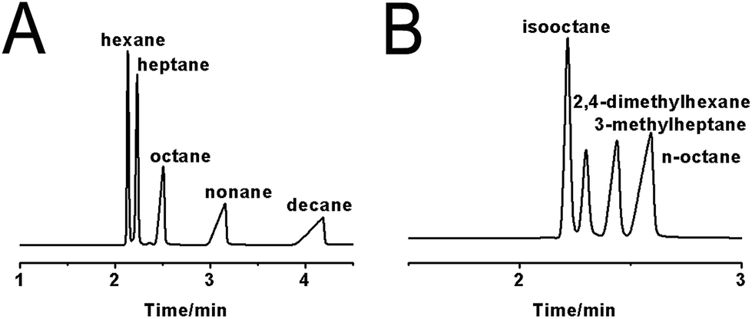

critical new insight. Note that all 4 compounds in **B** have the same molecular mass and molecular formula: **C8H18.**  Their individual structures, though, vary widely as seen in **Figure 13**. The more branched the compound becomes, the *smaller i*ts’ retention time.

decreasing retention time

Geometrically, greater `branchiness’ means the molecule is contracting and curling up into the equivalent of a molecular ball. The contraction translates into less interaction with the active phase, thus naturally ***lower*** retention times.



iso-octacat is out of contact

**n-octacat is interacting**

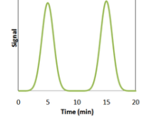

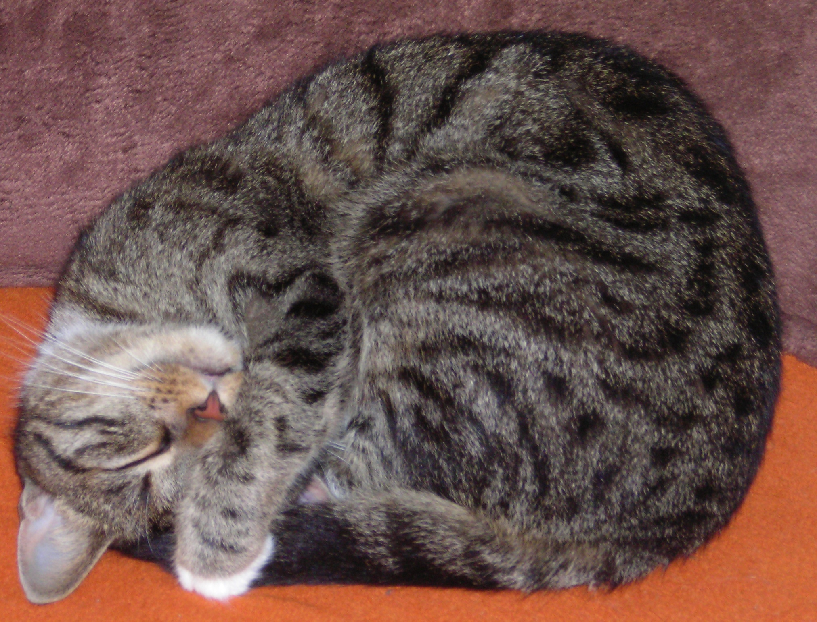

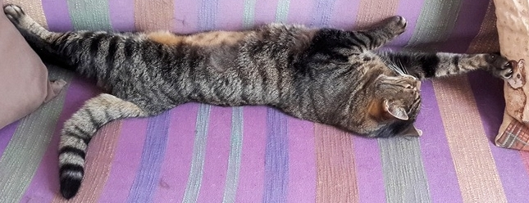

isooctane (2,2,3-trimethylpentane)

2,4-dimethylhexane

2-methylheptane

octane

**Figure 13: Structures of Molecules in Figure 12B**

**5. Practical Notes on Running a Gas Chromatograph**



**5.1. Meet the Instruments**

The GC you are to use are both Agilent 6890 N models. **Figure 14** shows the front face of one of them. The *manual control module* is

**injector port**

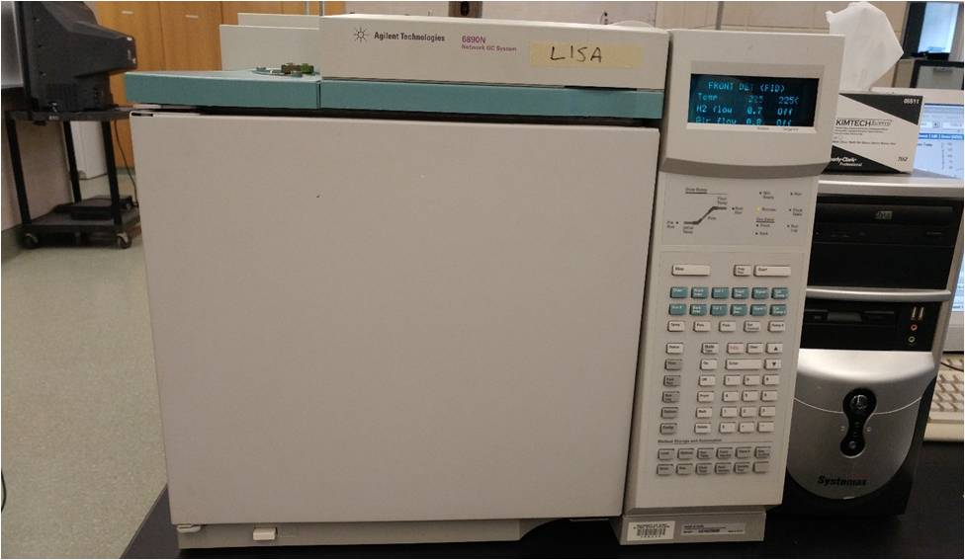

where you will eventually push buttons to

initiate a run (with computer help.)

Both of the instruments have *FID = Flame Ionization* **Detectors.** This style of detector burns compounds exiting from the column in an H2+air flame creating ions in the flame across which the FID measures a current (usually in picoamps=pA=10-12 A ).

More compound=> more ions=> more current.

On our instruments the *FID* is on the right

**oven door**

**manual control module**

**Figure 14: Front Face Of An Agilent 6890n GC**

side of the oven as you face it, across from the injector port, where (duh) we

inject samples. (FYI, getting an *FID* to `light’ and *stay on* is a frustrating business that

can require 30-40 entertaining minutes of instructor cursing and fiddling.)

Behind the oven door (see **Figure 15** below), is where the **capillary column** lives.

I haven’t talked about *why* we need an oven yet, but as you’ll soon find out without it the column will have a tough time giving you a good chromatogram.

It’s hard to see, but the capillary comes out of the *injector housing*, winds around and around and eventually out to the *FID*. The arrows give you an idea of the direction the samples and He carrier are following.

We will use two GCs: one for alkanes (Lisa), the other for alcohols (Bart).

Both can be used for ketones.

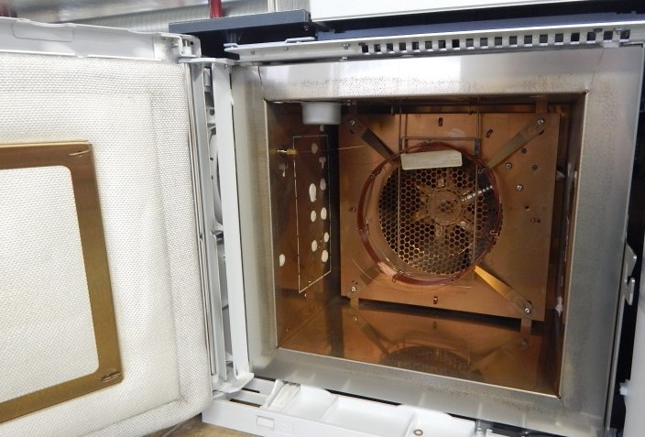

**to FID**

**injector housing**

**capillary column**

**Figure 15: Capillary Column Mounted in GC Oven**

**5.2. The Chem Station GC Method**

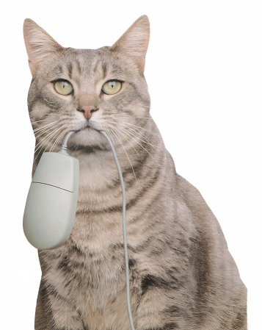

The instruments will generally be on and ready

to use when you come to lab. Both will have a

specific **Method** loaded on the *Chem Station software*

that controls the instruments during a run.

The **Method** is programmed through the computer interface shown in **Figure 16.**

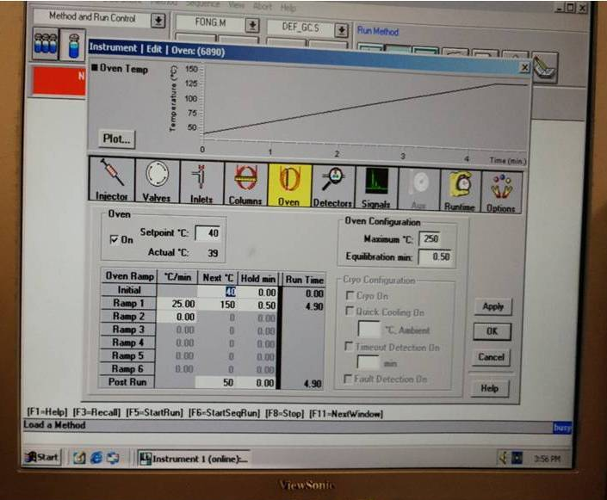

**Figure 16: Interface for Editing a GC Method**

While you won’t likely need to monkey with the **Method** settings, it’s important to know some of them since you’ll be tasked to include the run conditions set forth therein on your chromatograms. (See example in **Figure 22** .) Three of the icons on the above screen shot are relevant: **`Injector’, `Inlets`, and ‘Oven’.** (Boxed in **red** in **Figure 16**.)

The *injector temperature* must be high enough that any injected liquid sample is vaporized. You change that temperature through the **`Injector’** icon. Normally, it’s set around 280 -300 oC.

The `**Inlets’** icon controls He flow rates and the `**split’** **ratio.** The ‘**split ratio’** can be anywhere from 0:1 to 500:1 and is the relative volume of the injected sample *discarded* vs. the relative volume of the sample sent *through the column.* The `**split’** allows us to adjust sampling so that reasonable signal sizes appear at the detector.

Finally, the `**`Oven’** icon lets us set up a ***thermal ramp***. This is probably the most important part of the **Method**. Because the compound mixtures have boiling points that can span a wide range, if we just hold the capillary column at a fixed temperature, the higher boiling components may never properly vaporize and make it to the detector.

To remedy this, the oven is set at some initially low temperature. (**In Figure 16** it’s 40 OC). When the GC run is initiated, the oven is triggered to increase (or `***ramp***’) its’ temperature at some designated rate (In **Figure 16** it’s 25OC/min) until an upper bounds temperature is reached. (In **Figure 16** it’s 150 oC).

Often, the oven is held for a short time at the upper bounds temperature to allow time for the highest boiling components to clear the column entirely. (In **Figure 16**, we hold at 150 oC for 0.5 minutes.) **Figure 16** also gives us an alternative visual of the thermal ramp schedule just above the icons. The entire run takes 4.90 minutes.

After the entire ***ramp*** schedule is done, the oven cools itself down to the initial temperature by turning on a fan. The usual cycle time from the time you start, to the time the instrument is cooled back down and ready for another injection is about 10-15 minutes.



**5.3. Running the Method**

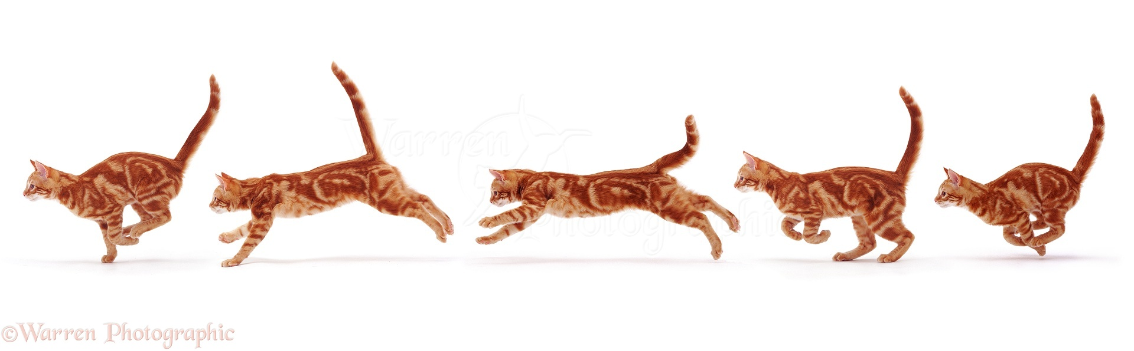

The **Method** will be loaded and set to **Run** when you arrive in lab. However, to actually make a measurement, you need to press the

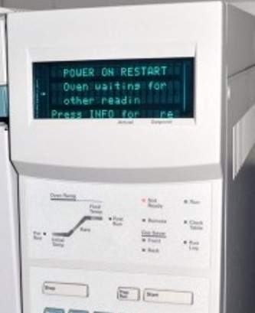

***`Prep Run’*** button on the *Manual Control*

*Module* (See **Figure 17).** This sends a message from

the GC to the *Chem Station* *software,* signaling

your wish to make a measurement.

The software ***will not***, however, let you proceed until ***all*** the relevant pressures, temperatures and flow rates are attained.

It tells you this in two ways.

First, there is a `**not ready’** light on the *Manual Control Module*, which remains **on** after you **push `*Prep Run’*** *until* the instrument ***is*** ready. The **not ready** light then goes out.

Second, the *ChemStation* display shows either

a **red** ***not ready*** message or a ***green ready*** message on the left side of the Chem Station upper control ribbon (See **Figure 18**).

Once you get the **`Ready’** signal from the instrument, you can inject your sample at the the injector inlet. This will be done `*wet needle’* which means you merely dip the outside of the microliter syringe needle (see **Figure 19**) into your sample, then quickly push the needle tip through the injector port seal and down as far as the syringe barrel allows.

**Figure 19: Microliter syringe used for `wet**

**needle’ GC Injection**

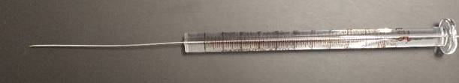

**Start**

**Figure 18: ChemStation RunControl**

**Page in `Not Ready’ state**

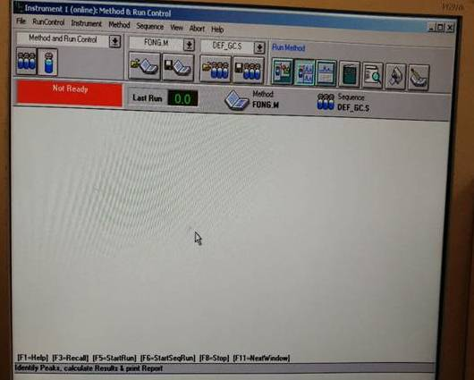

**not ready light**

**Prep Run**

**Figure 17: Prep Run and Start Buttons**

**on Manual Control Module**

**syringe barrel**

**syringe needle**

The injector inlet you will be using is shown in **Figure 20.** You should practice injecting a few times with a dry needle. There is a rubber septum you must penetrate that resists

your motion. You can easily end up putting a permanent kink in the needle so take some care.

A `good’ injection is both smooth and quick. Leave the needle in place until after you press the ***`Start’*** button on the *Manual Control Module*.

Do this ***immediately*** after your syringe has been inserted. Then remove the syringe. Usually, if you have a lab partner, one does the inject and the other does ***Start*** button duty.

A vertical line will appear on the real time, moving pA vs. time plot on the computer display indicating when you pressed ***Start*** (and simultaneously injected.)

**Figure 21** is an example of a real time plot. Sit back and enjoy the ride. You’ll just need to wait till the run is done and it prints out your chromatogram. An example of a print out is shown on the next page in in **Figure 22.** Tada ! You’ve taken your first GC chromatogram**.**

**Now for cat nap time !**

**front of instrument**

**back of instrument**

**not**

**here**

**inject**

**here**

**Figure 20: Top View of GC**

**Injector Port**

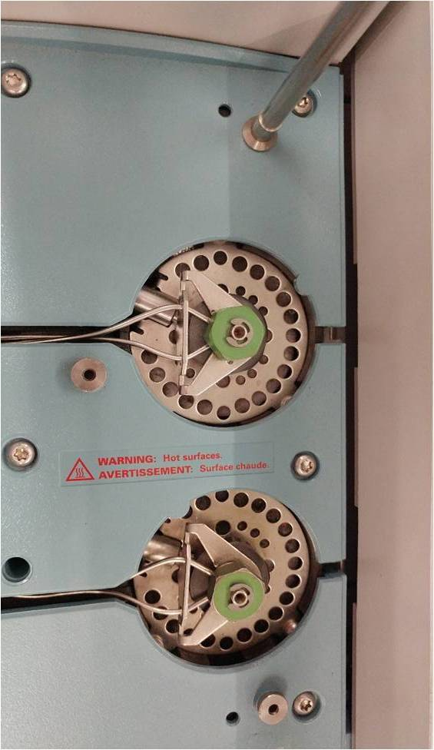

**plot moves this way**

**injected here**

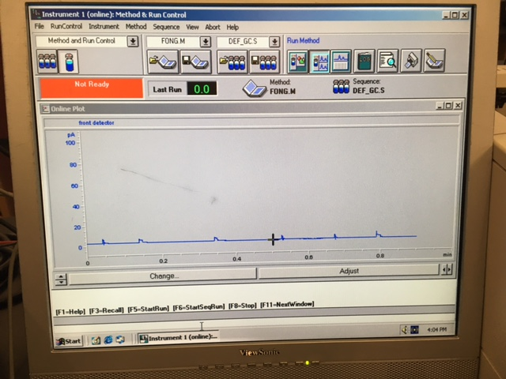

**Figure 21: Real Time GC Output**

**During a Run**

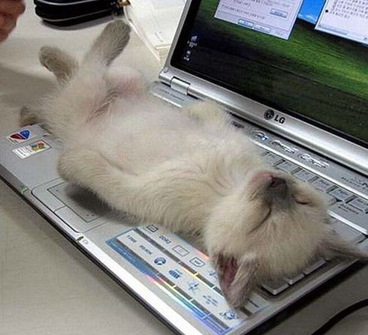

**Figure 22: Example of GC Chromatogram Generated by**

**Selected GC Method**

