1. Name the following compounds. (4 pts)

____/30

|  |  |
| --- | --- |
| ________________________________________ | ________________________________________ |

1. Problem #59. Use Newman projects or chair conformations as needed. (3 pts)
2. Problem #64 a and b. Draw mechanisms and predict the major product. (4 pts)

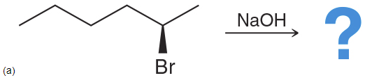 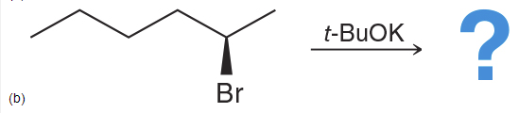

1. Problem #65 a and b. (2 pts)

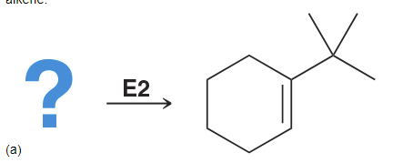 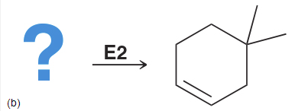

1. Problem #67 a and b. (2 pts)
   1. ________________________ b. ________________________
2. Problem #76. Identify SN1, SN2, E1, E2. Draw a mechanism and predict the major product. Show Newman projections and chair conformations as needed. (15 pts)

|  |  |
| --- | --- |
| SN1 SN2  E1 E2 |  |
| SN1 SN2  E1 E2 |  |
| SN1 SN2  E1 E2 |  |
| SN1 SN2  E1 E2 |  |
| SN1 SN2  E1 E2 |  |