1. Use Table 6.1 to predict the ΔHo (in kJ/mol) of the proposed reactions below. In each case indicate whether the reaction is exothermic or endothermic. (Show work)

ΔHo (kJ/mol) exo or endothermic ?

1. H2 + CH3CH2-OH 🡪 CH3CH3 + H2O ____________ ____________
2. CH3CH2-CH3 + HF 🡪 CH3CH3 + CH3F ____________ _____________



____________ ______________

(hint: estimate bond energies using the CH3CH2- Y data available in table 6.1)

1. Decide whether the reactions below involve negative, positive or ~ no entropy change, ΔS:
2. HCl + H2C=CH2 🡪 H3C-CH2Cl ΔS _________________
3. CH­3CH2Br + HCl🡪 CH3CH2Cl + HBr ΔS _________________



ΔS__________________

1. 2C8H18 + 25O2🡪 16CO2 + 18H2O ΔS__________________
2. Given that K = [P]/[R] for a simple conversion of R🡪P , compute the ~ %product P formed assuming the ΔG below and assuming RT=2.500 kJ/mol (T~ room temperature, 300 K).

Recall that K= e-ΔG/RT and % P = 100*K/(1+K)

%P

1. ΔG=-8 kJ/mol
2. ΔG=-1 kJ/mol
3. ΔG=+8 kJ/mol
4. Problem 6.26a

Problem 6.26c

Problem 6.26f

Problem 6.26 g

Problem 6.26h

1. Identify mechanistic pattern. (2 pts)

Problem 6.27a___________________________

Problem 6.27b____________________________

1. 6.28 a (1 pt)
2. Identify the nucleophile and electrophile in the following compounds. (3 pts)



1. Problem 6.38 (6 pts)

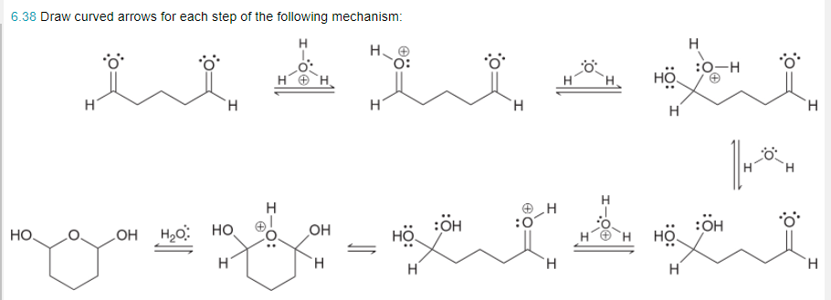

1. Predict whether each of the following carbocations will rearrange. If so, draw the expected rearrangement using curved arrows. (3 pts)

