Name_____________________________________________

/30

1. Practice problem 5.36. Determine the relationship (enantiomers, diastereomers, same compound, constitutional isomers) between the two compounds. (4 pt)
2. ________________________________________
3. ________________________________________

d) ________________________________________

1. ________________________________________
2. Practice problem 5.37. Circle all the chiral centers. (4 pt)

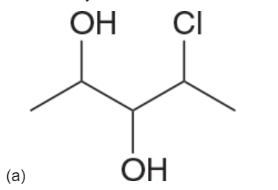 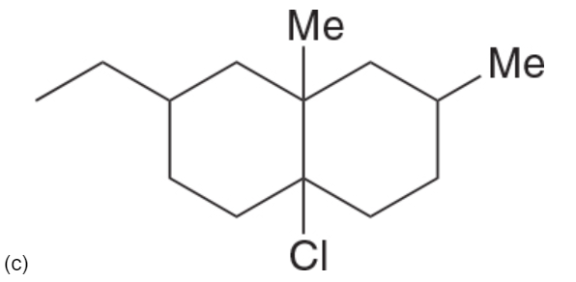

1. Practice problem 5.39. Identify the configuration (R or S) of each chiral center. (10 pt)

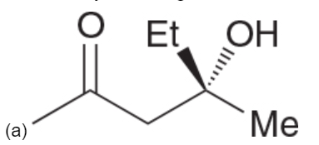 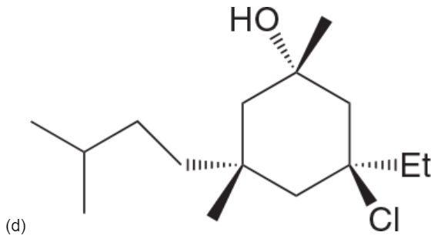

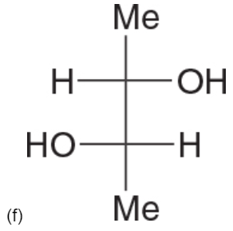

1. The specific rotation of D-alanine in water (at 25°C) is -2.8. A chemist prepared a mixture of D-alanine and its enantiomer, and 1.50 g of the mixture was dissolved in 15.0 mL of water. This solution was then placed in a sample cell with a pathlength of 10.0 cm and the observed rotation was -0.17. Calculate the % ee of the mixture. (4 pt)
2. Practice Problem 5.55. Determine if the compound is chiral or achiral. Label as meso if appropriate. (3 pts)
3. ________________________________________

c) ________________________________________

1. ________________________________________
2. Practice problem 5.63. Determine the relationship (Enantiomers, Diastereomers, Same, Constitutional Isomers) between the two compounds. (2 pt)

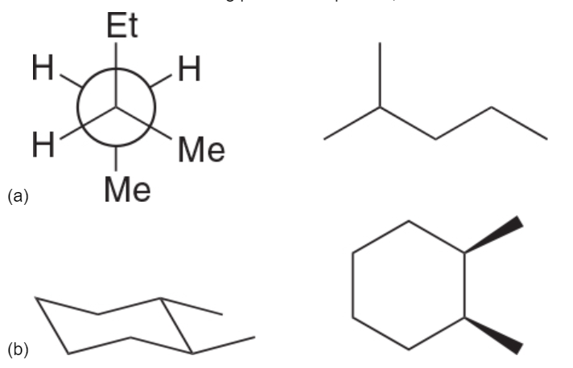

1. Apply cis/trans or E/Z to all the alkenes in the following structure. (3 pt)

