Supplement #1: Zoology of Elementary Electron Descriptions Reviewed
Chemistry 3514 Organic Chemistry I
(see also indicated text pages, Klein text)

1) Electrons in Isolated Atoms (see p. 4)

- CORE (innies’ ...= no chemistry)
- VALENCE (‘outies’ ... =chemistry)

Examples of Lewis dot representations of atomic valence electrons

:S: neutral sulfur :Mg neutral magnesium
[Ne] 3s²3p⁴ [Ne] 3s²
Core Valence Core Valence

2) Electrons in Ionic Compounds (see p. 10)

Ionic compounds generally form from elements at opposite sides of the Periodic Table and with >1.7 differences in electronegativity. Valence electrons in such initially neutral, isolated atoms transfer to produce `core’ (octet) structures using a minimum number of electrons (or, equivalently, to produce minimum formal charge- see pp. 8-9))

:S: + :Mg :O:²⁻ Mg²⁺

[Ne] 3s²3p⁴ [Ne] 3s² [Ne]3s²3p⁶=[Ar]²⁻ [Ne]²⁺

Ionic compounds are held together by the electrostatic attraction of opposite charges.

3) Bonding in Organic Covalent Compounds (see pp 4-12)

Elements closer together in the Periodic Table form `covalent’, not ionic bonds. They do so by “sharing” rather
than exchanging electrons. Each covalent bond contains two (2) electrons. Except for H, elements in stable covalent compounds all `appear’ to share an octet of electrons when drawn using the `line-bond’ structure formalism.
covalent bond

Example: :C≡O: lone pair

If two (or more) alternate ways of distributing electrons in bonds and lone pairs satisfies the octet rule, you pick the structure that minimizes formal ( ) charge. [see pp. 8-9)

Example: CO₂
.. .. ..

(-1):O-C≡O: (+1) vs. (0) :O=C=O: (0) more stable (preferred)
..

- Ad hoc HONC electron book-keeping rules for covalent bonding (see Fig. 1.1 p.3)

Element¹ covalent bonds lone pairs #( bonds+ lone pairs) # electrons
H 1 0 1 2

O 2 2 4 8
N 3 1 4 8
C 4 0 4 8

Halogens 1 3 4 8
(F,Cl,Br,I)
¹Same rules can be applied to elements in same column as above, e.g. S acts like O; P acts like N.

- Lewis Rules lead to the same result as ad hoc HONC (usually)…and applies beyond HONC
(see pp. 5-8)
i) 8 valence electrons around each atom (except H, He)*
ii) minimize formal charge*
iii) for identical formal charges, structures with resonance are more stable
iv) For elements starting with P, formal charge rule trumps octet rule
*main rules used in most cases except when resonance appears (see pp 36-42)

- Covalent geometries (see pp 24-30)

Covalent and lone pairs around any atom always arrange themselves into ~ tetrahedrons to minimize repulsion.
Examples
..
:NH₃ H₂O: CH₄
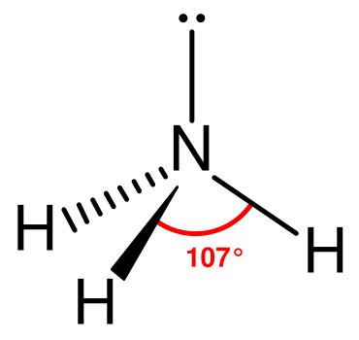
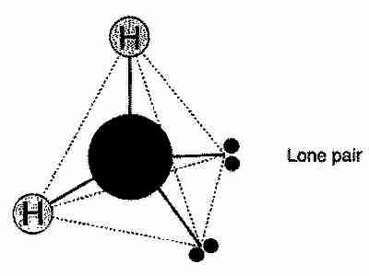
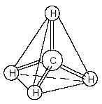

- Drawing Organic Compounds ( pp 50-52)
Condensed complete bond-line Skeletal or `Abbreviated’ Bond line
CH₃CH₃

CH₃CH₂CH₃

(CH₃)₄C

CH₃CH₂OH

