Review questions for exam 3 (Rugg)
Predict the major products and mechanism for the proposed reactions below. (Put mechanism guess in box).
1 | 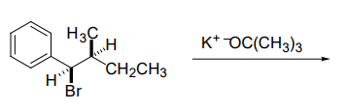  acetone
2 | 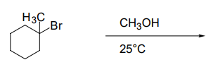
3
4
5 | 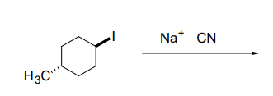  acetone
6
7 | EtOH, 50 ºC
8
9
10

Railroad

