**exercise #14: More Advanced On-the-Road Problems to and from RX**

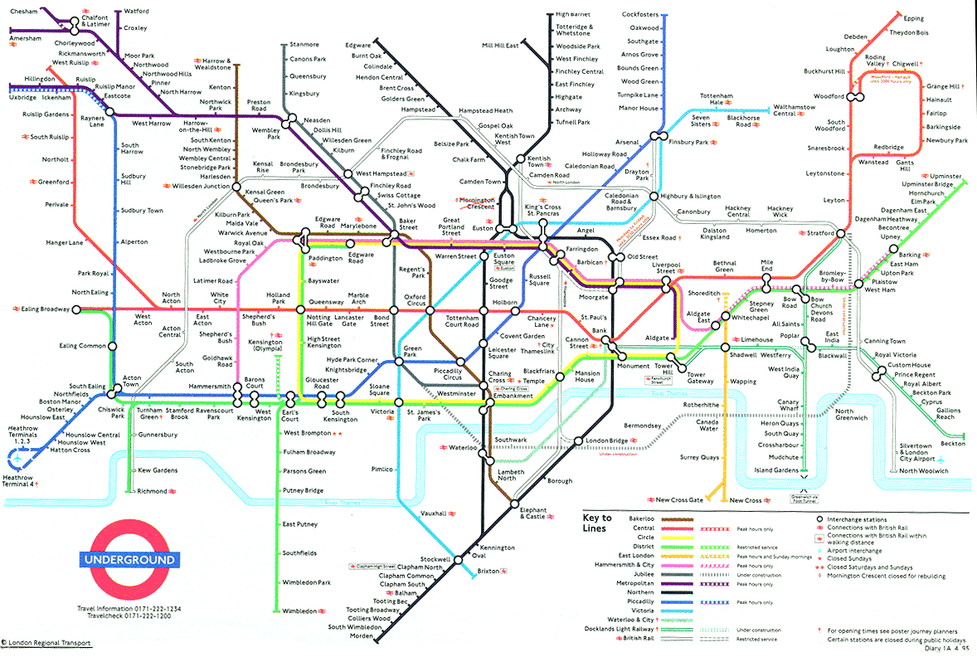

**Organic Chem I Alfred State College**

**Organic Roadmapping 101**



1. **Starting from any alcohol, suggest a route to:**



1. **Starting from any alcohol suggest a route to:**
2. **Starting from a single alkene with 4 or fewer carbons, suggest**



**a route to:**

**R’**



**|**

1. **Starting from any carbonyl (R-C=O) and any 4-carbon or less alkyl halide suggest a route to :**



1. **Starting from acetic acid ( ) and any alkene**

**suggest a route to:**







1. **Starting from just suggest a route to:**



1. **Starting from just suggest a 2 step route to:**

Hint: use a carbocation rearrangement as part of the reaction sequence

