**Exercise 2: Resonance Round-Up**

**Organic Chem I Alfred State College**

1. Name the main `no nos’ to avoid when pushing electrons into alternative resonance structures.

2. What does `allylic’ mean?

3. Draw an example of the five kinds of resonance structures named below:

1. Allylic lone pair b)allylic carbocation c)lone pair adjacent to

Carbocation

d) π-bond between two atoms e) conjugated π bonds in ring

differing in electronegativity

4) Decide whether the given suggested electron pushing motion is legitimate. If not, why not?

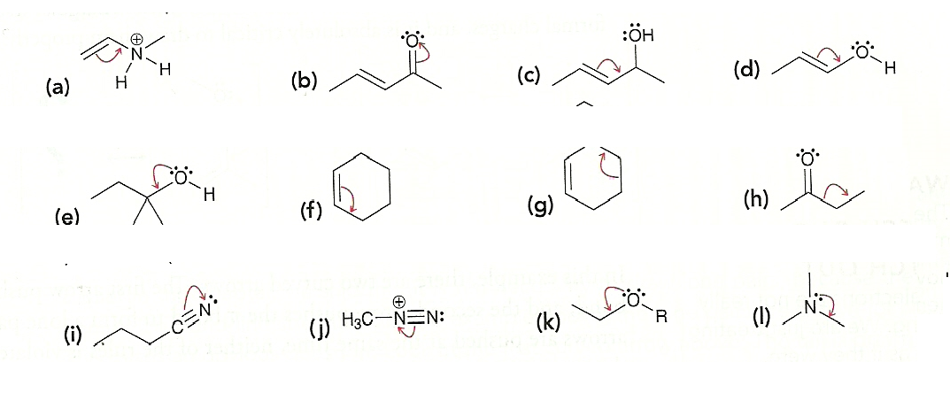

5) What is meant by a `resonance hybrid’ ?

6) What‘s the difference between a delocalized lone pair and a localized lone pair? (Examples are nice).

7) Decide whether resonance structures can be formed from the species below. If so, draw them. Do any

form resonance hybrids? Rank the legitimate resonance structures for stability.



8) Draw all the likely resonance structures for the compounds below and rank them for stability.

Note: the electronegativity for the elements below follow the order: O > N > C > H

(3.5, 3.0, 2.5, 2.1)

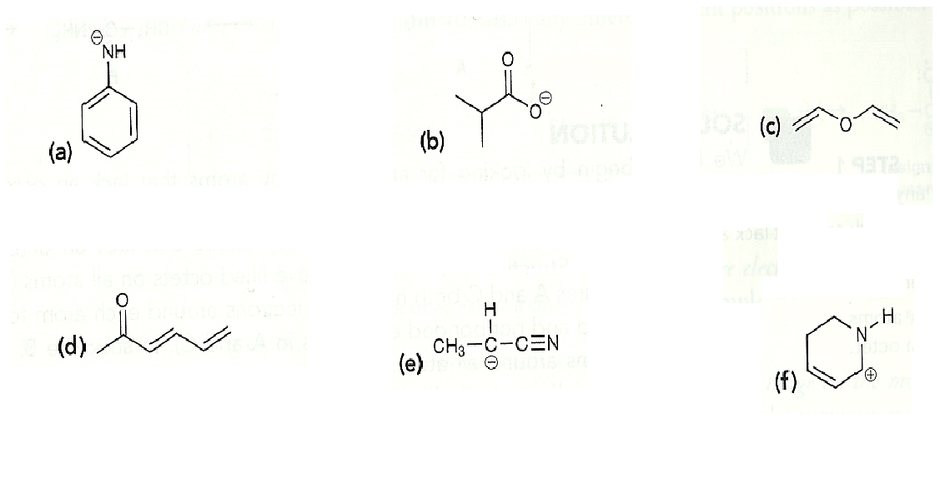

9) Rank the three resonance structures below from most to least likely and why.

