**Exercise 2: Resonance Round-Up**

**Organic Chem I Alfred State College**

1) Don’t break single bonds 2)don’t exceed an octet of electrons on row 2 elements (c.f. p. 65)

1. Name the main `no nos’ to avoid when pushing electrons into alternative resonance structures.



2. What does `allylic’ mean? (c.f. p. 70)

Site immediately adjacent to a double bond (the vinyl group)

allylic

3. Draw an example of the five kinds of resonance structures named below: (c.f. pg. 75)

1. Allylic lone pair b)allylic carbocation c)lone pair adjacent to

Carbocation







d) π-bond between two atoms e) conjugated π bonds in ring



differing in electronegativity



4) Decide whether the given suggested electron pushing motion is legitimate. If not, why not? (c.f. p 67)

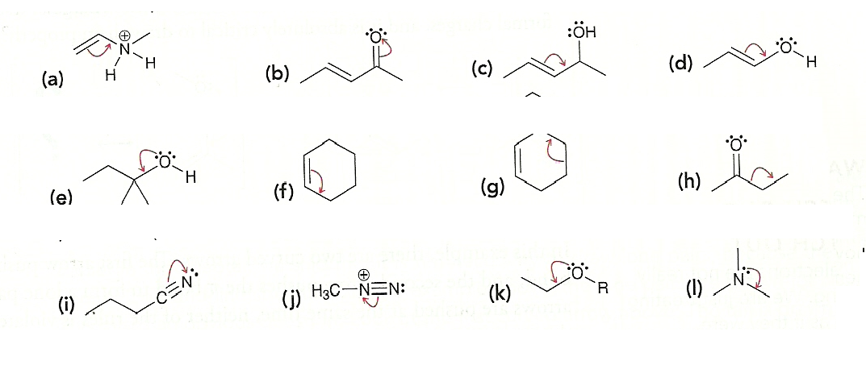



No. 5 bonds (10e’) to C receiving lone pair electrons

No. 5 bonds (10e’) to C receiving lone pair electrons

Yes. Forms terminal N+ and neutral inner N

Yes. Forms carbocation on C and N-

No. Breaks single bond

No. Breaks single bond

No. 10e- on C receiving π electrons

No. 10e- on C attached to OH

No. 10e- on O

No. 10e- on C with OH

Yes. Forms carbocation on C and O-

No. 10e- on N

5) What is meant by a `resonance hybrid’ ? example

Where the separate possible resonance structures for an entity collectively represent just one `blended’ structure .

6) What‘s the difference between a delocalized lone pair and a localized lone pair? (Examples are nice).

Localized lone pairs do not under go resonance since they are not adjacent to pi systems or carbocations. Ex.



Delocalized lone pairs are, and are involved in resonance shifts. Ex. (-):CH2-CH=CH2

7) Decide whether resonance structures can be formed from the species below. If so, draw them. Do any

form resonance hybrids? Rank the legitimate resonance structures for stability. c.f. pg. 79-80







Original structure better

No formal charges

Original structure better. O has higher electronegativity than C

Both – and + species resonances above are equivalent





8) Draw all the likely resonance structures for the compounds below and rank them for stability.

Note: the electronegativity for the elements below follow the order: O > N > C > H (c.f. p. 67)

(3.5, 3.0, 2.5, 2.1)

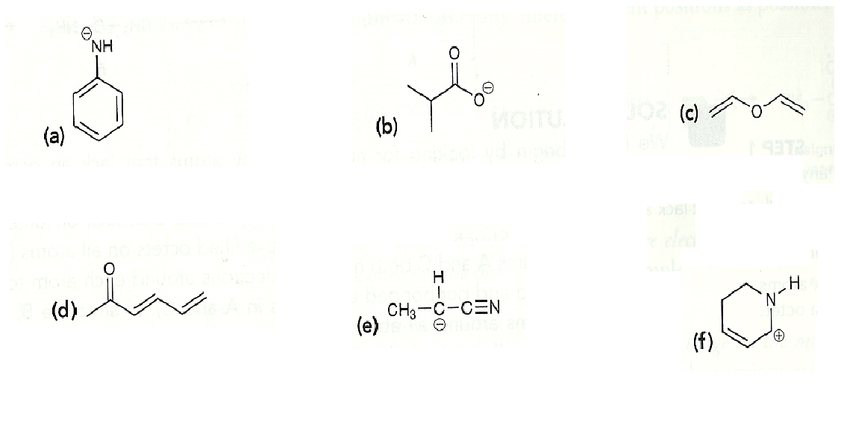



*

*





same

*

*





*





*

*

Most stable

9) Rank the three resonance structures below from most to least likely and why. (c.f. p. 77)



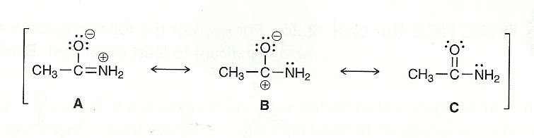

C > B > A

C is neutral (no formal charges). B places (-) on O which has high electronegativity and (+) on C with low electronegativity. A places (+) on N which is destabilizing since N has a high electronegativity.