**Organic Chem 3514 Alfred State**

**Exercise: Reaction Enthalpy ΔHo Calculations From Homolytic Bond Energies**

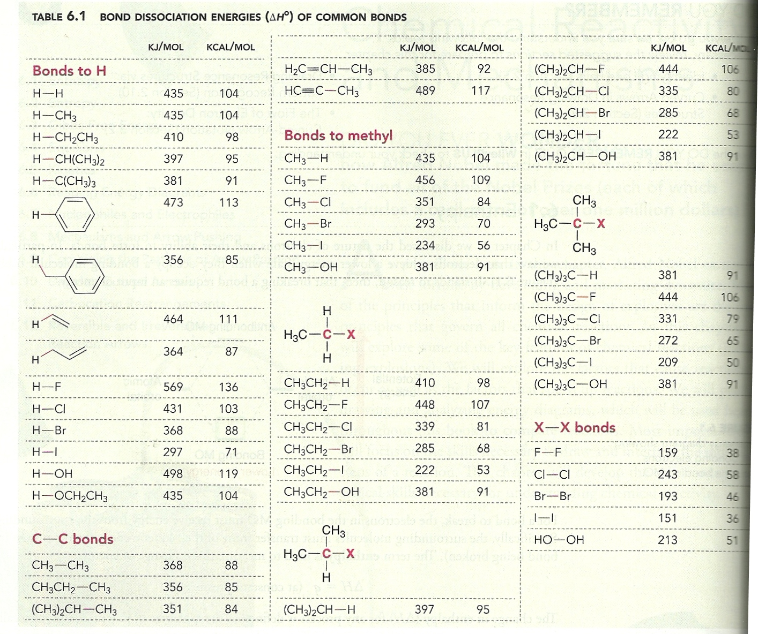

**Use the table above to predict ΔHo for the reactions below and decide if they are exo or endothermic reactions.**

1. **CH3-CH3 + HO-OH🡪 2CH3-OH c) CH­­3-CH2-CH3 + Br2 🡪 CH3-CHBr-CH3 + HBr**



1. **d)**



**e) CH3CH2-H + H2O 🡪CH3 CH2-OH + H2 f) CH3)3C-F + (CH3)2CH-Br🡪 (CH3)3C-Br + (CH3)2CH-F**