**Organic Chem 3514 Alfred State**

**Exercise: Reaction Enthalpy ΔHo Calculations From Homolytic Bond Energies**

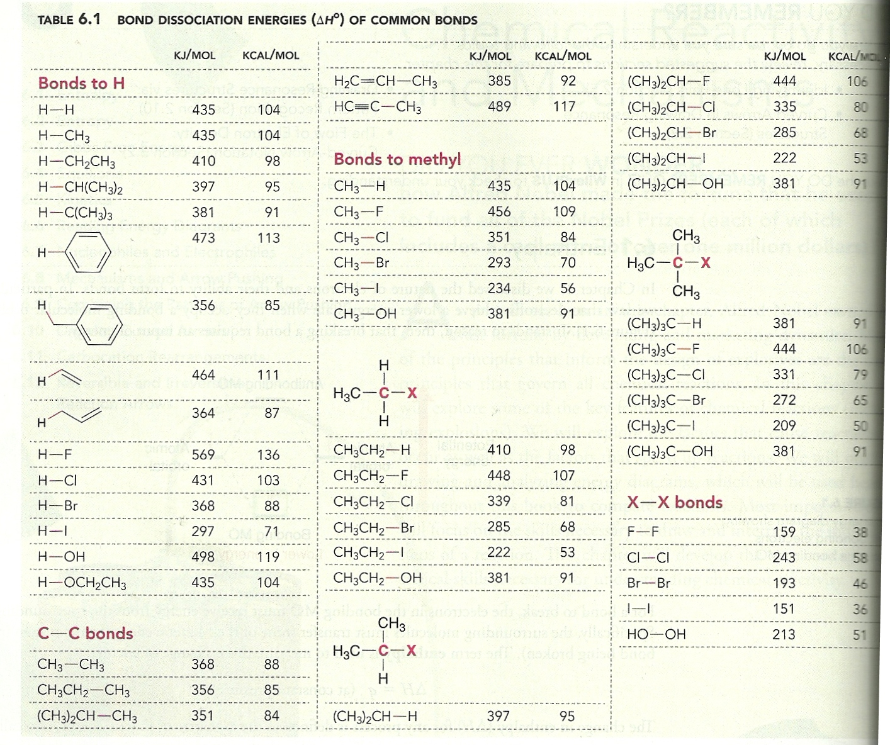

**Use the table above to predict ΔHo for the reactions below and decide if they are exo or endothermic reactions.**

1. **CH3-CH3 + HO-OH🡪 2CH3-OH c) CH­­3-CH2-CH3 + Br2 🡪 CH3-CHBr-CH3 + HBr**

**88 + 51-2*91=-43 exo 95+46-88-68=-15 exo**



1. **d)**



**79+119-91 -103= +4 endo 91+ 71-53-119 =-109 exo**

**e) CH3CH2-H + H2O 🡪CH3 CH2-OH + H2 f) (CH3)3C-F + (CH3)2CH-Br🡪 (CH3)3C-Br + (CH3)2CH-F**

**98+ 119-91-104 =+22 endo 106 + 68-65-106=+3 endo**