**Exercise #3:** **Practice with the Language of Pauling’s Valence Hybrid Model (spn)**

# Organic Chem I Alfred State College

**3.1. (s,p) atomic shapes vs. (s, p) molecular combos**

**Un- hybridized atomic shapes shape when hybridized in molecule**





**s + 1 (one) p**



**s + 2(two) p above +**



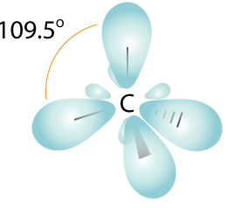



**s + 3 (three) p above +**

**(pz out of page)**

**3.2 Describe the hybridization on the indicated atoms in the molecules below**

**N**H3 __sp3_____ on **N** **N**O2- ___sp2_____ on **N**

**CO** _sp_____ on **C** **CO**2 ____sp____ on **C**

__sp____ on **O** _sp2_______ on **O**

H2**CO** ___sp2___ on **C** **C**H3**O**H ___sp3_____ on **C**

(formaldehyde) (methanol)

_sp2__ on **O**  _sp3_______ on **O**

(a) (b) (a)

H**C**≡**C**H __sp__ on **C** **C**H3-**C**-**C**H3  _____sp3______ on **Ca**

(acetylene) ||

**O** ___sp2_____ on **Cb**

(acetone)

___sp2_______ on **O**

**3.3 List the C valence atomic orbitals (AO) involved in making the σ (sigma)**

**bond linkages in ethene assuming the x,y, z axes are defined as below:**



z

x AO involved in σ___s ,px, pz____

y

How many sigma bonds are shown here ?__5____

Sketch how and where the π (pi) bond in ethene forms and identify the p orbital involved assuming the x,y,z axes orientations below:



Sigma in x-z plane







C C C C



uncombined p

combined as π orbital

py