1. Identify the nucleophilic and electrophilic sites on the following compounds.

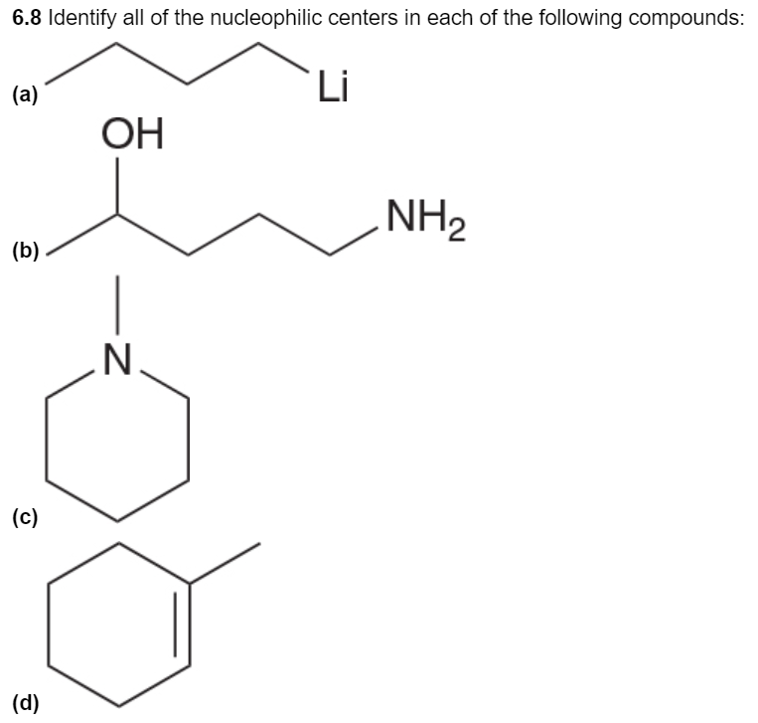  

1. Will each molecule act as a Nucleophile, Electrophile, or both?



1. Identify which arrow-pushing pattern is utilized: 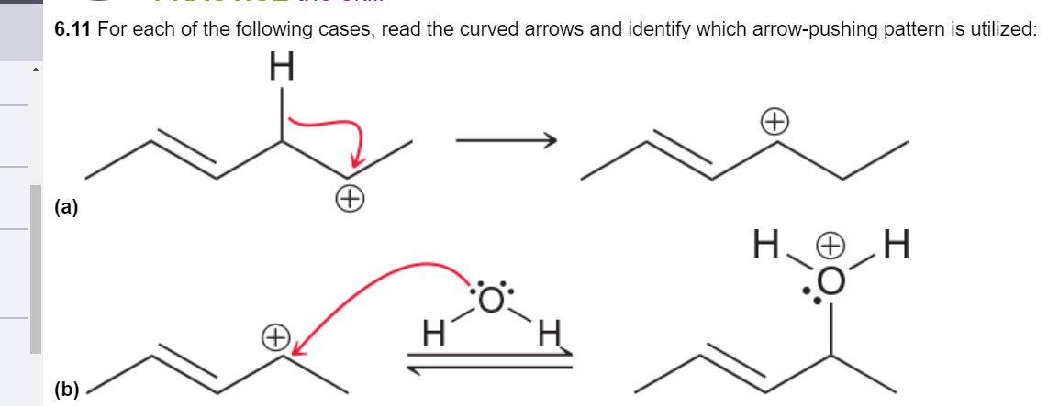

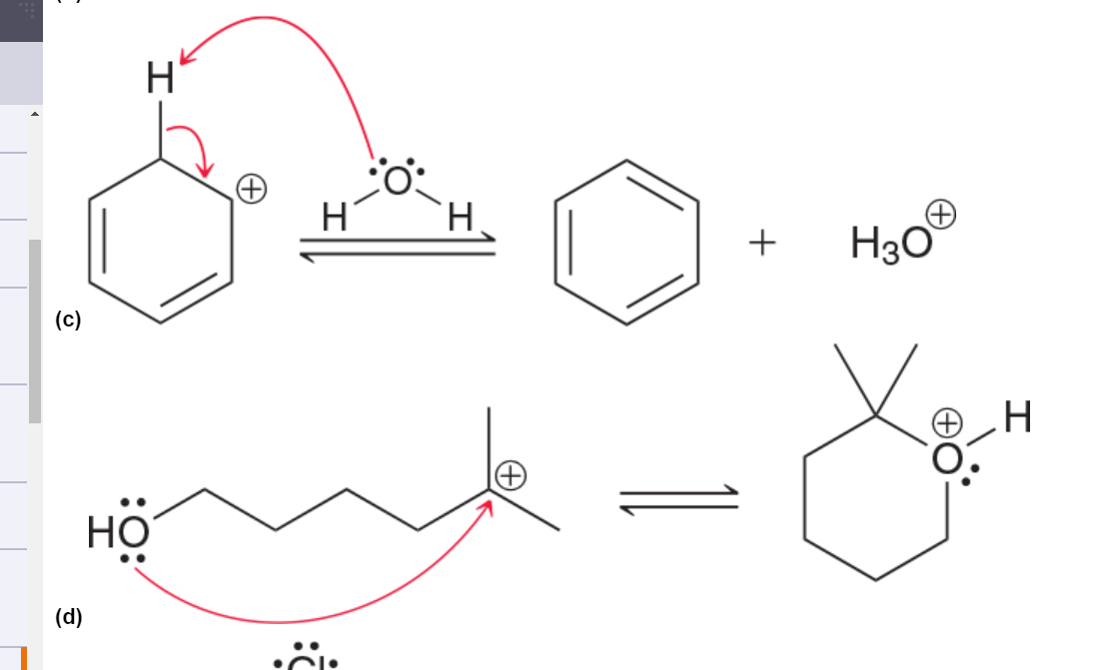

e)

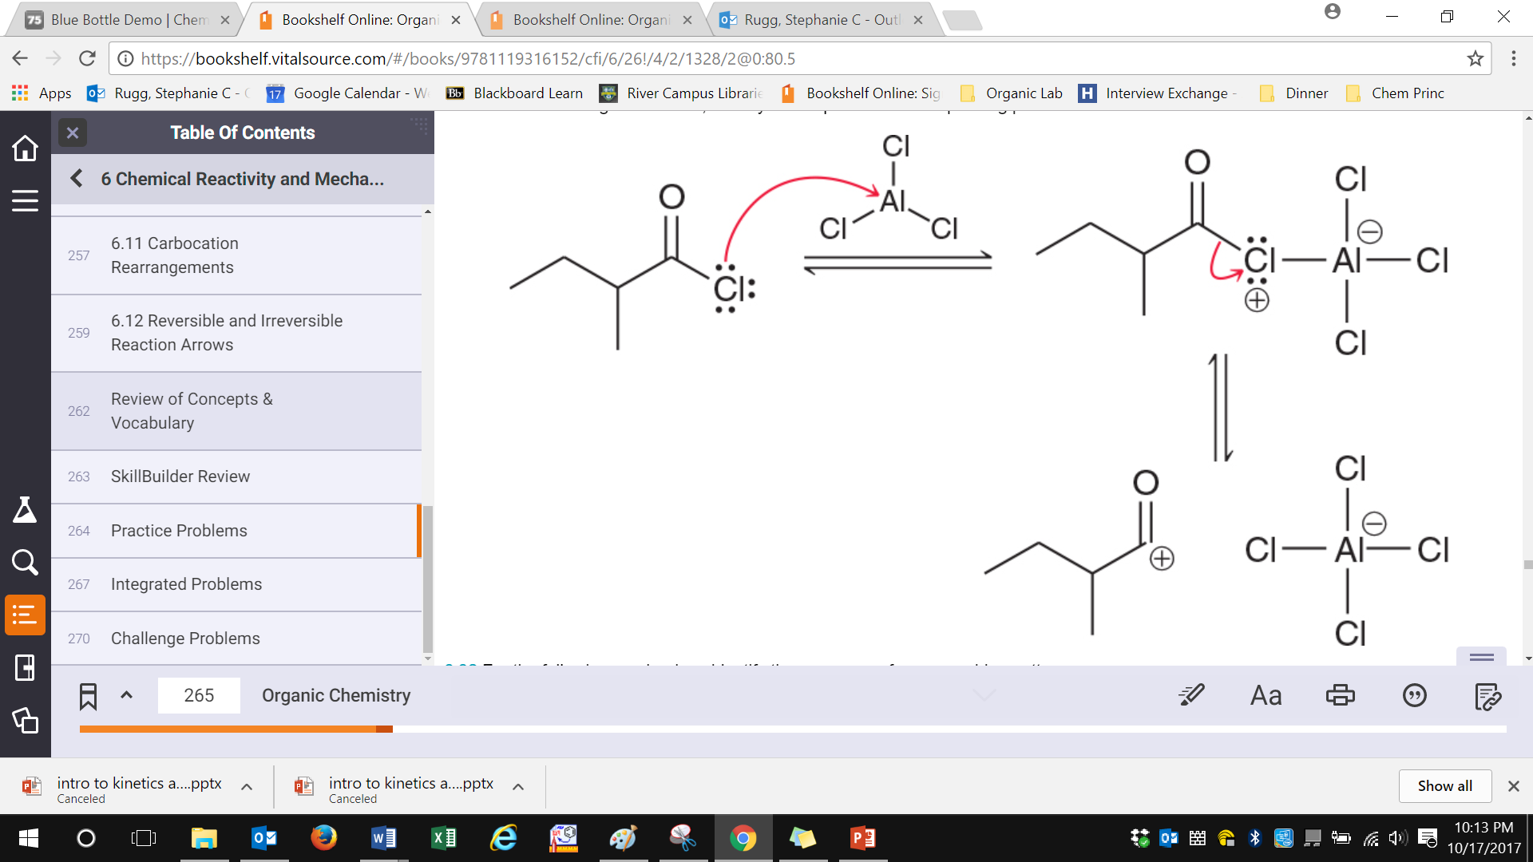

1. Will the following carbocations rearrange? If so, draw the mechanism.

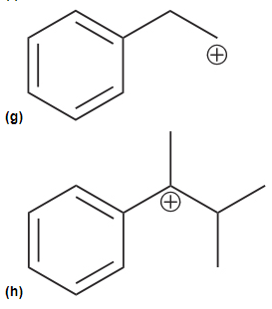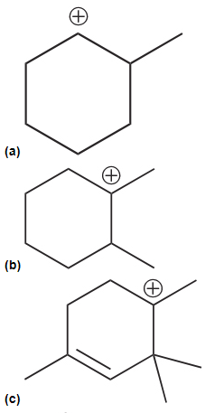

1. Draw mechanistic arrows and identify the mechanism type.

