1. Identify all the chiral centers in the following compounds.

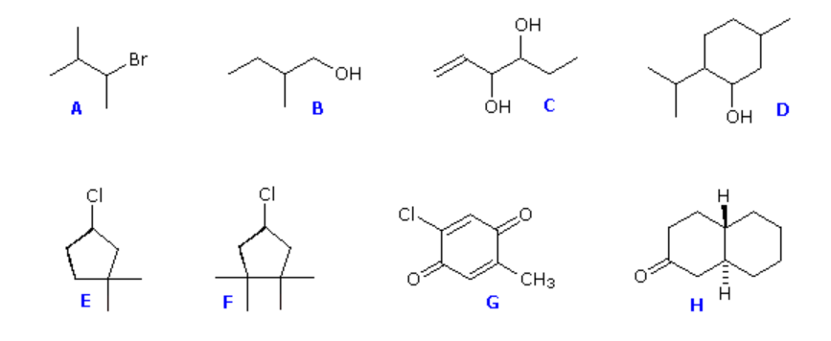

1. Assign R or S if applicable.

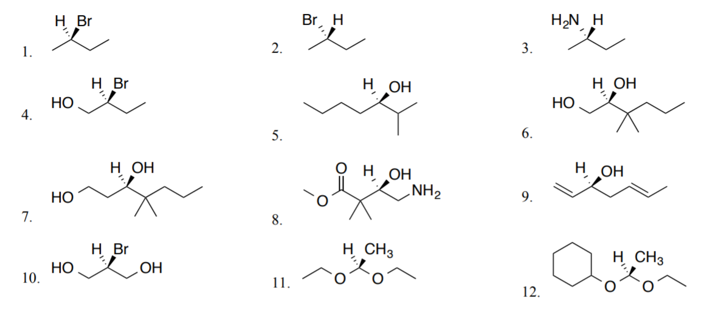 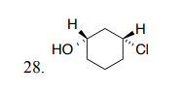

1. Determine the relationship between the following sets of compounds as enantiomers, diastereomers, same.

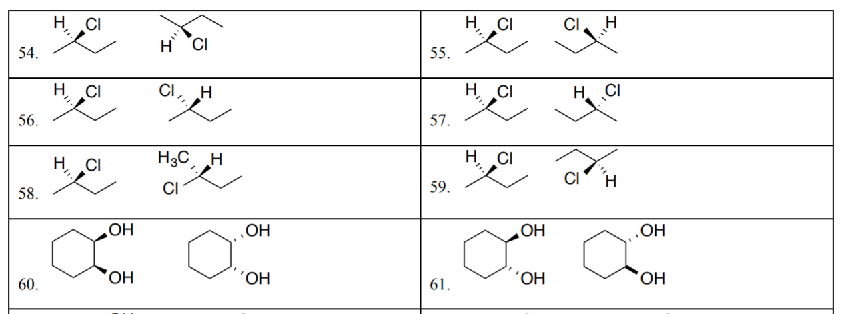

1. Identify if chiral or achiral. Write meso if it applies.

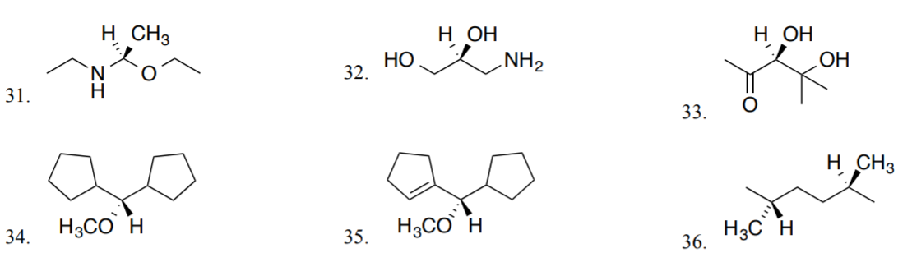

1. Identify any chiral centers in the following compounds and label them R or S.

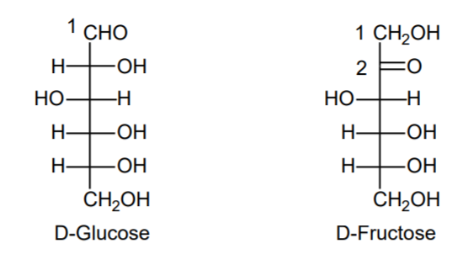

1. Assign cis/trans or E/Z to each compound.

