**HomeWork 15**

**Due Friday 11/13/15**

**Your name: __________________________________ ___/6**

1) Imagine that the atomic nucleus is represented by a ping pong

ball which has a radius of 20 mm.

a) What is the ~ radius of the electronic cloud given the above in

miles ?

_____________ miles

b) Suggest a sensible metaphor for the distance you calculated for

the electronic cloud radius given that the nucleus is the ping

pong ball.

2) Given that c= 3*108 m/s:

a) what is the wavelength of light λ in meters associated with 6

Hz ?

λ= _________ m

b) what is the frequency of light, f, in Hz associated with a

wavelength of 10-5 m.

f= ____________ Hz

3) According to the photoelectric effect, which part of the light `wave’ below determines the real energy of the light ?? Amplitude or wavelength (=c/f)[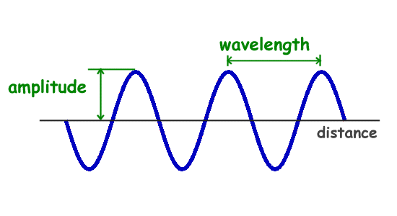](http://www.google.com/url?sa=i&rct=j&q=&esrc=s&source=images&cd=&cad=rja&uact=8&ved=0CAcQjRxqFQoTCIjH4_PviMkCFcNvPgodkZsM_Q&url=http://www.ducksters.com/science/physics/properties_of_waves.php&psig=AFQjCNEjZH8eh7MhKXqrpumbkUjtnaOZeQ&ust=1447348449634386)

Which light wave to the left is most likely to cause electrons to `jump’ in the Photoelectric effect ?

**High Medium Low**

[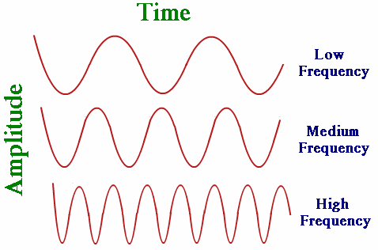](http://www.google.com/url?sa=i&rct=j&q=&esrc=s&source=images&cd=&cad=rja&uact=8&ved=0CAcQjRxqFQoTCOWL29fxiMkCFQp0PgodbJMFjQ&url=http://physics.tutorvista.com/waves/wave-frequency.html&psig=AFQjCNFXkTlKIOnWXJ0K2TWyfxPgWTyGag&ust=1447349091056702)