**Naughty Kitty Group Project Chem 1114**

My four very spoiled kitties have been bad kitties while I was out of the house. There are cat prints on the kitchen counter right over a bowl of chocolate cake mix. There is a large puddle of pee on the living room floor. The bathroom medicine cabinet is open and bottles of over –the-counter drugs lie broken in the sink. Finally, one my naughty kitties has made off with a box of diet cookies , leaving a trail of crumbs.

In order to see which kitty has done what, I have sampled various parts of their anatomies and carried out a compositional analysis of suspicious powders, liquids and goo. Results are below.

Table 1: Percent Composition Data of the Compounds Found on my 4 Naughty Kitties

Naughty Kitty C H N O anatomical site TEAM

Bosco 20.00 6.72 46.70 26.66 paws and tail 1

Buddy 57.14 6.16 9.52 27.18 whiskers, saliva, urine 2

Socks 63.15 5.30 - 31.55 paws 3

46.66 4.48 31.1 17.76 paws 4

Tigger 60.00 4.48 - 35.53 tail 5

72.15 7.08 4.68 16.03 paws and nose 6

Note: C=12 H=1 N=14 O=16 (atomic masses)

Table 2: Possible Compounds

**Identity Molecular formula Notes**

Aspirin C9H8O4  Over-the-counter pain killer

Codeine C­18H21NO4 Over-the-counter pain killer

Aspartame C­14H18N2O5 Artificial sweetener

Urea CH4N2O component in urine

Vanilla C8H8O3 Flavoring in cakes, pies, cookies

Thiobromine C7H8N4O2 Chocolate flavoring

Using the % composition data for your team:

1. Determine the compound on your assigned kitty

2) Decide what your kitty’s naughty act was

Mug shots of the culprits:

Tigger Socks

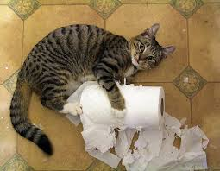

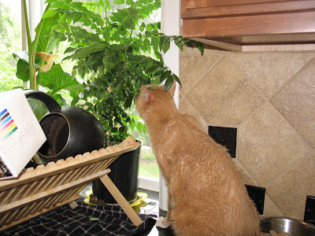

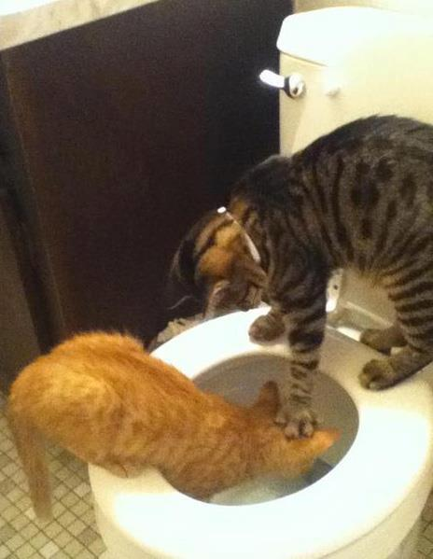

Buddy

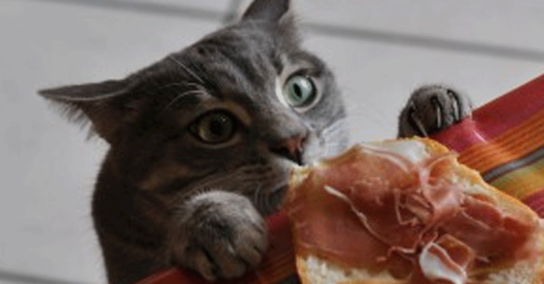

Bosco

Socks