**Mini-quiz #22 Chemistry 1114 Monday 18 November 2013**

**6 pts**

**Your name:____________answers________________________________ A**

**Draw the correct Lewis structures for the molecules below (with formal charges-if present, and lone pairs), then assign their shape (linear, trigonal planar, etc. ).**

**Lewis structure shape**

**SO3**



**Trigonal planar**

**H2S**



**Bent**

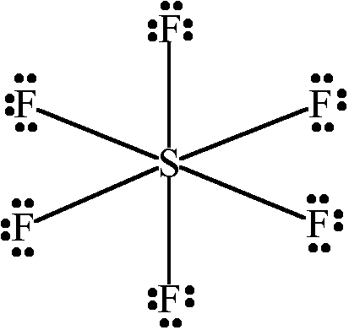

**SF6 Octahedral**

**Mini-quiz #22 Chemistry 1114 Monday 18 November 2013**

**6 pts**

**Your name:__________answers__________________________________ B**

**Draw the correct Lewis structures for the molecules below (with formal charges-if present, and lone pairs), then assign their shape (linear, trigonal planar, etc. ).**

**Lewis structure shape**

**CO2**



**linear**



**H2O bent**

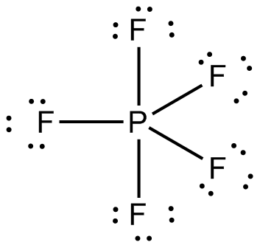

**PF5  trigonal bipyramid**