**Mini-quiz #10 Chemistry 1114 section 2 (Fong) Friday 20 Sept 2013**

Your name:____________answers_____________________________ A 7 pts

**A B C**

1. Name of column A _**alkali metals**__
2. Name of column B__**halogens**___
3. Name of column C**_noble (inert) gases**
4. Circle the metalloids on the Periodic

Table shown on the left

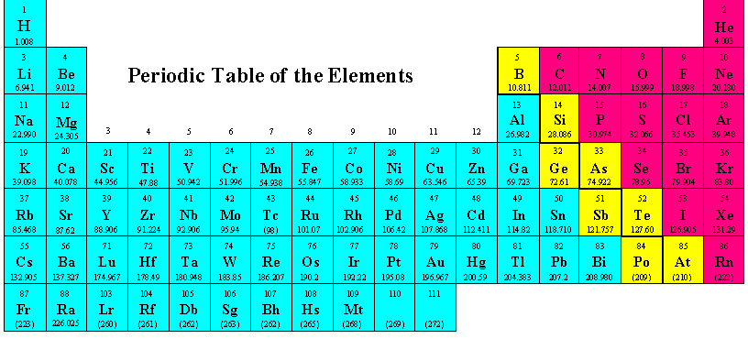

5. Ni is an example of what kind of metal ? __**transition metal**_______________

6. I own 20 protons and am part of limestone deposits. What family of elements am I part of?

______**alkaline earth metal**___________________

7. Gold, Au, is what kind of metal ? ____**noble metal**_____________

**Mini-quiz #10 Chemistry 1114 section 2 (Fong) Friday 20 Sept 2013**

Your name:______________answers____________________________ B 7 pts

A B

1. Name of column A **alkaline earth metals**
2. Name of column B_**halogens**______

3. Circle the Transition metal block

On the Periodic Table to the left.

4. Elements in the `p’ block are called:

__**Main Group**________ elements



5. Na is an example of what kind of metal ? _____**alkali metal**__________

6. I own 10 protons and don’t talk or consort with any other elements. What family of elements am I part of? _______**Inert (Noble) gases**_________________________

7. Ge, Si and B are part of which of the three main classifications of elements on the Periodic Table ? ___**_metalloids**_______________