**Mini-quiz #10 Chemistry 1114 section 2 (Fong) Friday 20 Sept 2013**

Your name:____________________________________________ A 7 pts

**A B C**

1. Name of column A _____________
2. Name of column B_____________
3. Name of column C______________
4. Circle the metalloids on the Periodic

Table shown on the left

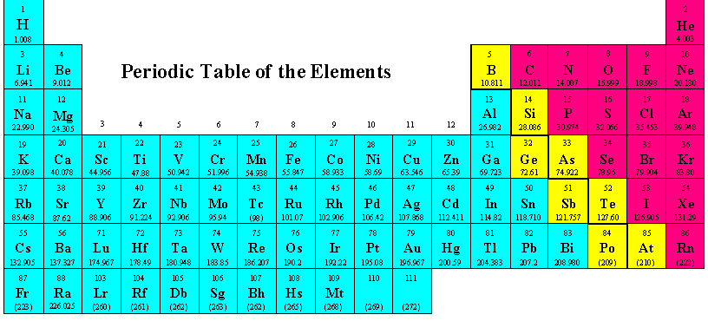

5. Ni is an example of what kind of metal ? _________________________

6. I own 20 protons and am part of limestone deposits. What family of elements am I part of?

________________________________

7. Gold, Au, is what kind of metal ? _____________________

**Mini-quiz #10 Chemistry 1114 section 2 (Fong) Friday 20 Sept 2013**

Your name:____________________________________________ B 7 pts

A B

1. Name of column A _____________

1. Name of column B_____________

3. Circle the Transition metal block

On the Periodic Table to the left.

4. Elements in the `p’ block are called:

_________________ elements



5. Na is an example of what kind of metal ? _________________________

6. I own 10 protons and don’t talk or consort with any other elements. What family of elements am I part of? ________________________________

7. Ge, Si and B are part of which of the three main classifications of elements on the Periodic Table ? ___________________