**Homework #1: Chemistry 1013 Spring 2012**

**Due Monday 23 January in class 20 pts**

1. Problem 6 a,b page 34

**a)As (arsenic) b) 33 (note that this assumes As did not`oxidize’ to its common As3+ form)**

1. Problem 10 a-e (assume for e that there is no solid ice floating in the tea) page 34

**a)OJ with pulp= heterogeneous mix b)milk = heterogeneous mix (can’t see through it)**

**Many of you wrote that milk is a homogeneous mixture. It’s `pure white color’ is still opaque and as you see below, it is composed of at least 4 major components. The picture on the right shows the milk solids from raw milk that are present. The remaining filtrate is mostly lactose + protein + minerals.**

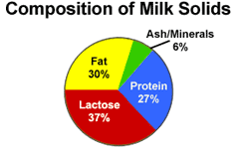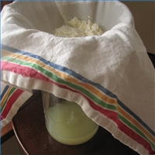

**c) bottled water=pure substance d) cottage cheese= heterogeneous mix e) iced tea=homogeneous mix**

1. Problem 12 a-d page 34
2. **Gas burning=chemical b)snow melting = physical c)alcohol boiling =physical (like water boiling…)d) dynamite exploding = chemical**
3. Problem 18 a-d page 34
4. **Equation is balanced**
5. **atom count for each element in equation: 4 H 2 S 6 O**
6. **same as in b**
7. **six molecules of H2S and 9 molecules of O2 is 3X what is in equation, so we should produce 3X as much product => 3*2=6 H2O molecules**
8. Problem 26 a page 35
9. **There are 6 O atoms on the product side (2 from ZnO and 4 from 2SO2). This means w must multiply O2 by 3 since 3 x 2= 6 . The coefficient in front of O2 is thus 3**
10. Problem 32, page 35 (4 pts)

**The mass of H in H2O is 1/8 (=0.125) that provided by the O . (Each O weighs ~ 16 amu in H2O while the two H contribute 2 x 1 amu. Thus mass H/mass O = 2/16= 1/8=0.125.) Comparing this ratio to the ratio of the %H/% O in the human body = 10% /61% = 0.16 we get a similar result. The discrepancy in the two ratios arises since the body is only ~90% water.**