Naming Alkanes Exercise #3 Chem. 1013

Name these Compounds

1. 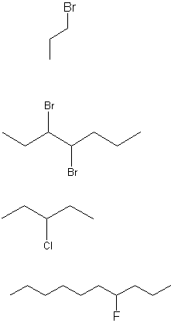


5. 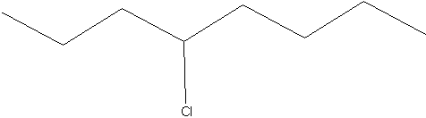
6. 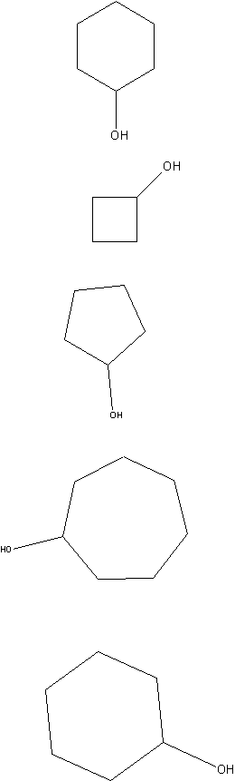



11. 