Naming Alkanes Exercise #2 Chem. 1013

Name these Compounds

1. 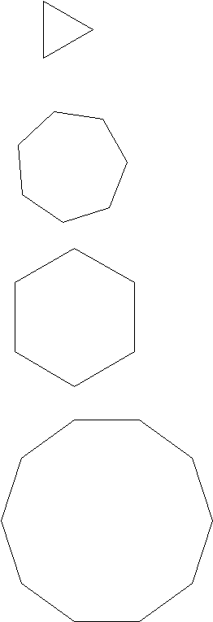

4. 